Running Notes
CSC 523 ADAVANCED SCRIPTING FOR DATA SCIENCE

COURSE OUTLINE

PART A: SURVEY OF APPROACHES FOR RETRIEVING DATA IN A SCRIPTING LANGUAGE ENVIRONMENT
A1. Regular expressions for extracting data from flat text
A2. Parsing libraries for extracting data from semi-structured text
A3. Reading data streams from sensors
A.4 Reading comma-separated value and similarly formatted files
A5. Reading data streams from network sources
A6. Script input-output with relational and NoSQL databases
PART B: DATA CLEANING, STRUCTURING, INTEGRATION AND TRANSLATION
B1. Identifying valid, potentially invalid, and missing data
B2. Approaches to compensate for missing and invalid data
B3. Formatting data for downstream analysis within the scripting language
B4. Formatting data for output to files, databases, and/or data streams
B5. Using language features and libraries to build data structures
B6. Using language features and libraries to integrate structured data
B7. Translating across domain-oriented and tool-oriented knowledge representation formats
PART C: SAMPLING OF DESCRETE AND NUMERICAL ANALYSIS MECHANISM USING SCRIPTING LIBRARIES
- The generalization / specialization continuum in machine learning
- Distance metrics and information entropy
- Analyzing structured data within a scripting language
- Analyzing structured data via connection to libraries and external tools
- Analyzing structured data via distributed and cloud-based services
- Batch, sequential analysis of large datasets driven by scripts
- Scripting for time series analysis
- Implementing basic machine learning algorithms in a scripting language
- Classification in a scripting language
- Regression in a scripting language
- Neural networks in a scripting language
- Association in a scripting language
- Clustering in a scripting language
- Instance-based approaches to pattern recognition in a scripting language
- Ensemble approaches to pattern recognition in a scripting language
- Deep learning approaches
PART D: SURVEY OF STATISTICAL ANALYSIS TECHNIQUES USING LIBRARIES
- Statistical distribution generation and recognition
- Unconditional probabilities, conditional probabilities, Bayesian techniques
- Sampling of distributions
  - uniform distributions
  - normal (Gaussian) distributions
  - lognormal distributions
  - negative exponential distributions
  - gamma distributions
  - beta distributions
  - von Mises distributions
  - other distributions
PART E: SAMPLING OF FORMATTING AND OUTPUT USING LIBRARIES
E1. Comma-separated value files for storage and communication with other tools
E2. Formatting and storing in relational databases
E3. Formatting and storing in NoSQL databases
E4. Formatting and storing in tool-specific formats for communication
E5. Using other file formats
PART F: SURVEY OF DATA VISUALIZATION AND DATA SONIFICATION
F1. Basic graphical approaches and libraries
F2. Specialized libraries for data visualization
F3. Overview of libraries and scripting language for audio recognition and synthesis

RUNNING NOTES FOR FALL 2025 CSC 523 ADVANCED SCRIPTING FOR DATA SCIENCE

Part Extra A1 AN OVER VIEW AND INTRDUCTION TO “ADVANCED SCRIPTING FOR DATA SCIENCE

- WHAT IS “SCRIPTING”?
- WHAT IS “DATA SCIENCE”?
- LOGICAL THREAD CONNECTING “SCRIPTING” AND “DATA SCIENCE”
- ADVANCED SCRIPTING FOR DATA SCIENCE HAS “FOUR” CHALLENGES
- TYPES OF DATA
- STRCTURED
- UNSTRCTURED
- SEMI-STRCTURED
- REGULAR EXPRESSIONS OF DATA SCIENCE
- RETIEVING DATA FROM SCRIPTING LANGUAGE ENVIRONMENT

WHAT IS “SCRIPTING” AND “SCRIPTING LANGUAGE”?

Scripting is basically a form of programming that uses few specific langauges (known as scripting languages) to automate tasks. It is used to make computer programs more dynamic and responsive to user inputs or events. In general, scripting langauges are easier to learn, than the traditonal programming languages like C, C++, Java and Python. There are FIVE main advantages often associated with every Scripting Langauge viz.,

Automation: Useful for more repetitive tasks – saving time and efforts for users.
Functionality: Dynmic behavior for real life applications – allowing them to respond to user actions or events
Interpretation: More of interpreted, means line by line execution at run time – correct the mistakes then and there itself, without proceeding further
Dynamic content: Manipulates the contents at a real-time - more interactive and engaging with users
Event-Driven: These are written to respond to a specific event – through button clicks, form submission and mouse movements.

Mostly used in, (1) Web Development: JavaScript; (2) System Administration: Shell scripts; (3) Game Development: Specific langauges like Lua to control game logic and behavior

TRADITIONAL COMPUTER PROGRAMMING OR CODING: AIMS AT A BROADER PROCESS OF WRITING PROGRAMS USING LANGUAGES LIKE JAVA AND PYTHON

SCRIPTING: AIMS AT AUTOMATING TASKS, ADDIDING FUNCTIONALITIES AND MANIPULATINGEXISTING COMPUTER SYSTEMS

WHAT IS Data Science?

This is an interdisciplinary field, that uses scientific methods, processes, algorithms and system to extract knowledge and insight from data. It basically involves in
- Collecting:
- Cleaning:
- Interpreting data to understranding patterns/trends/relationalships:
- Finally helps us in informed decision-making and problem solving:

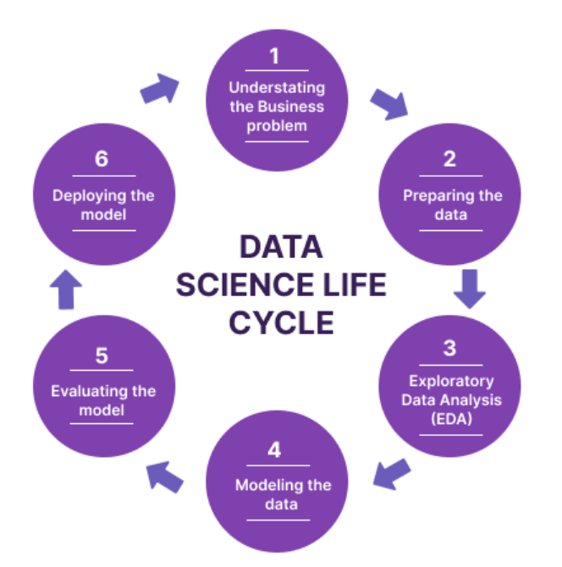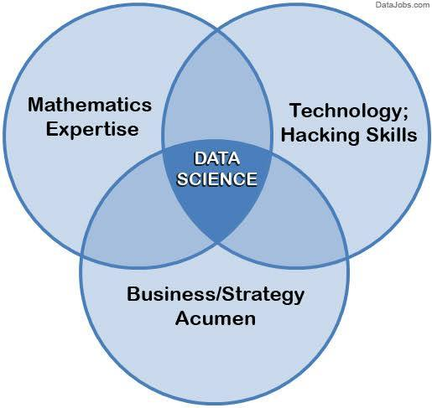
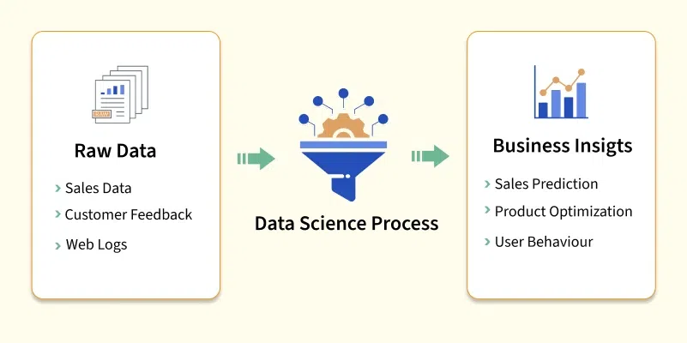
A scripting language is a programming language designed to automate the execution of tasks that would otherwise be executed one by one by a human operator. These languages are typically interpreted, meaning that they are executed line by line by an interpreter rather than being compiled into machine code beforehand. Here are some key features of scripting languages:
- Interpreted Execution: Scripting languages are typically interpreted rather than compiled.
- Ease of Use: Scripting languages have simpler syntax, making them easier to learn, especially for beginners.
- Dynamic Typing: Variables are typed at runtime, allowing more flexibility during execution.
- Integration: Scripting languages are used to automate tasks by connecting and controlling different programs or system components.
- High-Level Abstractions: They offer high-level features that simplify interaction with systems and applications.
WHAT IS ADVANCED SCRIPTING FOR DATA SCIENCE
This refers to the application of sophisticated programming techniques and languages to address complex data-related challenges. For example, the data-related challenges includes
- Data inherent characterstics such as data volume and quality of data
- Technical issues such as data integration and data security
- Human factors such as lack of skilled analysts and poor data governance
CHALLENGE 01 - DATA INHERENT CHARACTERSTICS
“DATA VOLUME” AND “DATA QUALITY”
DATA VOLUME
Data Volume refers to the sheer amount or quantity of data, measured in units like bytes or records, and is a critical component of Big Data. Data Quality, on the other hand, refers to how reliable, accurate, complete, consistent, and valid the data is for its intended purpose, determining its "fitness for use" in business operations, analytics, and decision-making.
Definition: The total amount of data generated, stored, and processed by an organization.
Measurement: Quantified using units such as kilobytes (KB), megabytes (MB), gigabytes (GB), terabytes (TB), and beyond.
Impact: Influences data management needs, requiring greater storage capacity, processing power, and more complex handling procedures.
Context: A key characteristic of Big Data, which is often defined by its large volume.
DATA QUALITY
Data quality is a measure of how well data meets specific requirements for accuracy, completeness, consistency, and other relevant characteristics. High-quality data is essential for making reliable decisions, performing accurate analyses, and achieving business objectives.
Definition: The degree to which a dataset is fit for its intended use, considering factors like accuracy, completeness, consistency, validity, timeliness, and reliability.
Key Dimensions: Includes criteria such as:
  - Accuracy: The data correctly reflects the real-world object it represents.
  - Completeness: All necessary data fields are present.
  - Consistency: Data doesn't contradict itself across different systems or instances.
  - Timeliness: The data is up-to-date and relevant for the given timeframe.
  - Validity: Data conforms to defined formats or rules.
Importance: High-quality data is essential for making informed business decisions, supporting analytics, powering data products, and training AI models.
Management: Often integrated into data governance programs to ensure data is consistently managed and used across an organization.
Data quality measures a data set's condition based on factors such as accuracy, completeness, consistency, timeliness, uniqueness and validity. Measuring data quality can help organizations identify errors and inconsistencies in their data and assess whether the data fits its intended purpose. Organizations have grown increasingly concerned about data quality as they've come to recognize the important role that data plays in business operations and advanced analytics, which drive business decisions. Data quality management is a core component of an organization's overall data governance strategy. Data governance ensures that the data is properly stored, managed, protected and used consistently throughout an organization.
WHY DATA QUALITY IS IMPORTANT?
Low-quality data can have significant business consequences for an organization. Bad data is often the culprit behind operational snafus, inaccurate analytics and ill-conceived business strategies. For example, it can potentially cause any of the following problems:
- Shipping products to the wrong customer addresses.
- Missing sales opportunities because of erroneous or incomplete customer records.
- Being fined for improper financial or regulatory compliance reporting.
According to the 2023 Monte Carlo report "The Annual State of Data Quality Survey," data quality issues in many organizations are on the rise, and their negative effects are growing. Average monthly data quality incidents per organization rose from 59 in 2022 to 67 in 2023; data quality-related issue resolution increased from less than four hours on average in 2022 to more than four hours; and the average percentage of impacted revenue rose from 26% in 2022 to 31%.
THE SIX ELEMENTS OF DATA QUALITY?
Low-quality data can lead to transaction processing problems in operational systems and faulty results in analytics applications. Such data needs to be identified, documented and fixed to make sure that business executives, data analysts and other business users are working with good information. High-quality data should possess the following six characteristics:
- Accuracy. The data correctly represents the entities or events it is supposed to represent, and the data comes from sources that are verifiable and trustworthy.
- Completeness. The data includes all the values and types of data it is expected to contain, including any metadata that should accompany the data sets.
- Consistency. The data is uniform across systems and data sets, and there are no conflicts between the same data values in different systems or data sets.
- Timeliness. The data is current (relative to its specific requirements) and is available to use when it's needed.
- Uniqueness. The data does not contain duplicate records within a single data set, and every record can be uniquely identified.
- Validity. The data conforms to defined business rules and parameters, which ensure it is properly structured and contains the values it should.
A data set that meets all of these measures is much more reliable and trustworthy than one that does not. However, these are not necessarily the only standards that organizations use to assess their data sets. For example, they might also consider qualities such as appropriateness, credibility, relevance, reliability or usability. The goal is to have trusted data that fits its intended purpose.
BENEFITS OF GOOD DATA QUALITY
Maintaining good data quality produces a broad range of positive results, including the following:
- It enables organizations to reduce the costs associated with identifying and fixing bad data when a data-related issue arises. Maintaining data quality also helps to avoid operational errors and business process breakdowns, which can increase operating expenses and reduce revenue.
- It increases the accuracy of analytics, including those that rely on AI technologies. This can lead to better business decisions, which in turn can lead to improved internal processes, competitive advantages and higher sales. Good-quality data also improves the information available through BI dashboards and other analytics. If business users consider the analytics to be trustworthy, they are more likely to rely on them instead of basing decisions on gut feelings or simple spreadsheets.
- It frees up data teams to focus on more productive tasks, rather than on troubleshooting issues and cleaning up the data when problems occur. For example, they can spend more time helping business users and data analysts take advantage of the available data while promoting data quality best practices in business operations.
DATA QUALITY vs. DATA INTEGRITY vs. DATA PROFILING
The terms data quality and data integrity are sometimes used interchangeably, although they have different meanings. At the same time, some people treat data integrity as a facet of data quality or data quality as a component of data integrity. Others consider both data quality and data integrity to be part of a larger data governance effort, while some consider data integrity to be a broader concept that combines data quality, data governance and data protection into a unified effort for addressing data accuracy, consistency and security. From a broader perspective, data integrity focuses on the data's logical and physical validity. Logical integrity includes data quality measures and database attributes such as referential integrity, which ensures that related data elements in different database tables are valid.
Physical integrity is concerned with access controls and other security measures designed to prevent data from being modified or corrupted by unauthorized users. It is also concerned with protections such as backups and disaster recovery. In contrast, data quality is focused more on the data's ability to serve its specified purpose.
Data profiling adds a wrinkle; while data quality ensures that data is usable, and data integrity ensures that it is trustworthy, data profiling specifies what is actually in the data. It includes examining, analyzing and summarizing data to understand its structure and content. It is useful to think of data quality as the end goal, data integrity as the guiding principle, and data profiling as the diagnostic process used to realize the other two.
HOW TO ASSESS DATA QUALITY? The following essential steps must be part of a data quality assessment:
- Define data quality requirements. What does high-quality mean to the organization? What dimensions matter most and how will they be measured?
- Inventory the data assets. Conduct baseline studies to measure the relative accuracy, uniqueness and validity and each data set. The established baselines can then be compared against the data on an ongoing basis to help ensure that existing concerns are being addressed and to identify new data quality issues.
- List and prioritize data sources. Map all databases, application programming interfaces and other sources that fall within the scope of the quality assessment.
- Profile the data. Analyze the structure and content of all data, with attention to completeness, value distributions, format consistency and outliers.
- Score and report on data quality. Measure against selected dimensions, assign scores and rank identified issues that surface.
- Investigate root causes of issues. Once issues have been identified, trace them back to workflows and entry points to determine root causes for remediation.
- Implement continuous monitoring. After problem areas are identified, keep an eye on them.
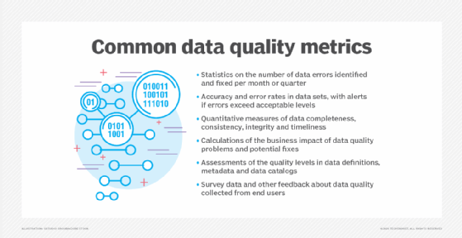
These metrics can be used to track data quality levels and how quality issues affect business operations.
Various methodologies have been developed for assessing data quality. For example, data managers at UnitedHealth Group's Optum healthcare services subsidiary created the Data Quality Assessment Framework (DQAF) in 2009 to formalize a method for assessing its data quality. The DQAF provides guidelines for measuring data quality based on four dimensions: completeness, timeliness, validity and consistency. Optum publicized details about the framework as a possible model for other organizations.
The International Monetary Fund (IMF), which oversees the global monetary system and lends money to economically troubled nations, has also specified an assessment methodology with the same name as the Optum one. Its framework focuses on accuracy, reliability, consistency and other data quality attributes in the statistical data that member countries must submit to the IMF. In addition, the U.S. government's Office of the National Coordinator for Health Information Technology has detailed a data quality framework for patient demographic data collected by healthcare organizations.
HOW TO IMPROVE DATA QUALITY Assessment is important. But continuous data improvement should become a priority. The following are the essential steps in improving data quality:
- Establish clear goals. A central question in assessing data quality is: What does high-quality data look like to the organization? The answers to that question should be used to align business objectives with the data quality requirements that will be put in place for ongoing data improvement. The prioritized dimensions -- accuracy, completeness, timeliness and validity -- will be central.
- Prioritize the issues. Once data quality issues in the organization have been surfaced, it is important to rank them according to their effect on the organization's processes and efficiency, to effectively remediate the most important problems. This could change over time and should thus be periodically revisited.
- Establish remediation standards. For the sake of consistency and efficiency, ensure that remediations are known, understood and adhered to across the enterprise.
- Implement data governance. Establishing data roles -- owners, stewards and custodians -- is a good idea. Data policies and standards should be formally published and maintained, and metadata, data definitions and transformation logic should be documented.
In many organizations, analysts, engineers and data quality managers are primarily responsible for fixing data errors and addressing other data quality issues. They are collectively tasked with finding and cleansing bad data in databases and other data repositories, often with assistance and support from other data management professionals, including data stewards and data governance program managers.
A data quality initiative might also involve business users, data scientists and other analysts to help reduce the number of data quality issues. Participation might be facilitated, at least in part, through the organization's data governance program. In addition, many companies provide training to end users on data quality best practices. A common mantra among data managers is that everyone in an organization is responsible for data quality. To address data quality issues, a data management team often creates a set of data quality rules based on business requirements for both operational and analytics data. The rules define the required data quality levels and how data should be cleansed and standardized to safeguard accuracy, consistency and other data quality attributes.
After the rules are in place, a data management team typically conducts a data quality assessment, documenting errors and other problems -- a procedure that should be repeated at regular intervals to ensure the highest data quality possible. However, not all data management teams approach data quality in the same way. For example, data management consultant David Loshin outlined a data quality management cycle that begins with identifying and measuring the effect that bad data has on business operations. The team then defines data quality rules and sets performance targets for improving data quality metrics.
Next, the team designs and implements specific data quality improvement processes. These include data cleansing or data scrubbing, fixing data errors, and enhancing data sets by adding missing values or providing more up-to-date information or additional records. The results are then monitored and measured against the performance targets. Any remaining deficiencies in data quality serve as a starting point for the next round of planned improvements. Such a cycle is intended to ensure that efforts to improve overall data quality continue after individual projects are completed.
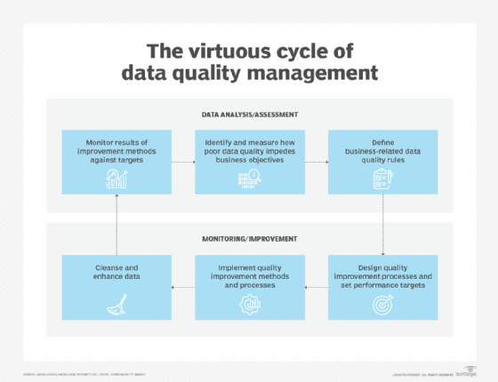

These are the key steps in the data quality improvement process.
DATA QUALITY MANAGEMENT TOOLS AND TECHNIQUES Organizations often turn to data quality management tools to help streamline their efforts. These tools can match records, delete duplicates, validate new data, establish remediation policies and identify personal data in data sets. Some products can also perform data profiling, which examines, analyzes and summarizes data sets. Many of these tools now include augmented data quality functions that automate tasks and procedures, often through the use of machine learning and other AI technologies. Most tools also include centralized consoles or portals for performing management tasks. For example, users might be able to create data handling rules, identify data relationships or automate data transformations through the central interface.
Data quality managers and data stewards might also use collaboration and workflow tools that provide shared views of the organization's data repositories and enable them to oversee specific data sets. These and other data management tools might be selected as part of an organization's larger data governance strategy. The tools can also play a role in the organization's master data management initiatives, which establish registries of data on customers, products, supply chains and other data domains.
The following are examples of data quality platforms:
- Acceldata.
- Ataccama.
- Bigeye.
- Great Expectations GX Cloud.
- Informatica Data Quality.
- Monte Carlo Data + AI Observability Platform.
- Qlik.
- SAP Data Services.
- SAS Data Quality.
- Soda Core.
Some current data quality management techniques include AI-augmented quality management, in which platforms automatically create and enforce quality rules, and stream-first quality monitoring, which supports real-time validation and anomaly detection for unbounded data streams. Note that some of these platforms are open source.
EMERGING DATA QUALITY CHALLENGES For many years, data quality efforts centered on structured data stored in relational databases, which were the dominant technology for managing data. However, data quality concerns expanded as cloud computing and big data initiatives became more widespread. In addition to structured data, data managers must now also consider unstructured data and semi-structured data, such as text files, internet clickstream records, sensor data and network, system and application logs.
The following factors play a role in data quality, adding to the complexity of managing data:
- Many of today's organizations work with both on-premises and cloud systems.
- Data source proliferation is rampant, as organizations integrate more external data into their processes.
- Modern data stacks are increasingly complex.
- A growing number of organizations are incorporating machine learning and other AI technologies into their operations and products; the quality requirements for data used in these operations are generally very high.
- Many organizations have implemented real-time data streaming platforms that continuously funnel large volumes of data into corporate systems.
- Many organizations lack unified governance.
- Data scientists are implementing complex data pipelines to support their research and advanced analytics.

Data quality concerns are also growing due to the implementation of data privacy and protection laws, such as the European Union's General Data Protection Regulation and the California Consumer Privacy Act. Both measures give people the right to access the personal data that companies collect about them. This means organizations must be able to find all the records on an individual in their systems without missing any because of inaccurate or inconsistent data.
SIX STANDARDS & DIMENSIONS TO DETERMINE THE DATA QUALITY
The Data Quality Assessment Framework (DQAF) is a set of data quality dimensions, organized into six major categories: completeness, timeliness, validity, integrity, uniqueness, and consistency.
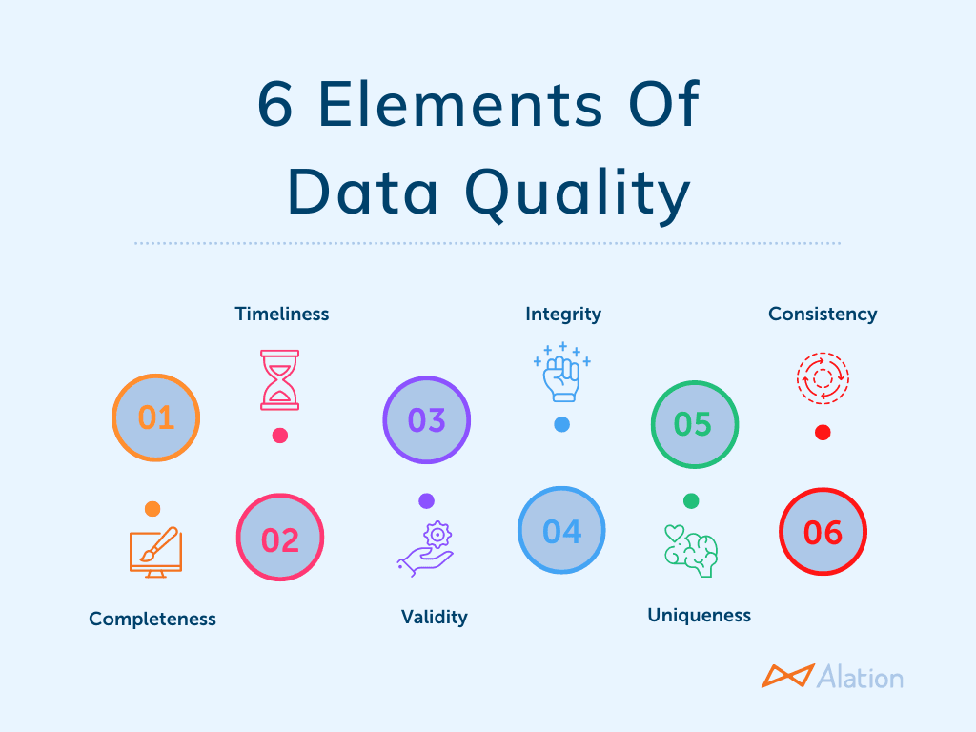
These dimensions are useful when evaluating the quality of a particular dataset at any point in time. Most data managers assign a score of 0-100 for each dimension, an average DQAF.
1. Completeness: Completeness is defined as a measure of the percentage of data that is missing within a dataset. For products or services, the completeness of data is crucial in helping potential customers compare, contrast, and choose between different sales items. For instance, if a product description does not include an estimated delivery date (when all the other product descriptions do), then that “data” is incomplete.
2. Timeliness: Timeliness measures how up-to-date or antiquated the data is at any given moment. For example, if you have information on your customers from 2008, and it is now 2021, then there would be an issue with the timeliness as well as the completeness of the data. When determining data quality, the timeliness dimension can have a tremendous effect — either positive or negative — on its overall accuracy, viability, and reliability.
3. Validity: Validity refers to information that fails to follow specific company formats, rules, or processes. For example, many systems may ask for a customer’s birthdate. However, if the customer does not enter their birthdate using the proper format, the level of data quality becomes automatically compromised. Therefore, many organizations today design their systems to reject birthdate information unless it is input using the pre-assigned format.
4. Integrity: Integrity of data refers to the level at which the information is reliable and trustworthy. Is the data true and factual? For example, if your database has an email address assigned to a specific customer, and it turns out that the customer actually deleted that account years ago, then there would be an issue with data integrity as well as timeliness.
5. Uniqueness: Uniqueness is a data quality characteristic most often associated with customer profiles. A single record can be all that separates your company from winning an e-commerce sale and beating the competition. Greater accuracy in compiling unique customer information, including each customer’s associated performance analytics related to individual company products and marketing campaigns, is often the cornerstone of long-term profitability and success.
6. Consistency: Consistency of data is most often associated with analytics. It ensures that the source of the information collection is capturing the correct data based on the unique objectives of the department or company.
For example, let’s say you have two similar pieces of information:
- the date on file for the opening of a customer’s account vs.
- the last time they logged into their account.
The difference in these dates may provide valuable insights into the success rates of current or future marketing campaigns. Determining the overall quality of company data is a never-ending process. The most crucial components of effective data quality management are the identification and resolution of potential issues quickly and proactively.

SECOND CHALLENGE - TECHNICAL ISSUES:
DATA INTEGRATION AND DATA SECURITY
Data integration is the process of combining data from different sources into a single, unified view, while data security is the protection of that data from unauthorized access, corruption, or loss. These two concepts are intertwined, as data integration introduces new challenges to security, requiring measures like encryption, access controls, and regular security audits to ensure data remains confidential, accurate, and available throughout its lifecycle and across different systems.
THREE DIMENSIONS OF “DATA INTEGRATION”
Consolidating disparate data: It involves collecting data from various sources (like applications, databases, and cloud platforms) that may have different formats and structures.
Creating a unified view: The goal is to provide a single, comprehensive view of the data, which is essential for gaining deeper business insights and making informed decisions.
Enabling data flow: It allows different systems and applications to communicate, share data, and function together more effectively.
FOUR DIMENSIONS OF ”DATA SECURITY”
- Protecting data from unauthorized access: This includes preventing hackers from getting to sensitive information like customer details or financial records.
- Maintaining data integrity: Ensuring that data remains accurate, complete, and unaltered during and after the integration process.
- Ensuring data availability: Making sure that data is accessible to authorized users whenever they need it, through mechanisms like regular backups.
- Adhering to regulations: Complying with industry-specific laws and regulations regarding data privacy and handling, especially in sensitive sectors like finance and healthcare.
THE RELATION-SHIP AMONG THESE
- Increased risk: Integrating data creates multiple points of connection and data movement, expanding the "attack surface" for potential security breaches.
- Integrated security measures: Security must be a fundamental part of the integration strategy, with measures like data masking, encryption for data in transit and at rest, and robust audit trails implemented at every stage.
- Compliance is key: Integrating data, especially sensitive data, requires strong security protocols and governance to meet compliance requirements and avoid regulatory penalties.
THIRD CHALLENGE - HUMAN FACTORS:
SKILLED DATA ANLAYSTS AND POOR DATA GOVERNANCE
While skilled analysts are valuable, they cannot fully compensate for poor data governance, and attempting to do so is costly and inefficient. A strong data governance framework is essential for ensuring high-quality, trustworthy data, which is the foundation of effective analytics. Without it, even the most talented analysts will struggle with inaccurate information and operational hurdles, leading to flawed insights and compromised decisions.
HOW SKILLED ANALYSTS ADAPT TO POOR DATA GOVERNANCE
In the absence of a proper data governance framework, skilled analysts must spend a disproportionate amount of time on low-value, repetitive data preparation tasks instead of high-value analysis.
- Manual data cleansing: Analysts manually identify and correct inconsistencies, inaccuracies, and duplicate records across different data sources.
- Data discovery and validation: They must expend significant effort to locate data, determine its reliability, and manually validate its accuracy before use.
- Creating workarounds: Analysts often develop temporary, department-specific solutions to bypass data quality problems, leading to further data fragmentation and long-term technical debt.
- Dispute resolution: When reporting conflicts arise from different teams using disparate metrics, analysts are pulled into time-consuming meetings to determine which data to use.
THE INEVITABLE CONSEQUENCES OF POOR DATA GOVERNANCE
Despite the best efforts of skilled analysts, poor data governance will ultimately compromise business outcomes.
- Flawed business decisions: Inaccurate, incomplete, or inconsistent data can lead to poor strategies, wasted resources, and missed opportunities. Even a perfectly executed analysis on bad data will yield bad results.
- Eroding trust in data: Inconsistent reporting and conflicting insights cause business leaders to lose confidence in data-driven recommendations, creating a "data distrust" problem.
- Reduced productivity: When analysts must divert time from analysis to data-wrangling, it slows down decision-making and leads to operational inefficiencies. One estimate found that poor data quality costs companies an average of $15 million per year.
- Compliance and security risks: A lack of clear data ownership and security protocols can lead to non-compliance with regulations like GDPR or HIPAA, exposing the organization to legal penalties and security breaches.
- Stifled innovation: Fragmented data and delayed insights prevent the company from being agile and responding quickly to market changes. It also undermines AI and machine-learning projects that require clean, consistent data to function properly.
THE SOLUTION: PRIORITIZE DATA GOVERNANCE
To move beyond relying on overworked analysts to solve systemic data issues, organizations must build a strong data governance framework.
- Define ownership: Clearly assign roles like "data stewards" who are responsible for the quality, integrity, and management of specific datasets.
- Standardize data practices: Implement clear policies for how data is collected, stored, and used, ensuring consistent formats and definitions across the organization.
- Invest in automated tools: Deploy tools for data validation, cleansing, and monitoring to enforce policies and catch issues in real-time.
- Break down data silos: Use data catalogs and other technologies to integrate fragmented data landscapes, making information more accessible and understandable.
- Foster a data-driven culture: Provide training for all employees on the importance of data quality and their role in maintaining it. Secure leadership buy-in to ensure resources are properly allocated.
A.The following are few DATA QUALITY & INTEGRITY Challenges
- Inaccuracy and Incompleteness: Data may contain errors, missing values, or outdated information, leading to flawed analysis and decisions.
- Inconsistency: Data formats, units, or standards may vary across different sources, making it difficult to combine and analyze.
- Duplication: Redundant data entries can inflate storage costs and create confusion.
B.The following are few DATA MANAGEMENT & GOVERNANCE challenges
- Data Silos: Information is often fragmented across various systems and departments, hindering consolidation and access.
- Data Security and Privacy: Protecting sensitive data from breaches and complying with regulations is a significant concern.
- Data Governance: Establishing clear policies, roles, and procedures for data ownership, access, and usage can be complex and time-consuming.
C.The following are few TECHNICAL & OPERATIONAL challenges
- Data Volume & Velocity: Remember, managing the immense and rapidly growing amount of data generated today is a considerable technical and storage challenge.
- Data Integration: Combining diverse data types from multiple sources into a usable format can be difficult.
- Finding Skilled Personnel: A lack of experienced data professionals can hinder effective data management and analysis.
D.The following are few ANALYTICAL & STRATEGIC challenges
- Data Interpretation: Transforming raw data into actionable insights that non-technical stakeholders can understand requires strong communication and storytelling skills.
- Data Driven Cluture: Fostering an organizational culture where data is valued and used effectively for decision-making is a significant challenge.
- Keeping Pace with Technology: The rapid evolution of tools and techniques in data science requires continuous learning and adaptation.
Therefore ADVANCED SCRIPTING, goes beyond basic data manipulation and analysis, enabling data scientists to:
FIRST, Automate repetitive tasks: This includes data cleaning, data transformation, report generation, and model training, significantly increasing efficiency and reducing manual effort.
SECOND, Handle large and complex datasets: Advanced scripting allows for efficient processing of big data, often involving techniques like parallel processing and distributed computing.
THIRD, Develop custom solutions: When off-the-shelf tools are insufficient, scripting enables the creation of tailored algorithms, models, and analytical pipelines to meet specific business requirements.
FOURTH, Integrate diverse tools and systems: Scripting acts as a "glue" to connect various data sources, analytical platforms, and visualization tools, creating a seamless data ecosystem.
FIFTH, Implement advanced analytical techniques: This includes machine learning algorithms, deep learning models, natural language processing, and advanced statistical analysis that require programmatic control and customization.
SIXTH, Enhance data visualization and reporting: Scripting allows for the creation of dynamic, interactive, and highly customized data visualizations and reports that go beyond standard charting capabilities.
KEY LANGUAGE TOOLS commonly used in advanced scripting for data science include:
- Python: Widely used due to its extensive libraries (e.g., NumPy, Pandas, Scikit-learn, TensorFlow, PyTorch) and its versatility in data manipulation, machine learning, and automation.
- R: A powerful language specifically designed for statistical computing and graphics, with a rich ecosystem of packages for various analytical tasks.
- Shell scripting: Used for automating system-level tasks, managing files and processes, and orchestrating data pipelines.
- SQL: Essential for querying and manipulating data stored in relational databases.
Thus, advanced scripting empowers data scientists to move beyond the limitations of graphical user interfaces and pre-built functionalities, providing the flexibility and control needed to tackle the most challenging data science problems.
POPULAR SCRIPTING LANGUAGES
Several scripting languages are widely used in different domains of software development, automation, and web development. Some of the most popular scripting languages include:
- Python: Python is one of the most popular and versatile scripting languages. Known for its simple syntax and readability, Python is used for web development, data analysis, machine learning, automation, and more.
- JavaScript: JavaScript is the most widely used scripting language for web development. It is primarily used for client-side scripting to create interactive web pages but can also be used on the server-side with Node.js.
- Bash: Bash is a command-line shell and scripting language commonly used in UNIX-like operating systems such as Linux and macOS for system administration tasks.
- PHP: PHP is a server-side scripting language widely used for web development. It powers popular content management systems like WordPress and is embedded within HTML for dynamic content generation.
- Ruby: Ruby is a dynamic, object-oriented scripting language known for its elegant syntax and developer-friendly environment. It is commonly used with the Ruby on Rails framework for web development.
- Perl: Perl is an interpreted scripting language known for its text-processing capabilities. It is often used in system administration, network programming, and web development.
- PowerShell: PowerShell is a task automation and configuration management framework from Microsoft, which is used for system administration tasks, particularly on Windows systems.
FEW ADVANTAGES OF SCRIPTING LANGUAGES
Easy learning: The user can learn to code in scripting languages quickly, not much knowledge of web technology is required.
Fast editing: It is highly efficient with the limited number of data structures and variables to use.
Interactivity: It helps in adding visualization interfaces and combinations in web pages. Modern web pages demand the use of scripting languages. To create enhanced web pages, fascinated visual description which includes background and foreground colors and so on.
Functionality: There are different libraries which are part of different scripting languages. They help in creating new applications in web browsers and are different from normal programming languages.
FEW APPLICATIONS OF SCRIPTING LANGUAGES
Scripting languages are used in many areas:
- Web Development: Scripting languages like JavaScript, PHP, and Python are used for both client-side and server-side development, enabling dynamic content and interactivity.
- Automation: Scripting languages automate repetitive tasks like file management, system administration, and batch processing, saving time and reducing human error.
- System Administration: Bash and PowerShell are commonly used for managing servers, handling tasks like user management and system monitoring.
- Data Processing: Scripting languages like Python and Perl are used to manipulate, clean, and process data for tasks like ETL (Extract, Transform, Load).
- Testing: Scripting languages are often used for writing automated tests to ensure software functionality and efficiency.
DIFFERENCE BETWEEN SCRIPTING LANGUAGES Vs PROGRAMMING LANGUAGES
Below are the difference between scripting languages and programming languages:
Scripting Languages | Programming Languages
Interpreted (line-by-line execution) | Compiled (transformed to machine code)
Easier syntax, simpler tasks | More complex and powerful syntax
Automation, web scripting, task automation | Full-fledged application development
Slower execution due to interpretation | Faster execution due to compilation
Highly flexible for rapid development | Can be more rigid but optimized for larger systems

LIMITATIONS OF SCRIPTING LANGUAGES: While scripting languages are incredibly useful in many contexts, they also have some limitations:
- Performance: Scripting languages tend to be slower than compiled languages because they are interpreted line by line.
- Limited Complexity: While they are great for smaller tasks and scripting, scripting languages may not be suitable for large-scale, performance-intensive applications.
- Dependency on Interpreters: Scripting languages rely on interpreters to run the code, meaning that users must have the necessary interpreter installed to run the script.
Thus, scripting languages play a crucial role in modern software development, enabling automation, enhancing productivity, and simplifying the interaction between different systems. While they NOT BE SUITABLE for large-scale applications.

FALL 2025 CSC 523 COURSE PART A: SURVEY OF APPROACHES FOR RETRIEVING DATA IN SCRIPTING LANGUAGE ENVIRONMENT
- Regular expressions for extracting data from flat text
- Parsing libraries for extracting data from semi-structured text
- Reading data streams from sensors
- Reading comma-separated value and similarly formatted files
- Reading data streams from network sources
- Script input-output with relational and NoSQL databases

Data in general found in three forms viz., Unstrctured, Strctured and Semi-Structured
REGULAR EXPRESSION FOR EXTRACTING DATA

Before we go into regular expressions, let us first investigate the different types of data. “Structured”, “Unstructured” and “Semi-structured”, are terms used to classify data based on its format and schema rules or lack thereof. Structured data has a fixed schema and fits neatly into rows and columns, such as names and phone numbers. Unstructured data has no fixed schema and can have a more complex format, such as audio files and web pages. Structured data is highly organized, fitting into predefined fields, rows, and columns, like information in a spreadsheet or relational database, making it easy to search and analyze. In contrast, unstructured data lacks a fixed format or organization, such as emails, images, and videos, and requires advanced tools like natural language processing (NLP) and machine learning (ML) to extract value.

We also use the definitions of “DATA MODEL” or “SCHEMA” as following

A data model is a conceptual representation that defines how data is organized and related within a system. It provides a high-level view of the entities, their attributes, and the relationships between them, without necessarily specifying the exact technical implementation. Data models can be conceptual (showing high-level relationships), logical (defining structures like tables and columns), or physical (detailing the actual storage in a database).

A schema refers to the concrete, structured definition of how data is organized and stored within a specific database or data system. It is the blueprint that outlines the tables, fields (columns), data types, constraints (e.g., primary keys, foreign keys), and relationships between different data elements. In essence, a schema is the physical implementation of a data model within a particular database management system (DBMS).

The abstract design or blueprint of how data is structured and related, focusing on the meaning and organization of information. In summary, technical definition of how data is implemented and stored within a specific database, including details like tables, columns, data types, and constraints.

Think of it this way: a “data model” is like the architectural plans for a house, while the “schema” is the detailed construction blueprint that specifies every beam, pipe, and electrical wire.

THREE TYPE OF “DATA” AND THE IMPACT OF “SCRIPTING” ON THEM
FIRST - STRUCTURED DATA:
Data with a predefined data model or schema, organized in a way that makes it easily readable by both humans and machines.
- Format: Structured data has a strict, predefined data model. Unstructured data does not have a predefined format. Stored in tables with rows and columns, such as in relational databases or spreadsheets.
- Storage: Structured data storage systems have rigid schemas, such as those in relational databases or data warehouses. Unstructured data is often stored in its native format in nonrelational databases or data lakes.
- Use cases: Organizations can use both structured and unstructured data across artificial intelligence (AI) and analytics use cases. Structured data is often used in machine learning (ML) and drives ML algorithms. Unstructured data is often used in natural language processing (NLP) and is a rich and diverse data source for generative AI (gen AI) models.
- Complexity: Structured data is easier to manipulate and analyze for general business users with traditional tools. Unstructured data can be more complex and requires specialized skills and tools to parse and analyze.
- Characteristics: Quantitative information with defined data types (like numbers, dates, or short text) and clear relationships between data elements.
Examples: Online transaction processing (OLTP) systems, point-of-sale (POS) systems, IoT sensor readings in tabular format, and customer records in a database.
Analysis: Easily analyzed using traditional methods, such as SQL queries and statistical techniques.
Structured data is organized in a clear, predefined format. The standardized nature of structured data makes it easily decipherable by data analytics tools, machine learning algorithms and human users. Structured data can include both quantitative data (such as prices or revenue figures) and qualitative data (such as dates, names, addresses and credit card numbers). For example, a financial report with company names, expense values and reporting periods organized into rows and columns is considered structured data.
Structured data is typically stored in tabular formats, such as Excel spreadsheets and relational databases (or SQL databases). Users can efficiently input, search and manipulate structured data within a relational database management system (RDBMS) by using structured query language (SQL). Developed by IBM® in 1974, structured query language is the programming language used to manage structured data. Use cases for structured data include:
- AI model training
- Customer relationship management (CRM)
- Business intelligence (BI)
- Inventory management
- Search engine optimization (SEO) rich snippets
PROS and CONS of STRUCTURED DATA: The benefits of structured data are tied to its ease of use and access:
1.Works well with machine learning: Machine learning can process both structured and unstructured data. However, it can be easier for ML applications to analyze and draw insights from structured data due to its specific and organized architecture.
2.Accessible and easy to use: Understanding structured data does not require in-depth data science knowledge. Due to its standard format and high level of organization, most users find it easy to access and interpret structured data.
3.Abundance of tools: Structured data predates unstructured data, so there are more apps and tools available for use and data analysis. For example, online analytical processing (OLAP), SQLite, MySQL and PostgreSQL, among others.
The CHALLENGES OF STRUCTURED DATA revolve around data inflexibility: (1) Limited usage: Structured data has a predefined data model that can only be used for its intended purpose, which limits its flexibility and usability. Mining more insights requires modifications or additional data. (2) Limited storage options: Structured data storage repositories typically have rigid schemas, such as those within a relational database or data warehouse. Changes to data requirements need updating all structured data, which is time and resource-intensive.

SECOND - UNSTRCTURED DATA:
Unstructured data does not have a predefined format. Unstructured datasets are typically large (think terabytes or petabytes of data) and comprise 90% of all enterprise-generated data. This high volume is due to the emergence of big data—the massive, complex datasets from the internet and other connected technologies. Unstructured data can contain both textual and nontextual data and both qualitative (social media comments) and quantitative (figures embedded in text) data. Examples of unstructured data from textual data sources include:
- Emails
- Text documents
- Social media posts
- Call transcripts
- Message text files, such as those from Microsoft Teams or Slack
Examples of nontextual unstructured data include:
- Image files (JPEG, GIF and PNG)
- Multimedia files
- Video files
- Mobile activity
- Sensor data from Internet of Things (IoT) devices
How is unstructured data used? Because unstructured data does not have a predefined data model, it is not easily processed and analyzed through conventional data tools and methods. It is best managed in nonrelational or NoSQL databases or in data lakes, which are designed to handle massive amounts of raw data in any format. Frequently, machine learning, “advanced analytics” and “natural language processing (NLP)” are used to extract valuable insights from unstructured data.
Remember, a NON-RELATIONAL DATABASE (also kown as NoSQL), is a storage system that doesn't use the traditional tabular schema of rows and columns found in relational databases. Instead, it employs various flexible data models like key-value pairs, documents, wide-column stores, or graphs. These databases are designed for handling large volumes of varied, often unstructured or semi-structured, data and are optimized for horizontal scalability and rapid development, making them suitable for applications like social networks and content management systems.
NoSQL Database Key Characteristics
- Flexible Data Models: Unlike relational databases that have rigid, predefined schemas, non-relational databases offer flexibility, allowing for diverse data types and evolving data requirements.
- Horizontal Scalability: Non-relational databases scale out by adding more servers (nodes) rather than upgrading a single server's resources (vertical scaling), making them ideal for handling massive datasets and high traffic.
- Schema-less Design: They do not require a strict schema upfront, allowing for greater agility in application development and easier management of data with changing structures.
- Specialized Functionality: Each type of non-relational database is optimized for specific data storage and querying needs, such as key-value stores for caching or graph databases for analyzing relationships.
TYPES OF Non-Relational Databases
- Key-Value Databases: Store data as simple key-value pairs, often used for caching and user session information.
- Document Databases: Store data in semi-structured documents, typically in formats like JSON, making them well-suited for managing content and semi-structured data.
- Graph Databases: Organize data into nodes and edges, focusing on relationships between data points and ideal for networks and fraud detection.
- Wide-Column Databases: Store data in tables, rows, and columns but allow for dynamic and varying columns across rows, suitable for high-volume, distributed data.
WHEN TO USE NoSQL DATABASES? Non-relational databases are an excellent choice for:
- Managing diverse data types, including text, images, and videos.
- Applications requiring high availability, rapid development, and scalability.
- Big data and IoT (Internet of Things) applications.
- Social media platforms, e-commerce sites, and content management systems.
Remember, a DATA LAKE is a centralized repository that stores vast amounts of raw data in its native format, including structured, semi-structured, and unstructured data, from various sources like IoT devices and social media. Unlike a data warehouse, which requires data to be cleaned and structured beforehand, a data lake accepts data as-is, providing flexibility for users to perform analytics, machine learning, and big data processing on the raw information when needed.
THE MAIN CHARACTERSTICS OF DATA LAKE
- Stores raw data: Data is collected and stored in its original, unadulterated form, preserving its complete structure.
- Supports all data types: Data lakes can hold structured (e.g., database tables), semi-structured (e.g., JSON, log files), and unstructured (e.g., images, videos, audio, social media) data.
- Centralized repository: All organizational data, from various sources, is collected in one central location.
- Schema-on-read: The data structure or schema is applied when the data is accessed for analysis, rather than at the time of storage.
- Scalable and cost-effective: Data lakes are designed to handle large volumes of data and are often built on scalable cloud storage solutions, which can be cost-effective for long-term storage.
USE OF DATA LAKE
- Advanced Analytics: Data scientists and analysts can access and analyze the raw data to build machine learning models and uncover new insights that might be lost in processed data.
- Flexibility: Organizations can use a single data lake for multiple purposes, including big data applications, real-time analytics, and business intelligence.
- Cost Savings: By storing data in its raw format and using cost-effective cloud storage, organizations can often reduce data management costs compared to traditional data warehouses.
- Faster Data Ingestion: Data can be rapidly ingested into the data lake without the time-consuming process of cleaning, transforming, or structuring it first.
SPECIAL NOTE ON USE CASES: A use case is a methodology used in system analysis to identify, clarify and organize system requirements. The use case is made up of a set of possible sequences of interactions between systems and users in a particular environment and related to a particular goal. The method creates a document that describes all the steps taken by a user to complete an activity. Business analysts are typically responsible for writing use cases and they are employed during several stages of software development (SDLC), such as planning system requirements, validating design, testing software and creating an outline for online help and user manuals. A use case document can help the development team identify and understand where errors may occur during a transaction so they can resolve them.
In general, “Use cases” include:
FIRST, Retrieval augmented generation (RAG): Retrieval-Augmented Generation (RAG) is an AI framework that enhances Large Language Models (LLMs) by giving them the ability to access and incorporate external, authoritative information before generating a response. It works by first retrieving relevant data from sources like databases or documents and then augmenting the LLM's prompt with this information, leading to more accurate, timely, and contextually relevant answers compared to LLMs that only use their internal training data. How RAG Works
1. Retrieval: When a user asks a question, the RAG system uses search algorithms to query external knowledge bases, internal documents, or the web to find the most relevant information.
2. Augmentation: The retrieved information is then combined with the user's original query to form an enhanced prompt.
3. Generation: This richer prompt is sent to the LLM, which uses the provided factual information to generate a more informed, accurate, and specific response.
Key Benefits of RAG:
Reduced Hallucinations: By grounding responses in factual data, RAG significantly decreases the likelihood of the LLM generating incorrect or fabricated information.
Increased Accuracy & Relevance: RAG provides LLMs with up-to-date and specific data, leading to more accurate and relevant answers than LLMs solely relying on their static training data.
Contextualization: RAG allows for more personalized responses by tailoring information to specific user needs or an organization's private data.
Access to Current Information: RAG enables LLMs to access the latest data from external sources, overcoming the knowledge cut-off limitations of LLM training datasets.
Cost-Effectiveness: RAG offers an efficient way to provide LLMs with new knowledge without the high cost of retraining the model.
Common Use Cases
FIRST, Enhanced Chatbots: Building advanced customer support or sales assistants that can provide personalized and accurate answers to queries.
SECOND, Content Generation: Creating high-quality articles, blog posts, and product catalogs by retrieving and synthesizing information from reliable sources.
THIRD, Market Research: Gaining timely insights into market trends and competitor activities by analyzing vast amounts of external data.
FOURTH, Generative AI (gen AI): This is a type of artificial intelligence (AI) that creates new, original content—such as text, images, music, video, and code—in response to a user's prompt. It functions by learning from vast datasets of existing information to identify patterns and then producing novel output that mimics the characteristics of that training data, effectively simulating human creativity. Popular examples include ChatGPT, DALL-E, and Midjourney.
How Generative AI Works
1. Training on Large Datasets: Generative AI models are trained on massive amounts of data, which can include text, images, or other forms of media.
2. Learning Patterns and Structures: Through advanced machine learning techniques, especially deep learning and neural networks, these models learn the underlying patterns, structures, and rules within the training data.
3. Generating New Content: When a user provides a prompt or request, the model uses its learned statistical model to predict a relevant response and generate new content that is similar to, but not a copy of, the training data.
KEY CHARACTERSTICS
Content Creation: Its primary function is to generate entirely new and original content.
Creativity: It can mimic human creativity by producing unique and contextually relevant outputs.
Versatility: It can produce various types of content, including text, images, audio, video, and even software code.
Prompt-Driven: The generation of content is typically initiated by user prompts or requests.
Examples of Generative AI Applications
- Text: Chatbots like ChatGPT, which can generate human-like text and engage in conversations.
- Images: Tools like DALL-E and Midjourney that create images from text descriptions.
- Code: AI systems that can write software code based on specific requirements.
- Music: AI that can compose new musical pieces.
- Customer behavior and sentiment analysis
- Predictive data analytics
- Chatbot text analysis
What are the PROS and CONS of UNSTRUCTURED DATA? The benefits of unstructured data involve advantages in data format, speed and storage:
- Flexibility: Unstructured data is stored in its native format and remains undefined until needed. This file format flexibility widens the pool of available data and enables data scientists to use data for multiple use cases.
- Fast accumulation rates: For most organizations, this type of data is growing at 3x the rate of structured data. Since there is no need to predefine unstructured data, it can be collected quickly and easily, which is helpful for generative AI and large language model (LLM) fine-tuning.
- Easy and cheap to store: Unstructured data has more storage options than structured data. For instance, file systems or data lakes allow for massive storage and pay-as-you-use pricing, which cuts costs and eases scalability. The challenges of unstructured data center on expertise and available resources:
- Requires expertise: Due to its undefined or nonformatted nature, data science expertise is required to prepare and analyze unstructured data. This can alienate business users who might not fully understand specialized data topics or analysis.
- Specialized tools: Traditional tools such as Excel are not adequate for manipulating unstructured data, and product choices are limited for data managers. Some tools for unstructured data management include: MongoDB, DynamoDB, Hadoop and Azure.

DATA CLEANLINESS: The large volume and nonuniform data structure of unstructured data can introduce inconsistencies, inaccuracies and data quality issues. Data cleaning might be necessary before data processing. There is always a strong relation between AI and unstructured data. This is so, because in general, AI can quickly process large volumes of data. This is a key capability for organizations that want to transform massive amounts of unstructured data into actionable insights. With machine learning and natural language processing (NLP), AI algorithms can shift through unstructured data to find patterns and make real-time predictions or recommendations. Organizations can then incorporate these analytical models into existing dashboards or application programming interfaces (APIs) to automate decision-making processes.

THIRD - SEMI-STRUCTURED DATA:

Semi-structured data is the “bridge” between structured and unstructured data. It is useful for web scraping and data integration. Semi-structured data does not have a predefined data model. However, it uses metadata (for example, tags and semantic markers) to identify specific data characteristics and scale data into records and preset fields. Metadata ultimately enables semi-structured data to be better cataloged, searched and analyzed than unstructured data.

Examples of semi-structured data include JavaScript Object Notation (JSON), comma-separated values (CSV) and eXtensible Markup Language (XML) files. A more commonly cited example is email where some data sections have a standardized format (such as headers and subject lines) but unstructured data content within those sections.
Definition: Data that does not have a predefined format or organizational pattern.
Format: In various file formats including text, images, audio, and video.
Characteristics: Generally qualitative and stored in its raw form.
Examples: Emails, social media posts, articles, images, videos, audio files, and other document files.
Analysis: Requires advanced technologies like NLP, text mining, AI, and machine learning to find meaning and insights.

Once we have understood three types of “data”, next let us look at techniques vital for extracting such ‘data”

REGULAR EXPRESSIONS (regex) for extracting data are patterns of characters that define specific sequences or structures to find and retrieve from text. Unlike a simple search for an exact word, a regex uses a special syntax to match a wide range of possibilities, making it powerful for handling unstructured or semi-structured data. Common use cases (Note: use case means a specific situation in which a product or service can be used) for regex extraction include:
- Finding all email addresses or phone numbers in a document.
- Isolating numeric data, such as dollar amounts, from a sentence.
- Parsing log files to extract specific data, like IP addresses or dates.
- Web scraping to extract structured data from HTML.
To extract information, you typically use capturing groups, which are parts of the regex pattern enclosed in parentheses (). Anything matched inside a capturing group is isolated and can be returned as a separate piece of data. Core regex components for extraction
Component | Meaning | Example | Extracted Data
Literals | Match the exact characters as written. | Invoice | —
Character classes | Match any single character within a set of characters. | [0-9] or \d matches any digit.  [a-zA-Z] matches any letter. | [0-9]+ extracts one or more consecutive digits.
Anchors | Match a position in the text rather than a character. | ^ matches the beginning of a string.  $ matches the end of a string. | ^(\w+) extracts the first word of a line.
Wildcard | Matches any single character (except a newline). | . | b.g matches "big," "bag," or "bog."
Quantifiers | Specify how many times a character or group should appear. | + matches one or more times.  * matches zero or more times.  ? matches zero or one time.  {n,m} matches between n and m times. | (\d{3}) extracts a group of exactly three digits.
Capture group | The key to extracting data. Text matched inside () is returned. | () | See examples below.

PRACTICAL EXAMPLE OF REGULAR EXPRESSIONS
1. Extracting a phone number
To extract a phone number in the format XXX-XXX-XXXX:
- Regex: (\d{3})-(\d{3})-(\d{4})
- Explanation:
  - \d{3} matches exactly three digits.
  - - matches the literal hyphen.
  - The parentheses () create a capturing group for each segment of the number.
- Example text: "Please call 555-123-4567 for assistance."
- Extracted result: 555, 123, 4567.
2. Extracting an email address
To find an email address with a word, @, a word, and a domain:
- Regex: (\w+)@(\w+\.\w+)
- Explanation:
  - \w+ matches one or more "word" characters (letters, numbers, underscore).
  - @ and \. match the literal @ and . characters.
- Example text: "Contact me at dave@thecompany.com for updates."
- Extracted result: dave@thecompany.com.
3. Extracting quoted text
To extract any text inside double quotation marks:
- Regex: "([^"]*)"
- Explanation:
  - " matches the literal double quote.
  - [^"]* is a character class that matches any character except a double quote ([^...]), zero or more times (*).
  - The parentheses () capture the text within the quotes.
- Example text: The instructions said to "extract all important data".
- Extracted result: "extract all important data".
How these expressions are used: The implementation depends on the tool or programming language being used, but the process is generally the same:
- Define the regex pattern.
- Use a function (e.g., REGEXEXTRACT in Google Sheets, re.findall() in Python) that takes the text and the pattern as arguments.
- Specify the capturing groups () for the data to isolate.
SCRIPTING LANGUAGES are widely used for data retrieval due to their versatility and ease of use, particularly in tasks like web scraping, interacting with databases, and consuming APIs. Here are common methods and examples of data retrieval within scripting environments:
1. WEB SCRIPTING: This involves extracting data directly from websites by parsing HTML content.
- Languages: Python and JavaScript are popular choices due to their extensive libraries.
- Python Libraries:
  - Beautiful Soup: Parses HTML and XML documents, extracting specific content.
  - Scrapy: A high-level web crawling framework for extracting, processing, and storing data.
  - Selenium: Automates web browsers to interact with dynamic content (often rendered by JavaScript).
- JavaScript Libraries:
  - Puppeteer: Controls Chrome or Chromium browsers for scraping JavaScript-rendered content.
  - Cheerio: A fast and flexible tool for parsing and manipulating HTML.
2. API REQUESTS: Many online services and platforms provide APIs (Application Programming Interfaces) to allow scripts to programmatically access and retrieve data in structured formats like JSON or XML.
- Languages: Python and JavaScript are commonly used for writing API scripts.
- Python Libraries:
  - Requests: Simplifies making HTTP requests to interact with web services and APIs.
- JavaScript Libraries:
  - Axios: A promise-based HTTP client for making requests.
3. DATABASE INTERACTION: Scripting languages can connect to and retrieve data from databases using various techniques.
- SQL Queries: For relational databases, SQL (Structured Query Language) is used to retrieve data from tables based on specific criteria.
  - Example: SELECT * FROM Customers WHERE PurchaseDate = '2023-09-01'.
- NoSQL Databases: Languages and methods vary depending on the specific NoSQL database (e.g., using document-based queries or key-value lookups).
4. RETRIEVING DATA FROM FILES: Scripting languages often provide built-in functionalities to read and process data from files.
Examples: Python, JavaScript, Perl, and Ruby can open files, read line by line or character by character, and process the content as needed.
In addition to these common methods, the offices suhc as Ansys and Oracle Help Center also provide few specialized functions within their scripting environments, such as getresult, getdata, getelectric and getmagnetic for simulations in Lumerical, and retrievalFile and retrieveVersionedDocument for accessing documents in the Oracle scripting environment. Therefore, when choosing a scripting language for data retrieval, consider factors such as the type of data source, project complexity, performance requirements, and the developer's familiarity with the language and its libraries.
RETRIEVING DATA IN SCRIPTING LANGUAGE ENVIRONMENT

Scripting languages, such as Python, JavaScript, Ruby, and PHP, are widely used for interacting with various data sources and retrieving information. The choice of approach often depends on the specific data source, format, and the script's purpose. This survey will explore common techniques and considerations for data retrieval in scripting language environments:

1. Accessing structured data
- SQL queries: For relational databases (e.g., MySQL, PostgreSQL), SQL (Structured Query Language) is the primary tool for data retrieval. Scripting languages connect to these databases using libraries or modules and execute SQL queries to retrieve specific data.
- NoSQL databases: NoSQL databases handle unstructured data (e.g., document databases, key-value stores). Scripting languages interact with them using specific APIs or drivers provided by the database vendor, allowing for flexible data retrieval using methods like document-based queries or key-value lookups, according to FanRuan.

2. Retrieving data from web services (APIs)
- HTTP requests: APIs (Application Programming Interfaces) offer another powerful method for data retrieval from web services or cloud-based platforms. Scripting languages use libraries or built-in functionalities to make HTTP requests (e.g., GET requests) to retrieve data from APIs.
- JSON/XML parsing: APIs often provide data in structured formats like JSON (JavaScript Object Notation) or XML (Extensible Markup Language). Scripting languages have built-in capabilities or libraries (e.g., Python's json module, JavaScript's JSON.parse()) to parse these formats and access the desired information.

3. Web scraping
- HTML parsing: For retrieving data directly from web pages, web scraping techniques are employed. This typically involves making HTTP requests to fetch the page content and then using libraries to parse the HTML and extract the desired data elements.
- Headless browsers: For websites that rely heavily on JavaScript for rendering content, headless browser automation tools (e.g., Puppeteer for JavaScript, Selenium for Python) are utilized. These tools launch a browser instance (without a graphical user interface) to execute the JavaScript and dynamically render the page, allowing scripts to interact with the DOM (Document Object Model) and extract the generated content.

4. Other data sources
- File I/O: Scripting languages can directly access and process data stored in various file formats (e.g., CSV, text files, Excel spreadsheets) using built-in file input/output operations and libraries.
- Operating system utilities: Shell scripting, for instance, allows interacting with system commands and piping their output for data processing and analysis.

5. Error handling and data integrity
- Error handling techniques: Implementing robust error handling is crucial for preventing script crashes and ensuring data integrity. This involves using techniques like try-catch blocks (or their equivalents in different languages), checking return codes, and gracefully handling unexpected situations.
- Validation: Validating retrieved data is essential to ensure its accuracy and consistency. This can involve using validation rules, input sanitization, and data cleaning techniques.
- Logging and debugging: Logging script behavior and output can aid in debugging and troubleshooting data retrieval issues. Logging tools and debugging features are available in most scripting languages.

Thus, retrieving data in a scripting language environment involves a variety of approaches tailored to the specific data source and format. These range from database querying and API interactions to web scraping and file processing, all while emphasizing robust error handling and data validation to ensure efficient and reliable data access.

PART B: DATA CLEANING, STRUCTURING, INTEGRATION AND TRANSLATION
- Identifying valid, potentially invalid, and missing data
- Approaches to compensate for missing and invalid data
- Formatting data for downstream analysis within the scripting language
- Formatting data for output to files, databases, and/or data streams
- Using language features and libraries to build data structures
- Using language features and libraries to integrate structured data
- Translating across domain-oriented and tool-oriented knowledge representation formats

PART C: SAMPLING OF DISCRETE AND NUMERICAL ANALYSIS MECHANISM USING SCRIPTING LIBRARIES
- The generalization / specialization continuum in machine learning
- Distance metrics and information entropy
- Analyzing structured data within a scripting language
- Analyzing structured data via connection to libraries and external tools
- Analyzing structured data via distributed and cloud-based services
- Batch, sequential analysis of large datasets driven by scripts
- Scripting for time series analysis
- Implementing basic machine learning algorithms in a scripting language
- Classification in a scripting language
- Regression in a scripting language
- Neural networks in a scripting language
- Association in a scripting language
- Clustering in a scripting language
- Instance-based approaches to pattern recognition in a scripting language
- Ensemble approaches to pattern recognition in a scripting language
- Deep learning approaches

PART D: SURVEY OF STATISTICAL ANALYSIS TECHNIQUES USING LIBRARIES
- Statistical distribution generation and recognition
- Unconditional probabilities, conditional probabilities, Bayesian techniques
- Sampling of distributions
a. uniform distributions
b. normal (Gaussian) distributions
c. lognormal distributions
d. negative exponential distributions
e. gamma distributions
f. beta distributions
g. von Mises distributions
h. other distributions

PART E: SAMPLING OF FORMATTING AND OUTPUT USING LIBRARIES
- Comma-separated value files for storage and communication with other tools
- Formatting and storing in relational databases
- Formatting and storing in NoSQL databases
- Formatting and storing in tool-specific formats for communication
- Using other file formats

PART F: SURVEY OF DATA VISUALIZATION OF DATA SONIFICATION
- Basic graphical approaches and libraries
- Specialized libraries for data visualization
- Overview of libraries and scripting language for audio recognition and synthesis

