Desk Reviews Section 1 Project Documentation

Contents
Desk Reviews Section 1 Project Documentation 1
Contents 1
Folder manifest: 4
A note on project organization and re-usability 4
Report Running Guide: 5
Environment Setup 5
Exporting Datasets from Neoserra 7
Funding Milestones 7
Client List 11
New Business Start Milestones 12
Counselling Interval Snapshot 13
Satisfaction Survey 15
Training Events 17
Running The Reports 18
Network Wide Trainings Report 18
Graph Image Generation 18
Word Document Generation 20
Counselling Interval Snapshot Report 21
Word Document Generation 22
1. Navigate back to scripts\word_generation_scripts 22
3. Once the script completes, you should have a new word document at the location you specified 22
Milestone Analysis Reports 22
New Business Start Report Graph Generation 23
Capital Funding Report Graph Generation 23
Word Document Generation 24
1. Navigate back to the scripts\word_generation_scripts folder and open a Powershell terminal in the folder. 24
Satisfaction Survey Report 25
Word Document Generation 26
NAICS Coverage Report 27
Word Document Generation 27
Changing Script Mappings 29
mappings.json key Dictionary 30
Per file notes/docs 33
scripts/dataset/desk_review_dataset_generator/make_client_list_dataset.py 33
External data sources queried 34
Script data prerequisites: 34
Script command line arguments 34
Column Mapping Configuration 35
scripts/dataset/desk_review_dataset_generator/dataset/make_county_naics_dataset.py 35
Script data prerequisites 36
Script command line arguments 36
Column Mapping Configuration 36
Example usage 37
scripts/dataset/desk_review_dataset_generator/make_trainings_dataset.py 37
Description 37
Script Data Prerequisites 37
Script Command Line Arguments 37
Column Mapping Configuration 38
scripts/dataset/desk_review_dataset_generator/make_satisfaction_survey_dataset.py 38
Script data prerequisites 39
Script command line arguments 39
Column Mapping Configuration 39
scripts/dataset/desk_review_dataset_generator/make_nps_dataset.py 40
Script data prerequisites: 40
Script command line arguments 40
Column Mapping Configuration 40
Graph Image Generation Scripts 41
A Note on How Image Filenames are Derived 41
How Files Are Retrieved Once They are Written to Disk 41
scripts/graph_generation_scripts/pasbdc_desk_review_graph_scripts/counselling_interval_script.py 41
scripts/graph_generation_scripts/pasbdc_desk_review_graph_scripts/pasbdc_funding_analysis_script.py 44
scripts/graph_generation_scripts/pasbdc_desk_review_graph_scripts/nbs_analysis_script.py 46
scripts/graph_generation_scripts/pasbdc_desk_review_graph_scripts/naics_census_analysis_script.py 49
scripts/graph_generation_scripts/pasbdc_desk_review_graph_scripts/pasbdc_survey_analysis_script.py 52
scripts/graph_generation_scripts/pasbdc_desk_review_graph_scripts/pasbdc_trainings_analysis_script.py 55
scripts/graph_generation_scripts/pasbdc_desk_review_graph_scripts/pasbdc_center_topic_analysis_script.py 58
Word Document Generation Scripts 60
scripts/word_generation_scripts/counselling_interval_analysis.py 60
scripts/word_generation_scripts/generate_naics_word.py 61
scripts/word_generation_scripts/generate_trainings_analysis_word.py 62
scripts/word_generation_scripts/make_nbs_funding_analysis.py 64
scripts/word_generation_scripts/satisfaction_survey_report_controller.py 66

Folder manifest:
- libs – Python libraries written by me which are dependencies of this project
- notebooks – Python Jupyter notebooks that were used to prototype the finalized data analysis programs and graph generation. These were very early versions of the of the final analysis. You probably do not need these, but they have been kept in case they are needed for reference
- reports – Final exported report files
- scripts – Finalized data generation and analysis programs for this project

A note on project organization and re-usability
Within the scripts folder (the final working application for this report) there are several sub folders. Many of them are configured as python modules, any folder with a pyproject.toml can be installed as a module. Therefore, they can be taken out of this project and used somewhere else as long as that project’s virtual environment has them installed as editable packages. (See https://setuptools.pypa.io/en/latest/userguide/development_mode.html)

Internally this project uses this mechanism to install internal library code to the virtual environment so it can be imported anywhere it is needed in the code (See https://stackoverflow.com/questions/72257466/can-i-have-an-editable-entry-in-my-requirements-txt)

Report Running Guide:

Environment Setup
All final utilities contained within this project are meant to be used on the command line. Below are the Windows instructions for how to setup your computer to run these programs.
- Download python and install it from here: https://www.python.org/ftp/python/3.14.2/python-3.14.2-amd64.exe
- Open the Windows Powershell application as an administrator
  - 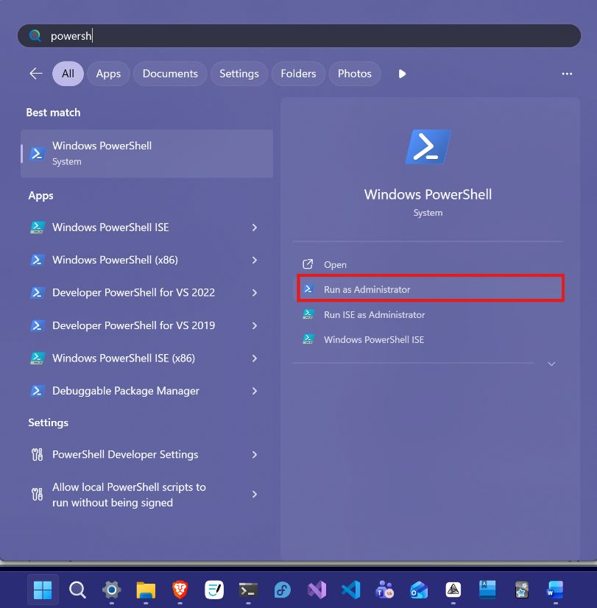

- Navigate to this project folder using the cd command
  - 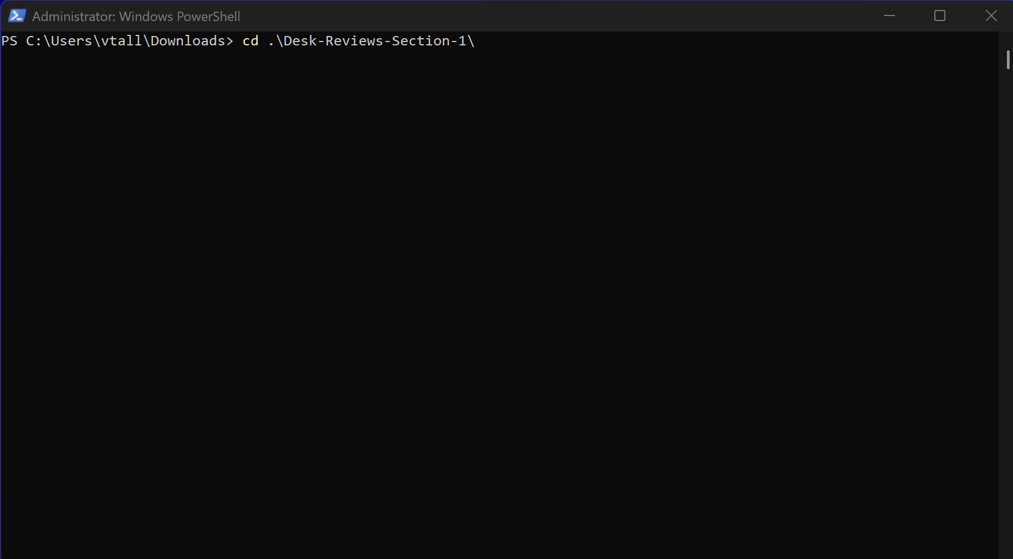

- Execute the command python -m venv .venv
  - This will create the place where dependencies will be downloaded and stored
- Execute the command .\.venv\Scripts\Activate.ps1
  - This enables the environment for scripts to execute in
- Execute the command pip install -r ./requirements.txt
  - This installs the necessary packages to run the scripts as well as registers the dependencies I have written myself
Now your environment is set up, simply execute .\.venv\Scripts\Activate.ps1 from the root of the project folder before executing any of the scripts to ensure they work properly

Additional note: The plotly package which is used to generate all of the graph figures in this project depends on a python package called kelido. Kelido requires an instance of Google Chrome to generate static image files. Before attempting to run any of these scripts ensure you have a copy of google chrome installed on your system. Either the official Google chrome or Chromium will work.

Exporting Datasets from Neoserra

Funding Milestones
To acquire the data for the capital infusion transaction milestones we will export the data from the “SBDC Minimum Deliverable Expectations” scorecard for the year of interest for the report.
- Navigate to https://pasbdc.neoserra.com/scorecards
- Click on “Goal Sets”
  - 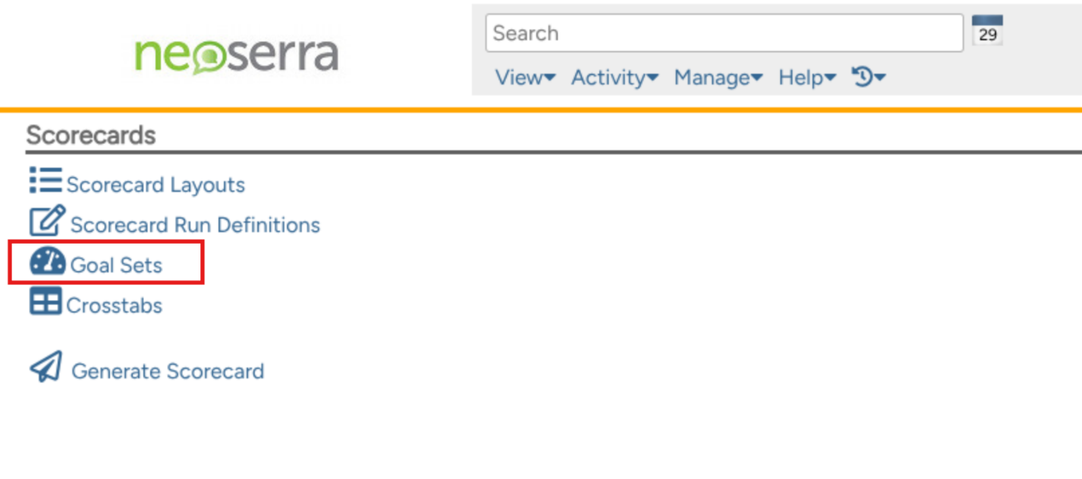
- Locate the goalset starting with “SBDC Minimum Deliverable Expectations” for the year you are interested in. You may have to flip through the pages of goalsets to find it. (Tip: Use Ctrl + F (Cmd + F on Mac) to search the website to find the correct goalset)
  - For this example we will be using FY25
  - 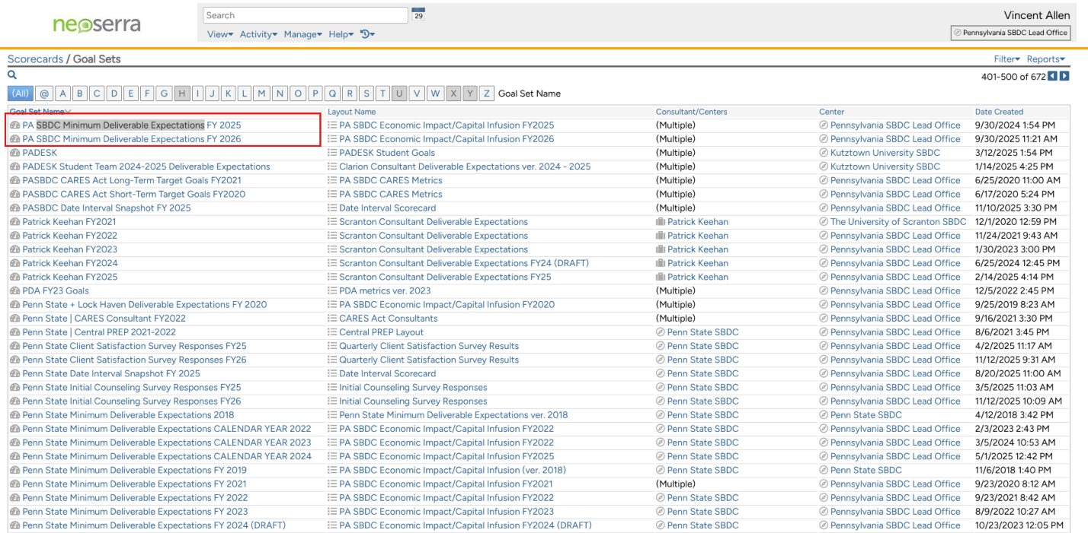
- In the “Data Elements” table, click on the number in the “Value” column for the “Capital Infusion Transactions” row

  - 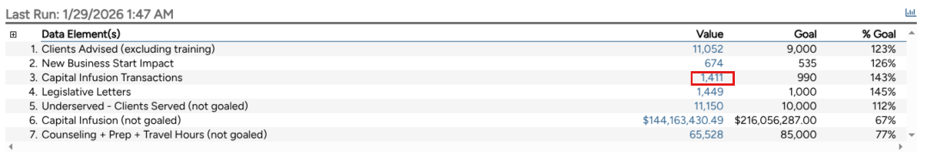
- Now we need to select the correct columns for the report to run
  - In the top right corner of the screen select “Filter > Select Columns.” Then, once the below dialog launches, select the columns as shown.
    - 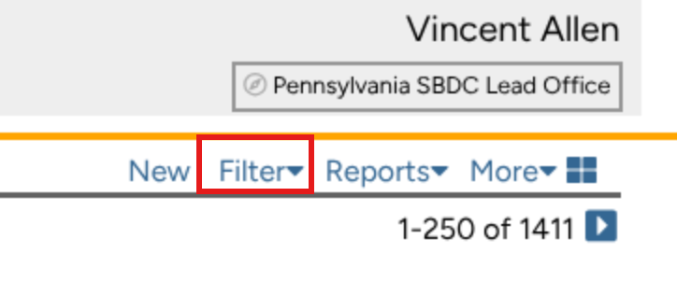
    - 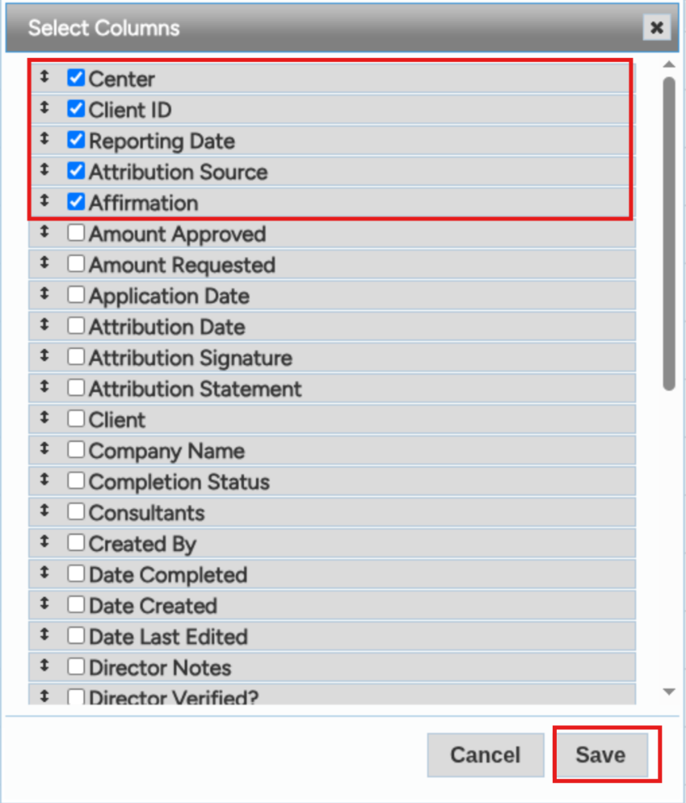
- To export the dataset as a CSV: In the top right corner select “Reports > Quick Report.“ On the resulting dialog click “Save.” This will bring you to a new tab with the contents of the CSV displayed. Copy this text and paste it in a file named “funding_milestones_raw_FY25.csv” (Or any other filename of your choice). Notepad is a good tool for this.
  - 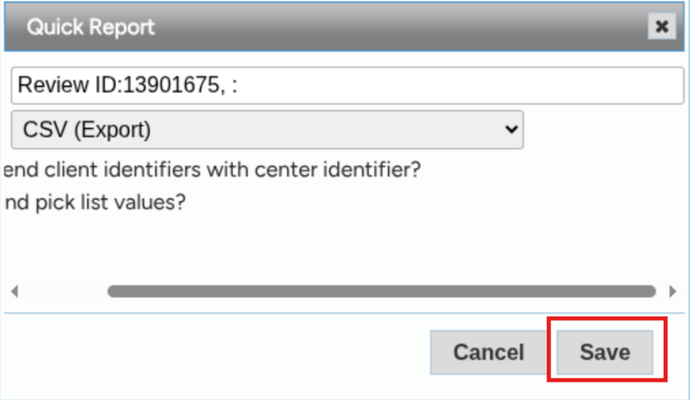

TIP: You can save a scorecard to your “Dashboard” in Neoserra.
- Locate the “Accounts” tab on the right side of the screen and select “Link”
  - 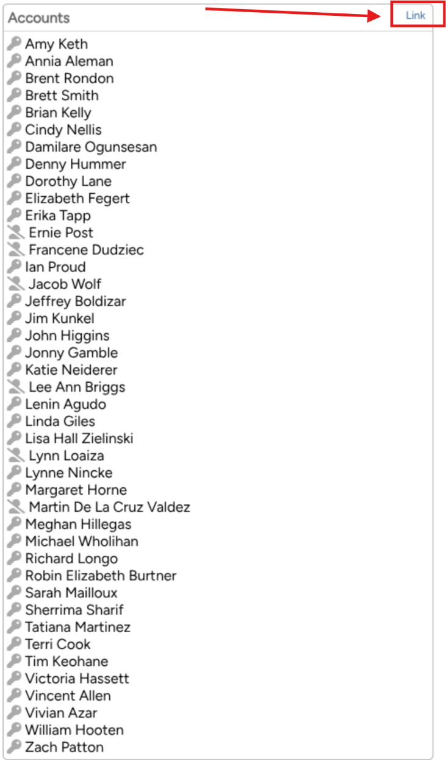
- Type in your name in the “Accounts” box and click your name once it appears
- Then click “Save”
  - 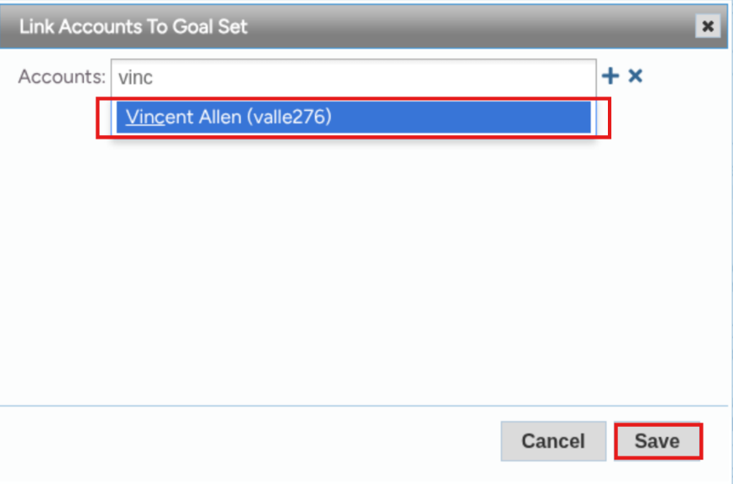
- The scorecard should show up at: https://pasbdc.neoserra.com/dashboard

Client List
- Stay on the same “SBDC Minimum Deliverable Expectations” scorecard as the previous dataset
- Click on the “Value” number for the “Clients Advised (excluding training)” data element
- Select the following columns from “Filter > Select Columns”
  - 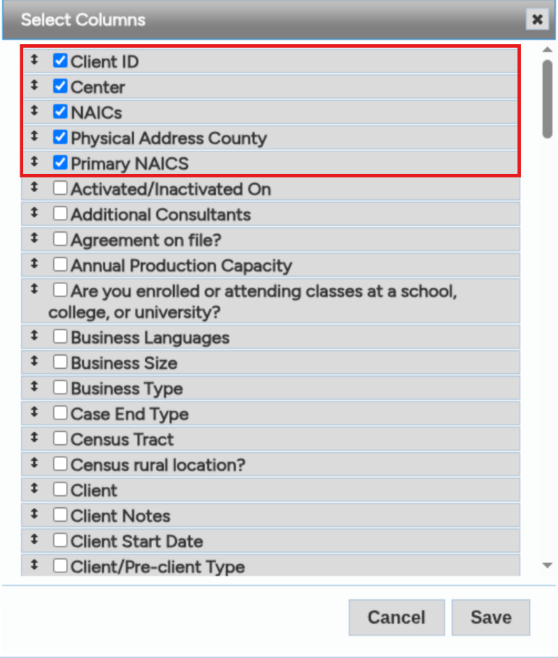
- Export the data as csv using “Report > Quick Report” to a csv file (client_list_raw_FY25.csv)

New Business Start Milestones
Note: While there is an option for this data within the deliverables scorecard, it does not allow the export of the columns we need, therefore we must source this data from a different section in Neoserra.
- Navigate to https://pasbdc.neoserra.com/activity/list/7?restore=1
- Recrate the following filter, changing the milestone date to the desired range, then click “Apply”
  - 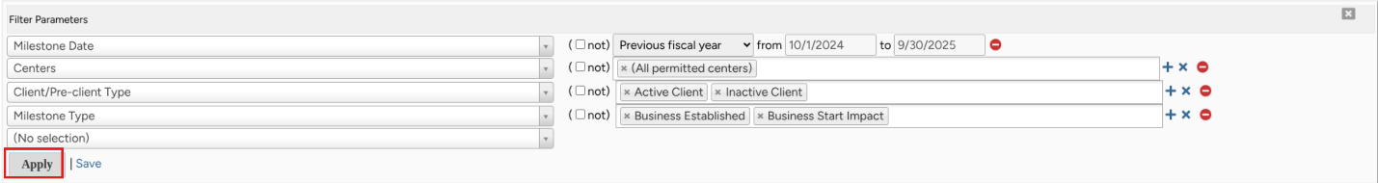
- In the same manner as before, in the top right corner, select “Filter > Select Columns” and check the shown columns
  - 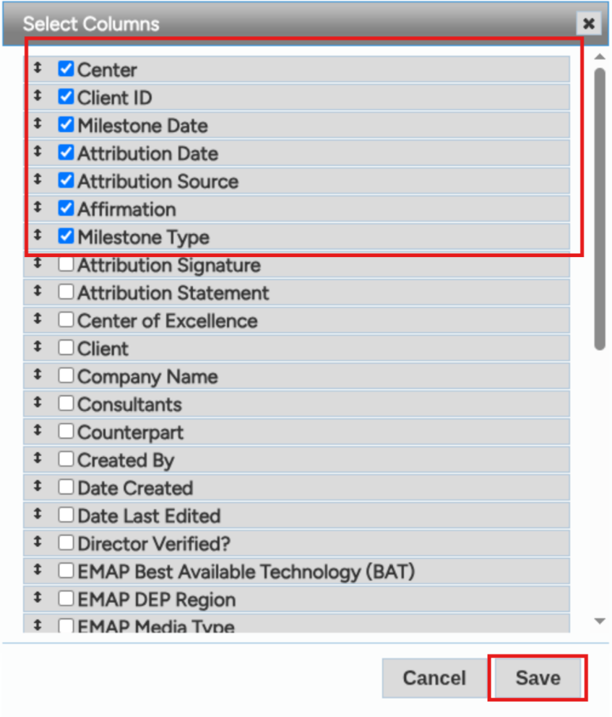
- Again, select “Reports > Quick Report”, click “Save,” then copy the resulting data into a file named “nbs_milestones_raw_FY25.csv”

Counselling Interval Snapshot
- Go back to the “Goal Sets” page (https://pasbdc.neoserra.com/scorecards/goalsets) and search for “PASBDC Date Interval Snapshot FY” and click the scorecard for the fiscal year of interest
  - 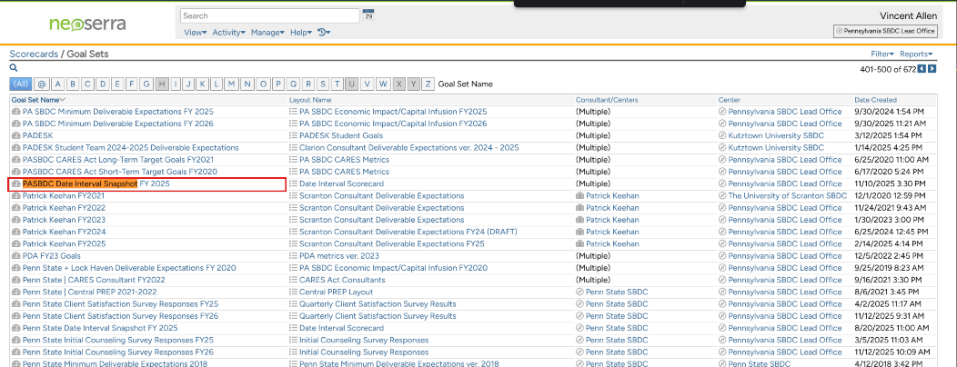
The following steps should be repeated for the following data elements (numbers 2-6). Filenames are for demonstration; you can, and should, use different names as long as you are consistent when you run the scripts.
- “Average # of Days between Client Sign-up and Client Start Date”
  - days_client_signup_to_start_FY25.csv
- “Average # of Days between Client Sign-up and 1st Counseling Session”
  - days_client_signup_to_counselling_FY25.csv
- “Average # of Days between Client Start Date to 1st Counseling Session”
  - days_client_start_to_counselling_FY25.csv
- “Average # of Days between Initial Counseling in the period to 1st Followup Counseling”
  - days_initial_to_followup_FY25.csv
- “Avg. # of Days between Training in the period to 1st Counseling Session”
  - days_training_to_counselling_FY25.csv
- Click on the number in the “Value” column for the data element you wish to export
- Select the shown columns from “Filter > Select Columns”
  - 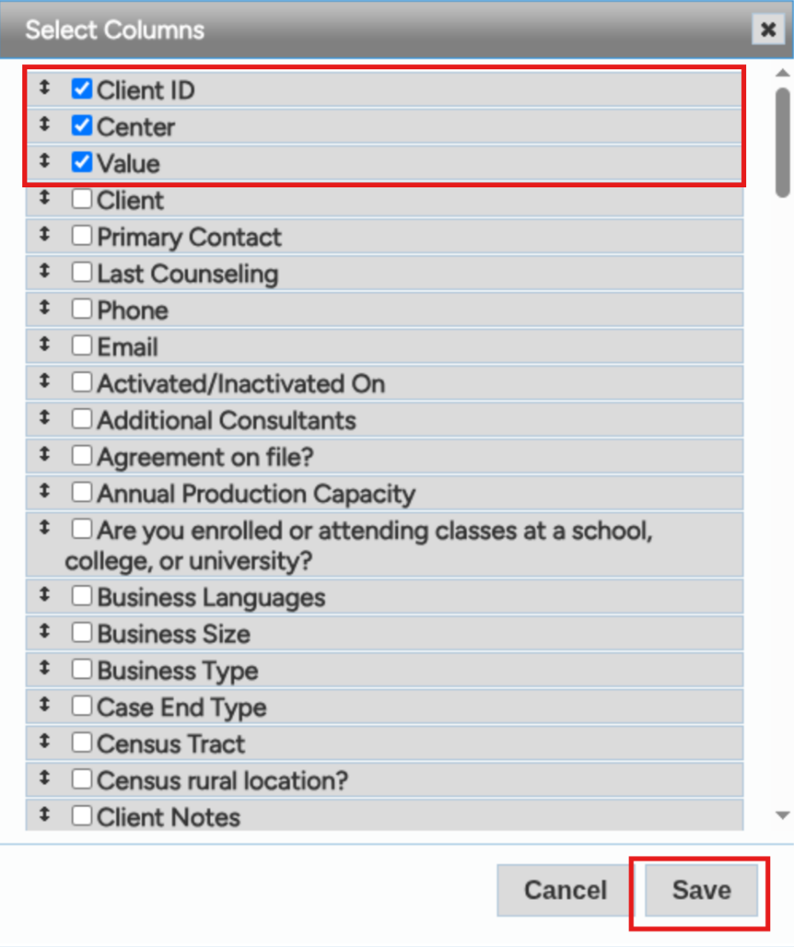
- Then export the CSV file with “Reports > Quick Report”
- Repeat steps 2-4 for each of the data elements listed above.

Satisfaction Survey
- Navigate to the goal sets page: https://pasbdc.neoserra.com/scorecards/goalsets
- Find the scorecard beginning with “PA SBDC Client Satisfaction Survey Responses FY” for the fiscal year of interest.
  - 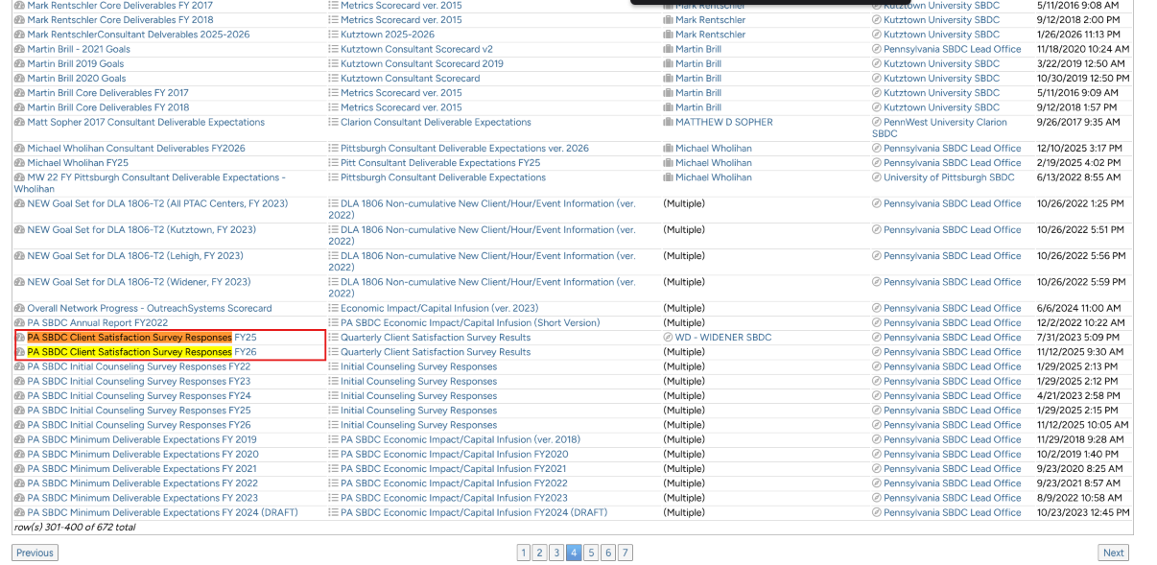
- Click on the number in the “Value” column for the “Total Survey Responses” row
  - 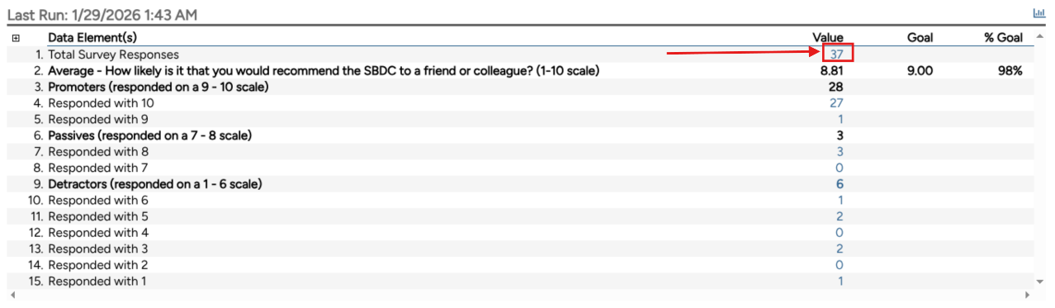
- Select the shown columns via “Filter > Select Columns”
  - 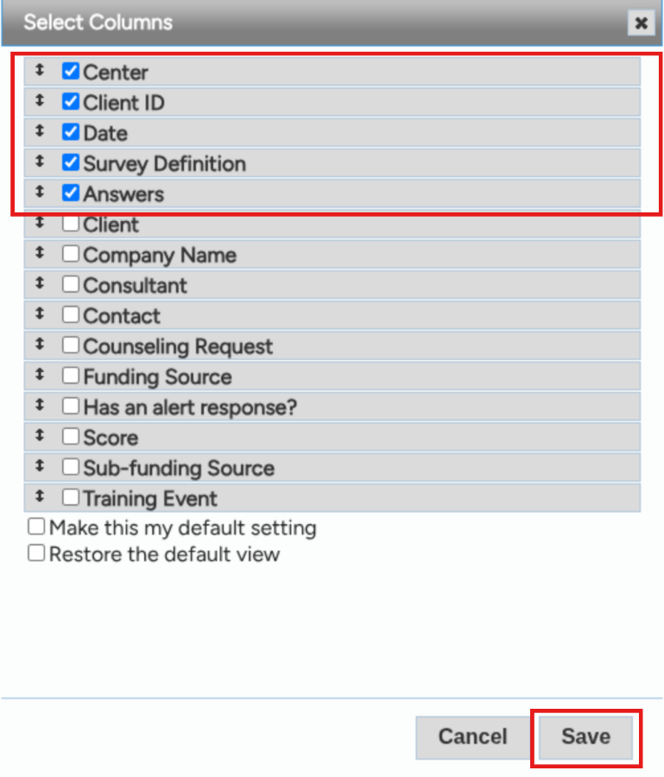
- Create a quick report via “Reports > Quick Report”, and save the resulting file to satisfaction_survey_FY25.csv

Training Events
- Navigate to the training events page: https://pasbdc.neoserra.com/conferences
- Ensure the following filter is set, apply it by clicking “Apply”
  - 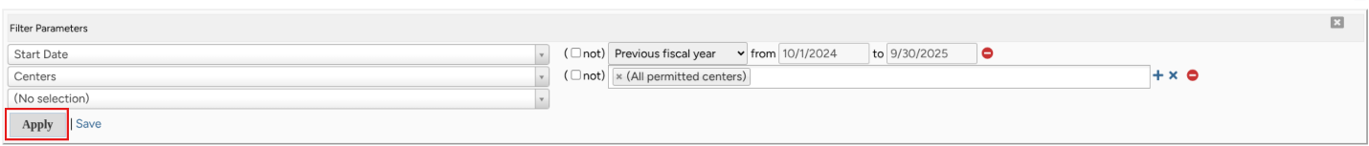
- Select the below columns with “Filter > Select Columns”
  - 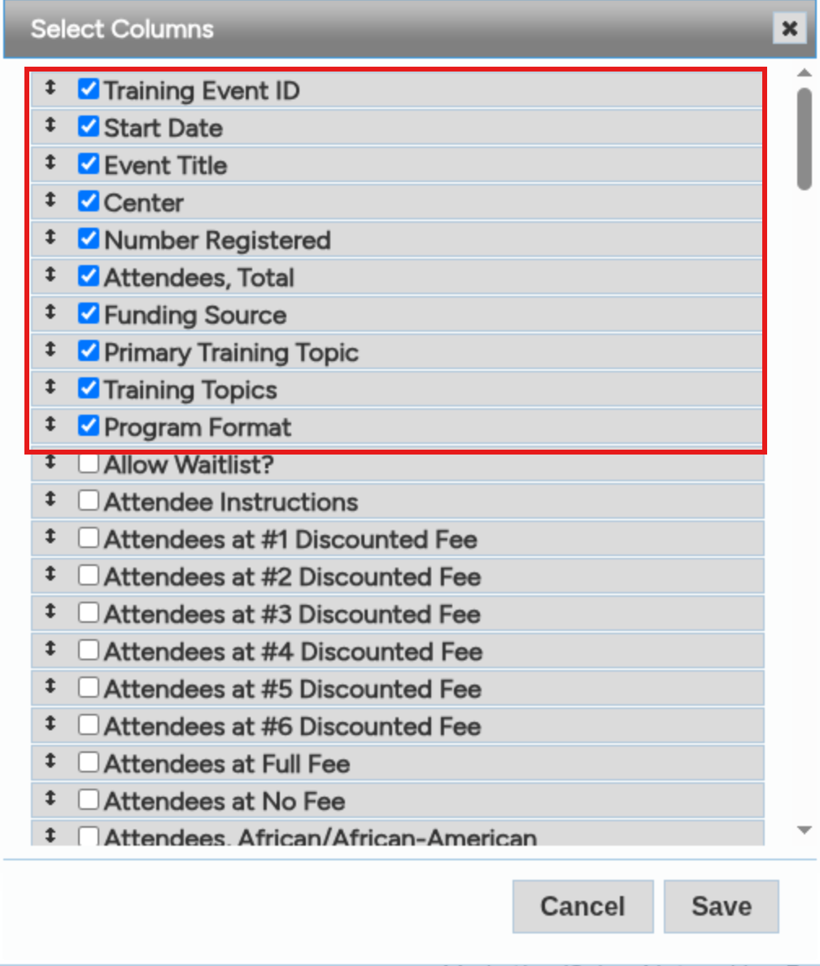
- Create a quick report and save it to the file trainings_raw_FY25.csv via “Reports > Quick Report”

Running the Reports With Make
Included in the root directory of the project is a makefile. Running this file will allow the entire report to be generated with a single command. Make is a code build system that works by tracking file modification times and allowing you to define steps that create files and other steps that depend on files. Therefore if an input file is changed, or an output file is deleted, then only the required commands will be run to update those parts of the report.
At the top of the makefile are the variables that control which files the script will use when it runs and how it will produce the output files. A makefile variable looks like this VARIABLE_NAME:=VALUE.
The makefile has 2 main sections that can be modified. The first is the CSV file section, each of the variables ending in CSV is the path to an input dataset file that the scripts expect. Change these variables to match where your csv files are located and what their names are. Below this section is the set of variables that control the naming of the output word documents. Leaving these as default is fine, but they can be customized if desired.
The make file will run on Linux or Windows. For Linux users, install make through your distribution’s package manager. For Windows users, follow the instructions at this link: https://leangaurav.medium.com/how-to-setup-install-gnu-make-on-windows-324480f1da69
For a crash course on make see: https://github.com/ahockersten/makefile_tutorial

Manually Running The Reports

Network Wide Trainings Report

Graph Image Generation
This report requires the raw trainings dataset we exported earlier.
- Navigate to the following subfolder in the project directory using an administrator Powershell window, either by using the cd command followed by the path you would like to navigate to, or by opening the path in file explorer and selecting “Open in Terminal”
  - Folder: section_1_graph_export_module/
- Within your powershell window, type: python trainings_analysis_script.py --fiscalyear <Fiscal year for the report> --inputcsv <path to the trainings csv file> --outpath <path to save the generated images to>
  - For example,
  - 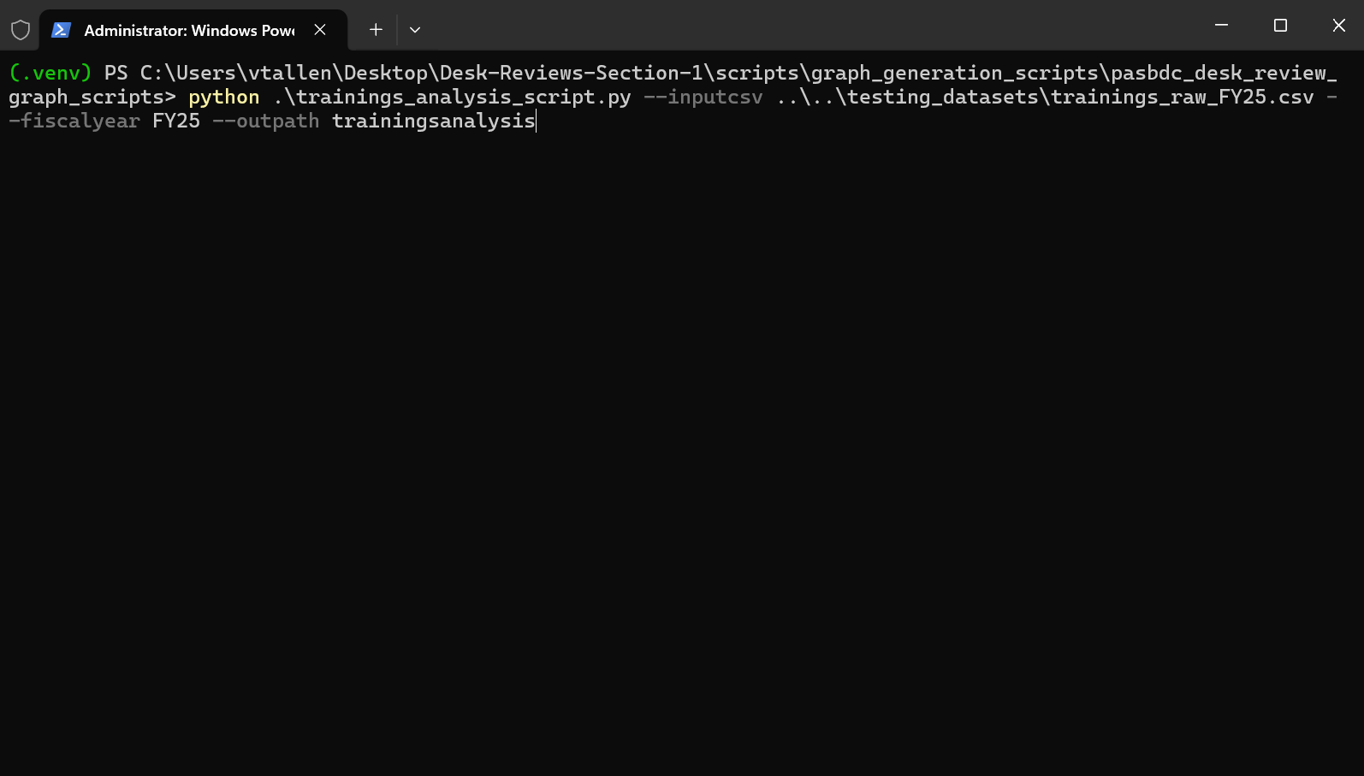
- The script may take some time to complete depending on the speed of your computer. Once it is done, all of the relevant files will be in the folder you specified when entering the command
- Next we need to generate the center specific trainings report by changing directories to section_3_graph_export_module/ then typing python trainings_topic_per_center_script.py --fiscalyear <Fiscal year for the report> --inputcsv <path to the trainings csv file> --outpath <path to save the generated images to> and hitting enter
  - For example, 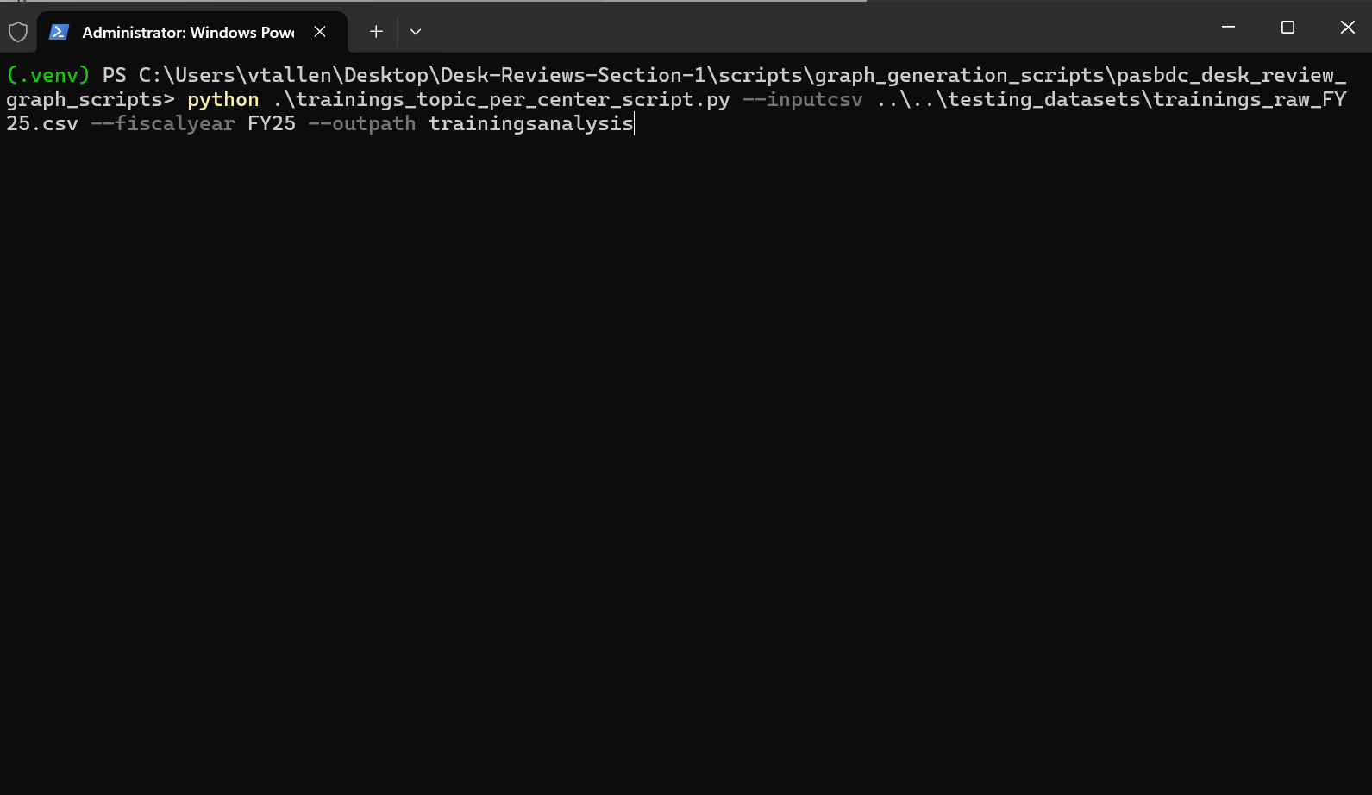
  - This will find each center that is in the input trainings csv and will create the same set of graphs for each center. For ease of use select the same folder you used for the last script.

Word Document Generation
Now that we have the image files, we can generate the word document
- Navigate to scripts\section_1_word_export_scripts/ and open a powershell terminal as before.
- Type the following command and press enter
  - python .\generate_trainings_analysis_word.py --images trainingsanalysis --output trainingsreport.docx -c "Lead Office" -c Wilkes -c Shippensburg -c Widener -c "Penn State" -c Bucknell -c "St. Francis" -c Gannon -c Clarion -c Temple -c Scranton -c Lehigh -c Duquesne -c Pittsburgh -c Kutztown -c “St. Vincent”
  - For each center that a center specific report was generated for, a -c argument must be supplied for the program to include the appropriate sections for that center. The name must be exactly as it appears in the filenames generated by the graph generation step.
    - Notice how in any center name that contains a space is wrapped in double quotes
- This process should be very quick; the resulting Word document will be saved to the filename you specified in the --output parameter

Counselling Interval Snapshot Report
This report requires the 5 CSV files exported from the Counselling Interval Snapshot scorecard.
- Navigate to section_1_graph_export_module and open a PowerShell terminal in the folder (either by opening one and using the cd command to change directory to the path or by navigating there in file explorer and right clicking to open in terminal)
- Execute the command
  - python counselling_interval_script.py
--signuptostartcsv ..\..\testing_datasets\days_client_signup_to_start_FY25.csv
--signuptocounsellingcsv ..\..\testing_datasets\days_client_signup_to_counselling_FY25.csv
--starttocounsellingcsv ..\..\testing_datasets\days_client_start_to_counselling_FY25.csv
--initialtofollowupcsv
..\..\testing_datasets\days_inital_to_followup_FY25.csv
--trainingtocounsellingcsv ..\..\testing_datasets\days_training_to_counselling_FY25.csv
--fiscalyear FY25 --outpath intervalanalysis
    - Ensure that a fiscal year is provided with --fiscalyear (if the desired fiscal year has spaces (ex. FY26 Q1), then surround it in double quotes (ex. “FY26 Q1”) when using it as an argument)
    - For the sake of ensuring clarity, I have left the testing filenames in instead of providing placeholders. Each of the arguments ending in csv should be pointed to the dataset CSV file they describe.

Word Document Generation

Navigate back to section_1_word_export_scripts/
- Execute the following command, providing the appropriate path to your image files with the --images argument and what you would like the output word document to be called with the --output parameter:
  - python3 counselling_interval_analysis.py --images <path to the folder containing the generated image files> --output example_document_name.docx
  - ex. 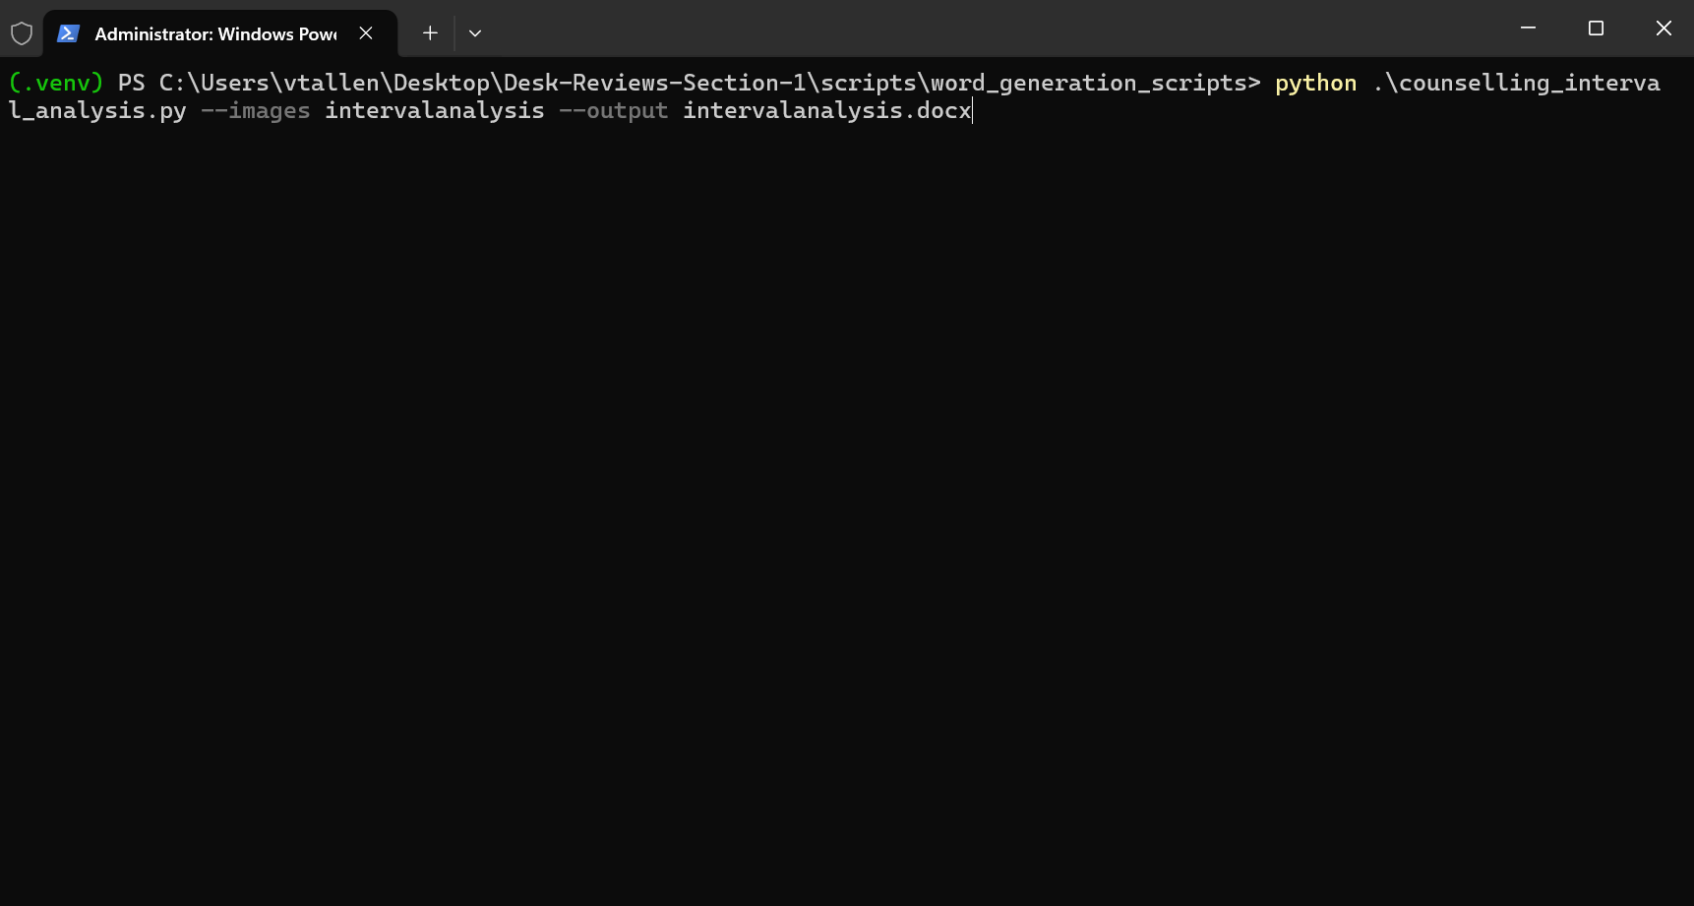

Once the script completes, you should have a new word document at the location you specified

Milestone Analysis Reports
There are two different graph generation scripts in this step. One for the new business start milestones and one for the capital funding milestones. They were kept as separate scripts as they deal with wholly separate sets of data (and thus combining them would go against best practices). They are grouped together as there is only 1 word document generation script that pertains to these images. This was kept as a combined script as the layout for the information is identical

New Business Start Report Graph Generation
- Navigate to section_1_graph_export_module/ and open a Powershell window into the folder.
- Execute the following python command supplying the path to the raw exported NBS data CSV via the --inputcsv argument.
  - python .\nbs_analysis_script.py --inputcsv <path to the raw NBS dataset> --fiscalyear <the fiscal year of the data> --outpath <folder to place the graphs in>
  - ex. 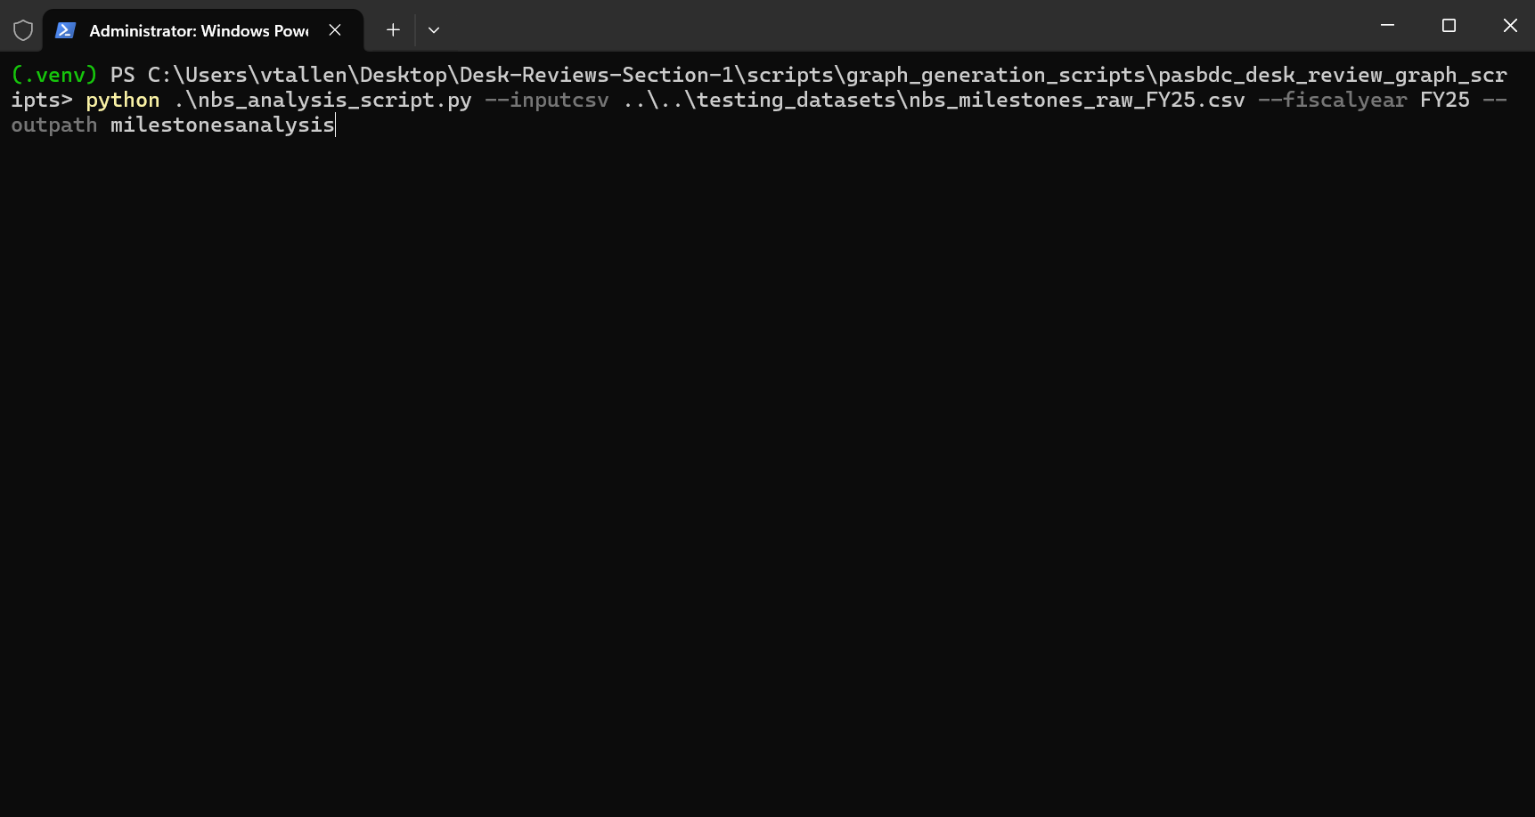
  - All of the NBS related graphs will now be in the folder specified by --output

Capital Funding Report Graph Generation
- Remain in the same folder you executed the NBS script in.
- Execute the following python command supplying the path to the raw exported funding milestones dataset. This script follows the same arguments as the previous one. You should supply the same –outpath you supplied for the last script
  - python .\funding_analysis_script.py --inputcsv ..\..\testing_datasets\funding_milestones_raw_FY25.csv --fiscalyear FY25 --outpath milestoneanalysis
  - ex. 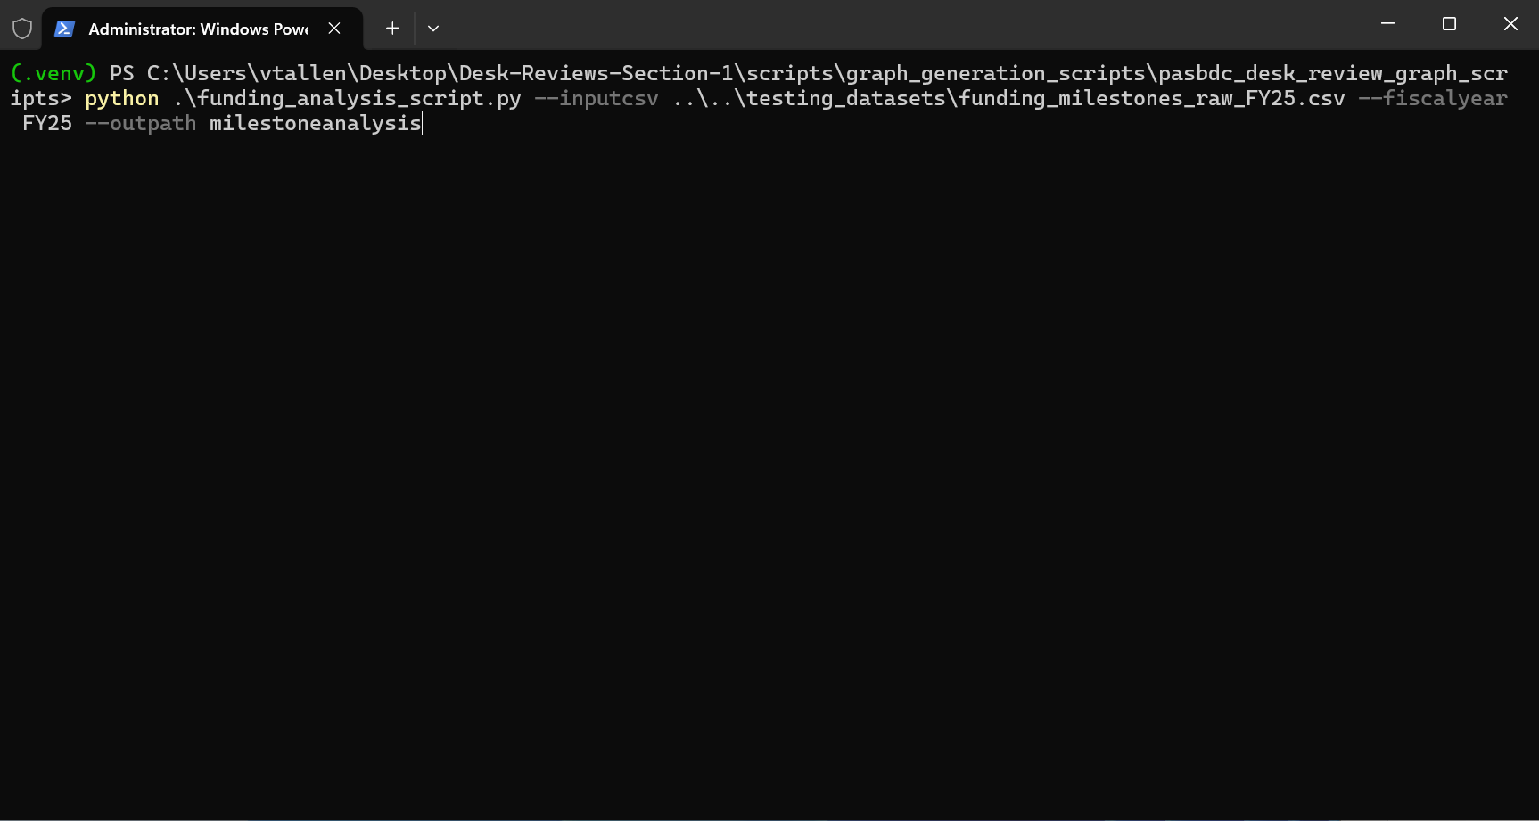
  - Now all the milestone report images should be in the folder you supplied to both scripts.

Word Document Generation

Navigate back to the section_1_word_export_scripts/ folder and open a Powershell terminal in the folder.
- Execute the following python command providing the path to the directory of milestone graph images and the desired output filename.
  - python .\make_nbs_funding_analysis.py --images .\milestoneanalysis\ --output milestone_report.docx
  - ex 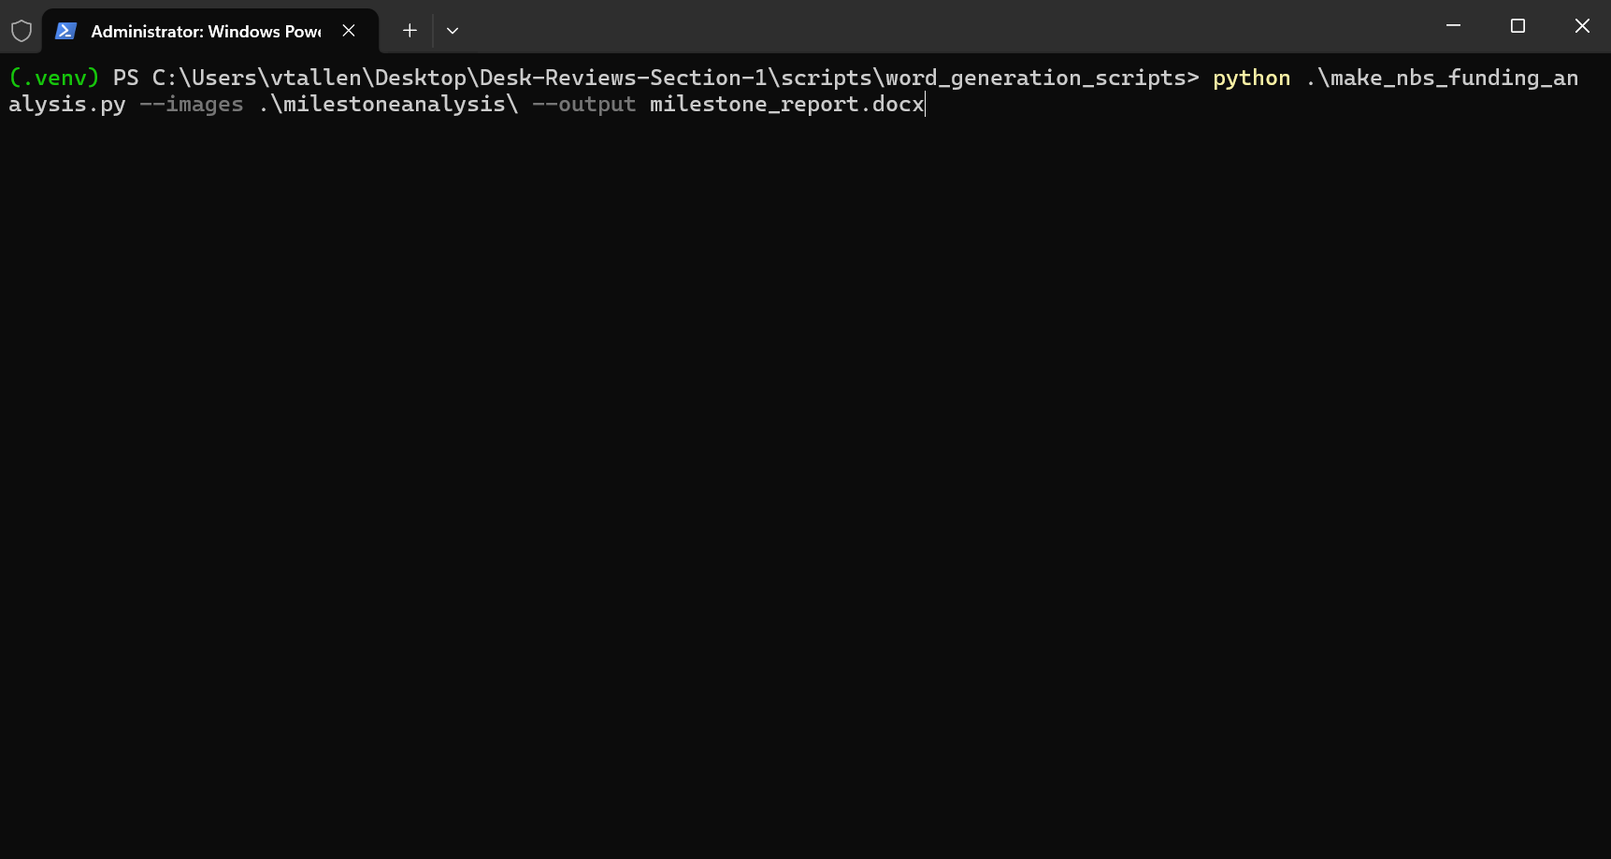
  - Now a word document containing both the NBS and funding milestone reports should be at the location specified in the command.

Satisfaction Survey Report
- Navigate back to the section_1_graph_export_module/ directory and open a Powershell terminal.
- Execute the following python command, providing the path to the satisfaction survey csv file to the --inputcsv argument, the path to the client list CSV file to the --clientlistcsv argument and the desired folder location in the --output argument.
  - python .\satisfaction_survey_analysis_script.py --inputcsv <satisfaction survey csv path> --clientlistcsv <client list csv path> --outpath <image output directory>
  - ex 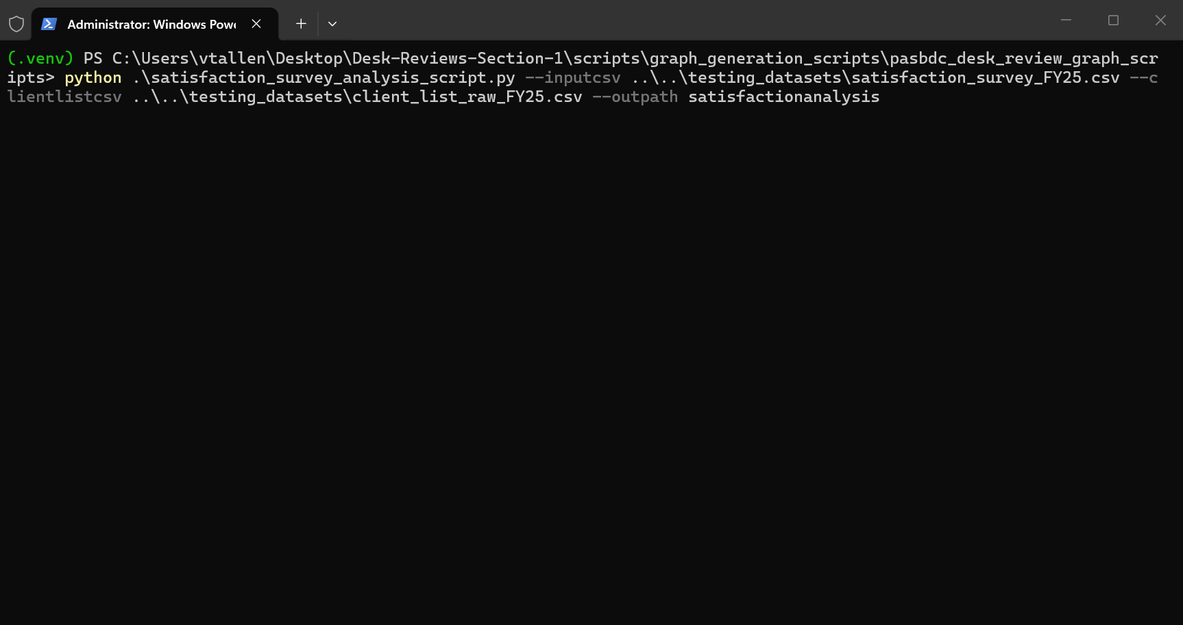

Word Document Generation
- Navigate to the section_1_graph_export_module/ directory
- Execute the python command providing the path to the folder containing the graph images to --images and the desired output word document filename to --output
  - python .\satisfaction_survey_word.py --images <path to the images folder> --output example_document_name.docx
  - Ex. 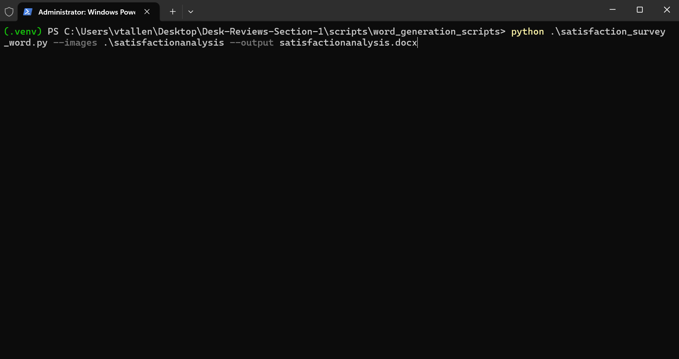
- The created word document will now be at the location specified by --output

NAICS Coverage Report
This script uses three US government APIs to source data for census NAICS codes, BLS statistics, and USDA statistics. As such, they are flakey at very best. If the script fails with an error message that mentions SSL certificate issue, just keep re-running the script till it works.
- Navigate back to scripts\graph_generation_scripts\pasbdc_desk_review_graph_scripts and open a Powershell terminal in the folder
- Execute the following python command providing the raw Neoserra client list dataset to the --inputcsv argument and the desired output folder path for the graphs to the --outpath argument
  - python .\naics_census_analysis_script.py --inputcsv <path to raw client list CSV file> --fiscalyear <the fiscal year of the data> --outpath <desired output directory path>
  - ex. 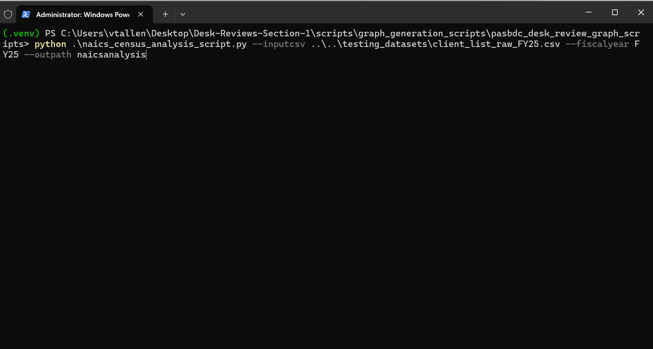
- The NAICs coverage report graphs will now be contained in the folder specified by –output

Word Document Generation
- Navigate to section_1_word_export_scritps/ and open a Powershell terminal.
- Execute the following python command supplying the path to the folder containing the graph images of the report to –images and the desired word document filename to –output
  - python .\generate_naics_word.py --images <path to report images> --output example_document.name.docx
  - ex. 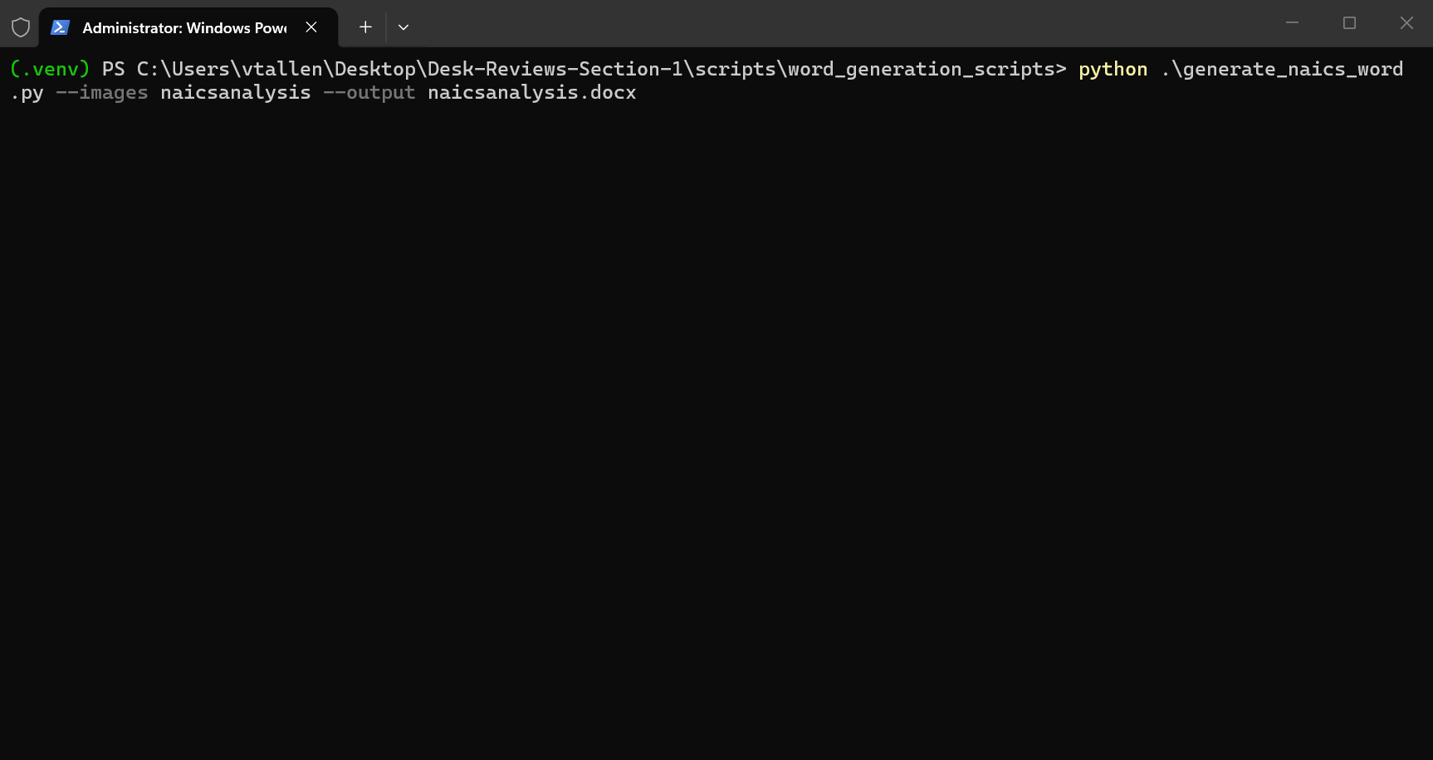
- The report document will now be written to the path and filename specified by --output

Changing Script Mappings
To balance both customizability and limit complexity for the end user of these scripts I have devised a simple single file solution for changing the naming of columns that the script expects in CSV files. Also included is the ability to change key sentinel values used to make data cleaning decisions within the script.
Each of the scripts in the project that need to ingest a CSV file also have a --mapping argument. This argument expects a JSON format file containing a list of strings that map to other strings. (See https://developer.mozilla.org/en-US/docs/Learn_web_development/Core/Scripting/JSON for more info on JSON)
In the documentation below, each script that uses the key value mapping system details which keys it will use if present in the provided mappings.json. You can then use that information in combination with the mappings.json key dictionary section to determine how to set your column mappings if you need to change them.
For example, take this mappings.json:
{
"col_unified_naics": "NAICS_CODE",
"col_census_pct": "Percentage",
"col_naics_2": "NAICS_2",
"col_naics_label":"NAICS2022_LABEL",
"col_pa_naics_pct": "PA NAICs Code Percentage",
"col_pasbdc_pct": "PASBDC NAICs Code Percentage",
"col_census_estab": "ESTAB",
"col_bls_industry": "industry_code",
"col_bls_estab": "annual_avg_estabs",
"col_usda_value": "Value",
"col_neo_primary_naics": "Primary NAICS",
"col_neo_naics": "NAICs"
}
The left side of the “:” is the name that these programs refer to the column names as, this is referred to as the key. The right side of the “:” is the value that replaces the left side value when the program runs, this is referred to as the value. This allows you to change what columns are expected to be called by the script as it will take the mappings.json and use each key to retrieve the correct value.

Additionally, if you only need to override one or two of the column names you can omit any of the keys that a script is listed as accepting and the defaults will be used.

Ex.
{
"col_unified_naics": "NAICS_CODE",
"col_census_pct": "Percentage",
}
The above mappings.json would still be valid for the previously shown mapping.json file.

Each script stores its default values as a constant python dictionary at the top of the script called DEFAULT_CONFIG.

mappings.json key Dictionary
- business_established_val: The tag to identify Business Established milestones.
- business_start_impact_val: The tag to identify Business Start impacts.
- col_attendees_range: The column containing the range of attendees that the total attendees value falls into
- col_attendees_total: The number of attendees that came to an event
- col_attrib_source: The column in the data at which the attribution source for a milestone can be found
- col_bls_estab: The column in the BLS stats API to look for the count of establishments for government run institutions
- col_bls_industry: The column in the BLS stats API to look for the NAICs code of an industry
- col_census_estab: The column in the US Census CSV API to look for the count of establishments for a certain NAICs code
- col_census_naics:
- col_census_pct: The column for the percentage a NAICs code represents of the PA census data in the industry descriptions table
- col_doc_level: The column in the data at which the documentation level can be found for a milestone
- col_event_title: The column containing the training event title
- col_funding_source: The funding source for an event
- col_interval_data_value: Maps to the column containing the numerical interval/day values (Default: "Value").
- col_is_preplanning: The output column that shows if an event is preplanning or not
- col_naics_2: The output column in the clients dataset for the combined and parsed NAICs codes. Neoserra has many digits for specific industry codes, but we only care about the first 2 which signify the main industry.
- col_naics_label: The output column at which the description of a NAICS code is stored
- col_neo_affirmation: The column indicating if the funding was affirmed. col_neo_answers: The column in the Neoserra data to look for the response survey answers
- col_neo_attendees_total: The column containing the total number of attendees for a training event
- col_neo_attribution_date: The date the attribution was recorded.
- col_neo_attribution_source: The source of the milestone attribution.
- col_neo_center: The column in the data at which the Center can be found
- col_neo_client_id: Unique identifier for the client.
- col_neo_county: The column in the Neoserra data to look for the county of a client
- col_neo_event_title:
- col_neo_funding_source: The column containing the funding source for a training event
- col_neo_milestone_date: The date a milestone occurred.
- col_neo_milestone_type: The category of a milestone.
- col_neo_naics: The secondary column in the Neoserra data corresponding to the NAICs code of a client. This data is combined with the primary column.
- col_neo_primary_naics: The column in the Neoserra data corresponding to the primary NAICs code of a client
- col_neo_primary_topic: The column containing the primary topic of a training event
- col_neo_program_format: The column containing information on if a training event was on demand (recorded and uploaded to the hub) or was in person
- col_neo_training_topics: The list of all training topics associated with a training event
- col_out_attendees_range: The output column for the tagged range of attendees for an event.
- col_out_county: The output column for the county of a row of data
- col_out_documentation_level: The output column name created during sanitization to store the ranked documentation status.
- col_out_fips: The output column for the fips code for a row of data
- col_out_missing: The output column for the number of missing NAICs codes for a county out of all possible codes
- col_out_of_state: The column in the cleaned Neoserra data that indicates whether a client is in state or out of state. This is only used to exclude any counties outside of PA as this data later gets used to create a county map.
- col_out_pct_missing: The percentage of possible NAICs codes that are missing from a county
- col_out_total: The output column for the total number of clients in a county
- col_out_unique: The output column for the number of unique NAICs codes that appear within a county.
- col_pa_naics_pct: The output column in the final clients dataset that contains the percentage a NAICs code makes up of all business in the PA census
- col_pasbdc_pct: The output column in the final clients dataset that contains the percentage that a NAICs code makes up of PASBDC client businesses
- col_satisfaction_score: The column containing the question to derive a net promoter score from.
- col_score: The column containing the answer to the question to derive a net promoter score from
- col_training_id: The unique ID for a training event
- col_training_topics: The column containing the additional training topics for a training event
- col_unified_naics: The column for the NAICs code to be placed in for the industry description table which will be combined from the col_neo_primary_naics and col_neo_naics columns as for some reason there are two spots to put a NAICs code in Neoserra
- col_usda_value: The column in the USDA stats API to look for the count of farm establishments
- val_affirmation_missing: The string value used to identify milestones that have documentation but lack proper affirmation.
- val_documented: The value to look for the the documentation level column that causes a milestone to be considered documented
- val_preplanning: The value that if seen in the primary training topic will cause the training event to be considered a preplanning event
- val_wrong_spot: The value to look for in the documentation level column that causes a milestone to be considered documented but in the wrong spot

Per file notes/docs
Each python file within this project that has something usable by the end user in it has some amount of documentation here.

If it is not included here then it is most likely library code. All python files have inline documentation that will be useful if you want to use them.

Listed here are required prerequisites for each script, what parameters they take as command line arguments, and a brief description of what they output.

scripts/dataset/desk_review_dataset_generator/make_client_list_dataset.py
Description: This file implements the data cleaning code to tag the Neoserra clients list score card with:
- A 2 digit NAICs code derived from the multiple NAICs columns in the data
- A percentage of how much that client’s NAICs code makes up of all NAICs codes across the PASBDC
- A percentage of how much that client’s NAICs code makes up of all business in the PA Census
- Whether the client’s physical address county is in or out of state e
It also generates a table that contains each 2 digit NAICs code with both a description of what that NAICs code means and how much it makes up of the PA census.

External data sources queried
- https://quickstats.nass.usda.gov/api - Used to obtain stats for number of NAICS code 11 organizations
- https://api.census.gov – Used to obtain US census data for PA including count of organizations by NAICs code
- https://data.bls.gov – Used to obtain number of NAICs code 92 organizations

Script data prerequisites:
The client list dataset export from Neoserra. See report running guide for how to export this.

Script command line arguments
-c / --censusyear
- The census year to use (must be a valid US census year)
- Optional, defaults to 2022
-u / --usdaapikey
- The API key used to access the USDA census API
- Optional, defaults to a key valid as of 12/17/25
- A new key can be obtained from: https://quickstats.nass.usda.gov/api
-i / --inputcsv
- The path to the exported client list CSV file from Neoserra, see above for instructions
- Required
-m / --mapping
- The path to a JSON file containing CSV column name overrides to enable changes in the schema of Neoserra’s data
- Optional, defaults are provided
-o / --out
- The path to save the tagged client list to
- Optional, the program gives it a name if you do not
-t / --tableout
- The path to save the census NAICs table data to
- Optional, if not provided the file will not be saved

Column Mapping Configuration
This script uses the following keys in for the mapping.json file described at the beginning of this document.
- col_unified_naics
- col_census_pct
- col_naics_2
- col_naics_label
- col_pa_naics_pct
- col_pasbdc_pct
- col_census_estab
- col_census_naics
- col_bls_industry
- col_bls_estab
- col_usda_value
- col_neo_primary_naics
- col_neo_naics

scripts/dataset/desk_review_dataset_generator/dataset/make_county_naics_dataset.py
Description: This file implements the data cleaning code to turn the dataset generated by make_client_list_dataset.py into a form that can be used to create a county heat map of which county’s clients have missing NAICs codes in their profiles. The output data contains the following for each county
- County name
- Fips code (an identifier used by to identify a specific state or county see : https://en.wikipedia.org/wiki/Federal_Information_Processing_Standard_state_code)
- The count of unique valid NAICs codes present
- The count of missing NAICs codes in client profiles
- The total number of clients in the county
- The percentage of clients with missing NAICs codes (derived from the previous attributes)

Script data prerequisites
This script requires the output file from running make_client_list_dataset.py. Pass this dataset’s file as the --inputcsv to this script. See the report running guide for how to obtain this data file

Script command line arguments
-i / --inputcsv
- The path to the raw clients list dataset
- Required
-m / --mapping
- The path to a JSON file containing CSV column name overrides to enable changes in the schema of Neoserra’s data
- Optional, defaults are provided
-o / --out
- The path to save the output dataset to
- Optional, the program gives it a name if you do not

Column Mapping Configuration
This script uses the following keys in for the mapping.json file described at the beginning of this document.
- col_out_county
- col_out_fips
- col_out_unique
- col_out_missing
- col_out_total
- col_out_pct_missing
- col_neo_county
- col_naics_2
- col_out_of_state
- col_unified_naics
- col_census_pct
- col_census_naics
- col_pa_naics_pct
- col_pasbdc_pct
- col_census_estab
- col_bls_industry
- col_bls_estab
- col_usda_value
- col_neo_primary_naics
- col_neo_naics

Example usage
python make_county_naics_dataset.py --inputcsv client_data.csv

This command would:
- Ingest the provided data
- Calculate the per county statistics above
- Save the resulting file

scripts/dataset/desk_review_dataset_generator/make_trainings_dataset.py

Description
This script contains all of the needed functionality to turn the raw export from Neoserra of all training events for a fiscal year into the dataset that can be used in our reports.

Script Data Prerequisites
This script requires the raw trainings dataset as exported in the report running guide.

Script Command Line Arguments
--inputcsv
- The path to the input dataset from Neoserra
- Required
-o / --out
- The filename to write the cleaned dataset to
- Required
-m / --mapping
- The path to a .json mappings file that allows the user to override column mappings
- Optional
--mode
- Whether to make the master all trainings dataset or the center specific statistics dataset
- Valid options: clean, stats
-f / --fundingsources
- The list of funding sources to include in the output dataset

Column Mapping Configuration
This script uses the following keys in for the mapping.json file described at the beginning of this document.
- col_neo_event_title
- col_neo_primary_topic
- col_neo_training_topics
- col_neo_center
- col_neo_funding_source
- col_neo_attendees_total
- col_is_preplanning
- col_neo_program_format
- col_out_attendees_range

scripts/dataset/desk_review_dataset_generator/make_satisfaction_survey_dataset.py
Description: This file implements the data cleaning steps required to extract both individual question prompts and their answers from survey data extracted from Neoserra.

While this script was tested on the client satisfaction survey, this code should work so long as there is a ‘Center’ column and an ‘Answers’ column that follows this format
- Survey questions start with a number and a . (ex 1., 2., 3. … etc)
- Following each survey question is a new line and an answer
This script then transforms the data by adding 2 columns for each question parsed. The first column contains the question’s text and the second column contains the recorded answer for the question.

Script data prerequisites
A CSV exported from the satisfaction survey scorecard as described in the report running guide.

Script command line arguments
-i / --inputcsv
- The path to the survey scorecard data
- Required
-m / --mapping
- The path to a JSON file containing CSV column name overrides to enable changes in the schema of Neoserra’s data
- Optional, defaults are provided
-o / --out
- The path to save the output dataset to
- Optional, the program gives it a name if you do not

Column Mapping Configuration
This script uses the following keys in for the mapping.json file described at the beginning of this document.
- col_neo_answers

scripts/dataset/desk_review_dataset_generator/make_nps_dataset.py
Description: This file implements the data cleaning code to take the processed satisfaction survey dataset and derive a per center net promoter score (NPS)
“The NPS assumes a subdivision of respondents into "promoters" who provide ratings of 9 or 10, "passives" who provide ratings of 7 or 8, and "detractors" who provide ratings of 6 or lower. Calculating the net promoter score involves subtracting the percentage of detractors from the percentage of promoters collected by the survey item.” – Wikipedia (https://en.wikipedia.org/wiki/Net_promoter_score)
The value is multiplied by 100 to obtain a percentage-like figure.

Script data prerequisites:
This script requires the output of make_satisfaction_survey_dataset.py as its input. Reference that scripts requirements as they also apply to this script
The computation done within this script can apply to any numeric 1-10 scale score column. Question 1 is the main question of interest for this analysis so that is the default. If you want to calculate per center NPS for another question, provide a mappings file as described below.

Script command line arguments
--inputcsv
- The path to the satisfaction survey dataset
- Required
-m / --mapping
- The path to a JSON file containing CSV column name overrides to enable changes in the schema of the input data
- Optional, defaults are provided
-o / --out
- The path to save the tagged client list to
- Optional, the program gives it a name if you do not

Column Mapping Configuration
This script uses the following keys in for the mapping.json file described at the beginning of this document.
- col_neo_center
- col_satisfaction_score

Graph Image Generation Scripts

A Note on How Image Filenames are Derived
A structured file naming scheme was developed to allow the word document generation scripts to load in all of the files they require without the user needing to manually specify each exact path.
The format is structured as follows <report>_<graph name>_<graph variant>.png. For example, trainingsreport_attendee-bins_no-first-no-pre-percent.png. The <graph variant> part of the filename is currently only used by the trainings report. It can be omitted as long as the filename still has a trailing underscore (ex. fundinganalysis_fundingattributionnetworkwide_.png).
The word document generation scripts are going to expect the default values that are already set in each script, however if you would like to modify how filenames are created, each script has command line arguments that allow you to change the report name and the name of each graph that script generates.

How Files Are Retrieved Once They are Written to Disk
Once these graph generation scripts are executed the word document generation scripts must construct a list of graph images somehow. This is where the ImageRegistry class comes in, it can be found at scripts/word_generation_scripts/image_registry.py. It works by first collecting all .png files from the target folder. Once this data is acquired, it splits each filename on the underscores to get 3 separate strings (<report>, <graph name>. <graph variant>). The class organizes this data within two nested python dictionaries that maps graph name -> variant -> image path on the disk. A single ImageRegistry object corresponds to a single <report>. Therefore, when one of the word generation scripts wants to access a specific chart, the .get() method of the class is called with the appropriate graph name and variant (variant may be empty) to get the path of the image.

scripts/graph_generation_scripts/pasbdc_desk_review_graph_scripts/counselling_interval_script.py
Description: This file implements the control code needed to process yearly satisfaction survey data (specifically counseling intervals) exported from Neoserra. It passes the data to library functions to generate comparative graph images. The script visualizes performance per center while maintaining a horizontal line to represent the network-wide average.
The script focuses on several key performance intervals:
- Days between Client Sign-up and Client Start Date
- Days between Client Sign-up and 1st Counseling Session
- Days between Client Start Date and 1st Counseling Session
- Days between Initial Counseling and 1st Followup Counseling
- Days between Training and 1st Counseling Session
External data sources queried:
- None. This script relies entirely on local CSV exports.
Script data prerequisites: Various interval datasets exported from the Neoserra scorecard. Each CSV must contain center-level data for the specific metric being graphed.
Script command line arguments:
- --signuptostartcsv
  - The path to the dataset containing "Average # of Days between Client Sign-up and Client Start Date".
  - Required.
- --signuptostartfigure
  - The filename for the generated sign-up to start date graph.
  - Optional, defaults to "signuptostart".
- --signuptocounsellingcsv
  - The path to the dataset containing "Average # of Days between Client Sign-up and 1st Counseling Session".
  - Required.
- --signuptocounsellingfigure
  - The filename for the generated sign-up to first counseling graph.
  - Optional, defaults to "signuptocounselling".
- --starttocounsellingcsv
  - The path to the dataset containing "Average # of Days between Client Start Date to 1st Counseling Session".
  - Required.
- --starttocounsellingfigure
  - The filename for the generated start date to first counseling graph.
  - Optional, defaults to "starttocounselling".
- --initialtofollowupcsv
  - The path to the dataset containing "Average # of Days between Initial Counseling to 1st Followup Counseling".
  - Required.
- --initialtofollowupfigure
  - The filename for the generated initial session to follow-up graph.
  - Optional, defaults to "initialtofollowup".
- --trainingtocounsellingcsv
  - The path to the dataset containing "Avg. # of Days between Training to 1st Counseling Session".
  - Required.
- --trainingtocounsellingfigure
  - The filename for the generated training to first counseling graph.
  - Optional, defaults to "trainingtocounselling".
- --fiscalyear
  - The fiscal year tag (e.g., "FY2025") to be appended to graph titles.
  - Required.
- --outpath
  - The base directory path where all generated PNG files will be saved.
  - Required.
- --report
  - The report prefix used for naming the output files.
  - Optional, defaults to "counselling-interval".
- --mapping
  - The path to a JSON file containing CSV column name overrides.
  - Optional.
Column Mapping Configuration: This script uses the following keys for the mapping.json file to identify the correct columns in the input CSVs:
- col_neo_center
- col_interval_data_value

scripts/graph_generation_scripts/pasbdc_desk_review_graph_scripts/pasbdc_funding_analysis_script.py
Description: This script processes raw capital funding data from Neoserra to perform a detailed attribution analysis. It cleans the data and generates several visualization charts and supporting datasets to evaluate how funding milestones are documented and affirmed across the SBDC network.
The script generates four primary analyses:
- Network-Wide Attribution: A stacked bar chart showing the documentation levels per center.
- Attribution Rate: A chart showing the percentage of documented funding per center.
- Theoretical Rate: A "what-if" analysis showing documentation percentages if all milestones with an attribution source had been properly affirmed.
- Director Confirmed: A visualization showing the percentage of funding attributions explicitly confirmed by a director.
Script data prerequisites: A raw capital funding CSV dataset exported from Neoserra. The data should include columns for center names, attribution sources, and affirmation status as shown in the report running guide.
Script command line arguments:
- -i / --inputcsv
  - The path to the raw capital funding CSV dataset.
  - Required.
- -o / --outpath
  - The base directory path where all generated PNG graphs and CSV datasets will be saved.
  - Required.
- -f / --fiscalyear
  - The fiscal year associated with the input data (e.g., "2025").
  - Required.
- -m / --mapping
  - Path to a JSON file containing CSV column name overrides to accommodate changes in Neoserra's export schema.
  - Optional.
- --netwidefilename / --netwidetitle
  - Filename and title for the network-wide stacked bar chart.
  - Defaults: "fundingattributionnetworkwide" / "Capital Funding Attributions Per Center FY 25".
- --ratefilename / --ratedatafilename
  - Filename for the attribution rate chart and its corresponding intermediate CSV dataset.
  - Defaults: "fundingattributionrate" / "funding_attribution_rate_data.csv".
- --theoreticalfilename / --theoreticaltitle / --theoreticaldatafilename
  - Filename, title, and intermediate dataset name for the theoretical "documented if affirmed" analysis.
  - Defaults: "theoreticalfundingattributionrate" / (Long title regarding affirmation) / "theoretical_funding_rate_data.csv".
- --directorfilename / --directortitle / --directordatafilename
  - Filename, title, and intermediate dataset name for the director-confirmed funding analysis.
  - Defaults: "directorconfirmedfunding" / "Percentage of Director Confirmed Capital Funding Attributions Per Center FY 25" / "director_confirmed_data.csv".
- --report
  - The report name used as a prefix for all output images to assist the Word document generation registry.
  - Optional, defaults to "fundinganalysis".
Column Mapping Configuration: This script uses the following keys in the mapping.json file to identify and process data:
- col_neo_center
- col_neo_attribution_source
- col_neo_affirmation
- col_out_documentation_level
- val_documented
- val_affirmation_missing

scripts/graph_generation_scripts/pasbdc_desk_review_graph_scripts/nbs_analysis_script.py
Description: This script implements the control logic for analyzing New Business Starts (NBS) milestones within the PASBDC network. It processes raw Neoserra data to evaluate how business starts are attributed and documented across different centers. The script performs data cleaning and sanitization specifically for NBS milestones before generating a suite of visualization graphs and intermediate datasets used for reporting.
The analysis focuses on four key areas:
- Network-Wide Attribution: A stacked bar chart showing the breakdown of documentation levels for NBS milestones per center.
- Attribution Rate: A performance chart indicating the percentage of NBS milestones that meet the "Documented" criteria.
- Theoretical Rate: An analysis of what the documentation rate would be if all milestones with an attribution source had received proper affirmation.
- Director Confirmed: A visualization of milestones that have been explicitly confirmed by an SBDC Director.
Script data prerequisites: A raw Neoserra export containing milestone data. The dataset must include client IDs, milestone types (specifically "Business Start" or "Business Established"), milestone/attribution dates, and affirmation status. See the report running guide for the full list of columns needed.
Script command line arguments:
- --inputcsv
  - The path to the raw NBS analysis CSV dataset.
  - Required.
- --outpath
  - The base directory path where generated PNG graphs and CSV data exports will be saved.
  - Required.
- --fiscalyear
  - The fiscal year tag (e.g., "2025") used for labeling graph titles and naming output files.
  - Required.
- --mapping
  - Path to a JSON file for overriding default column name mappings.
  - Optional.
- --netwidefilename / --netwidetitle
  - Filename and display title for the network-wide attribution stacked bar chart.
  - Defaults: "nbsattributionnetworkwide" / "New Business Start Attributions Per Center FY 25".
- --ratefilename / --ratedatafilename
  - Filename for the attribution rate chart and the corresponding CSV data.
  - Defaults: "nbsattributionrate" / "nbs_attribution_rate_data.csv".
- --theoreticalfilename / --theoreticaltitle / --theoreticaldatafilename
  - Filename, title, and CSV export path for the theoretical rate analysis.
  - Defaults: "theoreticalnbsattributionrate" / (Detailed title regarding affirmations) / "theoretical_nbs_rate_data.csv".
- --directorfilename / --directortitle / --directordatafilename
  - Filename, title, and CSV export path for the director-confirmed NBS analysis.
  - Defaults: "directorconfirmednbs" / "Percentage of Director Confirmed NBS Attributions Per Center FY 25" / "director_confirmed_nbs_data.csv".
- --report
  - The prefix for output files used by the image registry in the automated word generation pipeline.
  - Optional, defaults to "nbsanalysis".
Column Mapping Configuration: This script utilizes the following keys in the mapping.json file to manage the data schema:
- col_neo_center
- col_neo_client_id
- col_neo_milestone_date
- col_neo_attribution_date
- col_neo_attribution_source
- col_neo_affirmation
- col_neo_milestone_type
- col_out_documentation_level
- business_start_impact_val
- business_established_val
- val_documented
- val_affirmation_missing

scripts/graph_generation_scripts/pasbdc_desk_review_graph_scripts/naics_census_analysis_script.py
Description: This file serves as the main control script for the NAICS analysis pipeline. It processes an input dataset of Neoserra client records to:
- Clean and tag the client list with a unified 2-digit NAICS code.
- Enrich the data with external census statistics, specifically the percentage of businesses in Pennsylvania that fall under each NAICS code.
- Calculate internal statistics, such as the percentage of PASBDC clients that make up each NAICS code.
- Generate a "County Coverage" dataset that tracks missing NAICS codes per county.
The script outputs two CSV datasets (the tagged client list and the NAICS description table) and generates three visual reports:
- A table image describing the NAICS codes found.
- A bar/line comparison graph showing PASBDC client distribution vs. PA Census distribution.
- A heatmap of Pennsylvania showing the percentage of missing NAICS codes by county.
External data sources queried
- https://quickstats.nass.usda.gov/api
  - Used to obtain statistics for NAICS code 11 (Agriculture) organizations.
- https://api.census.gov
  - Used to obtain US census data for PA, specifically the count of organizations by NAICS code.
- https://data.bls.gov
  - Used to obtain the number of organizations for public administration (NAICS 92).
Script data prerequisites:
- A CSV export of the client list from Neoserra.
- A valid USDA QuickStats API key (a default is provided but may expire).
- See the report running guide for how to export this data.
Script command line arguments -inputcsv / --inputcsv
- The path to the exported client data list from Neoserra.
- Required.
-outpath / --outpath
- The directory path where all generated files (CSVs and Images) will be saved.
- Required.
-fiscalyear / --fiscalyear
- The fiscal year string (e.g., "FY 25") used to label graphs and titles.
- Required.
-usdaapikey / --usdaapikey
- The API key used to access the USDA census API.
- Optional, defaults to a key valid as of 12/20/25.
-censusyear / --censusyear
- The census year to use for fetching external data.
- Optional, defaults to "2022".
-mapping / --mapping
- The path to a JSON file containing CSV column name overrides.
- Optional, defaults are provided in the script.
-naicsexportpath / --naicsexportpath
- The filename for the output CSV containing NAICS code descriptions.
- Optional, defaults to "naics_description_table.csv".
-listclientscsv / --listclientscsv
- The filename for the output CSV containing the cleaned PASBDC client list.
- Optional, defaults to "pasbdc_cleaned_client_data.csv".
-tablefilename / --tablefilename
- The filename suffix for the NAICS description table image.
- Optional, defaults to "naicsdescriptiontable".
-graphexportname / --graphexportname
- The filename suffix for the PASBDC vs Census comparison graph.
- Optional, defaults to "pasbdccensuscomparisongraph".
-graphtitle / --graphtitle
- The title displayed on the comparison graph.
- Optional, defaults to "Comparison between PA Census NAICS code distribution and PASBDC client NAICs distribution".
-datasetcounty / --datasetcounty
- The filename for the output CSV containing county NAICS coverage data.
- Optional, defaults to "county_naics_coverage.csv".
-heatmapfile / --heatmapfile
- The filename suffix for the county heatmap image.
- Optional, defaults to "countyheatmapnaics".
-heatmaptitle / --heatmaptitle
- The title displayed on the county heatmap.
- Optional, defaults to "Missing Client NAICS Codes Per County".
-report / --report
- A prefix string added to all generated image files.
- Optional, defaults to "naicsanalysis".
Column Mapping Configuration This script uses the following keys for the mapping.json file configuration:
- col_unified_naics
- col_census_pct
- col_naics_2
- col_naics_label
- col_pa_naics_pct
- col_pasbdc_pct
- col_census_estab
- col_bls_industry
- col_bls_estab
- col_usda_value
- col_neo_primary_naics
- col_neo_naics
- col_neo_county
- col_out_county
- col_out_fips
- col_census_naics
- col_out_unique
- col_out_missing
- col_out_total
- col_out_of_state
- col_out_pct_missing

scripts/graph_generation_scripts/pasbdc_desk_review_graph_scripts/pasbdc_survey_analysis_script.py
Description: This file implements the data cleaning and analysis pipeline for Neoserra client satisfaction survey data. It performs the following operations:
- Cleans raw survey export data to parse JSON-formatted answers.
- Generates a cleaned intermediate dataset.
- Produces four key performance indicator (KPI) graphs:
  - Response Counts: Total number of survey responses per SBDC center.
  - Average Score: Average client satisfaction score (Question 1) per center.
  - Responses Per Client: A normalized metric showing survey response rates per 100 clients served.
  - Net Promoter Score (NPS): The NPS calculation derived from client satisfaction scores.
- Exports the backing data for each graph as a CSV file for further analysis.
Script data prerequisites:
- Survey Data: The raw client satisfaction survey export from Neoserra.
- Client List: The standard client list export (csv) used to normalize response data against the total client base.
- See the report running guide for how to export these datasets.
Script command line arguments
-inputcsv / --inputcsv
- The path to the raw Neoserra survey export CSV.
- Required.
-clientlistcsv / --clientlistcsv
- The path to the client list CSV.
- Required (used for the 'Responses Per Client' analysis).
-outpath / --outpath
- The base directory path to place generated files into.
- Required.
-mapping / --mapping
- Path to a JSON file to override default column names mappings.
- Optional.
-cleanedfilename / --cleanedfilename
- Filename to save the intermediate cleaned survey dataset to.
- Optional, defaults to "cleaned_survey_data.csv".
-report / --report
- The name to pre-append to output image filenames (e.g., for use with an ImageRegistry).
- Optional, defaults to "satisfactionsurvey".
-countfilename / --countfilename
- Filename for the survey response count bar chart image.
- Optional, defaults to "surveyresponsecounts".
-counttitle / --counttitle
- Title for the response count graph.
- Optional, defaults to "Client Satisfaction Survey Responses Per Center".
-countdatafilename / --countdatafilename
- Filename for the intermediate dataset used for the response count chart.
- Optional, defaults to "survey_response_counts_data.csv".
-avgfilename / --avgfilename
- Filename for the average score bar chart image.
- Optional, defaults to "surveyaveragescore".
-avgtitle / --avgtitle
- Title for the average score graph.
- Optional, defaults to "Average Score - How likely is it that you would recommend the SBDC...".
-avgdatafilename / --avgdatafilename
- Filename for the intermediate dataset used for the average score chart.
- Optional, defaults to "survey_average_score_data.csv".
-perclientfilename / --perclientfilename
- Filename for the responses per client bar chart image.
- Optional, defaults to "surveyresponsesperclient".
-perclienttitle / --perclienttitle
- Title for the responses per client graph.
- Optional, defaults to "Survey Responses Per 100 Clients Served".
-perclientdatafilename / --perclientdatafilename
- Filename for the intermediate dataset used for the per client chart.
- Optional, defaults to "survey_responses_per_client_data.csv".
-npsfilename / --npsfilename
- Filename for the Net Promoter Score (NPS) bar chart image.
- Optional, defaults to "surveynpsscore".
-npstitle / --npstitle
- Title for the NPS graph.
- Optional, defaults to "Net Promoter Score (NPS) By Center".
-npsdatafilename / --npsdatafilename
- Filename for the intermediate dataset used for the NPS chart.
- Optional, defaults to "survey_nps_data.csv".
Column Mapping Configuration This script uses the following keys in the mapping.json file to handle schema changes in the Neoserra data:
- col_neo_answers
- col_neo_center
- col_score

scripts/graph_generation_scripts/pasbdc_desk_review_graph_scripts/pasbdc_trainings_analysis_script.py
Description: This file implements the end-to-end data pipeline for analyzing Neoserra training event data. It performs three main functions:
- Data Cleaning: Ingests raw training export data, standardizes column names, calculates total attendees, and categorizes events (e.g., flagging "Preplanning" events).
- Statistics Generation: Creates a statistical summary dataframe required for high-level center reporting.
- Multi-Variant Graphing: Generates a comprehensive suite of charts for different funding groups (Core Services, LEXNET, PDA, NAP).
The script produces seven distinct types of visualizations:
- Center Statistics: Detailed metrics on event performance per center.
- Attendee Bins: Analysis of how many events fall into specific attendee count ranges.
- Primary Topics: Breakdown of training events by their primary topic.
- Center Attendees: Total attendee counts per center broken down by topic.
- Event Counts: Total number of events held per center.
- Attendee Ranges: Stacked bar charts showing the distribution of class sizes per center.
- Topic Pie Charts: Network-wide distribution of training topics.
Script data prerequisites:
- Trainings Data: The raw trainings/events CSV export from Neoserra.
Script command line arguments
-inputcsv / --inputcsv
- The path to the RAW Neoserra trainings CSV export.
- Required.
-outpath / --outpath
- The base directory path to place generated files into.
- Required.
-cleanedfilename / --cleanedfilename
- The name to give the intermediate cleaned dataset.
- Optional, defaults to "cleaned_trainings_data.csv".
-mapping / --mapping
- Path to a JSON file to override default column names mappings.
- Optional.
-fiscalyear / --fiscalyear
- The label for the fiscal year to appear in graph titles (e.g., "FY25").
- Optional, defaults to "FY25".
Base Filename Arguments (Output Prefixes) The following arguments control the naming conventions for the generated image files.
- --name_stats: Base filename for center statistics charts (default: "center-statistics").
- --name_bins: Base filename for attendee bins charts (default: "attendee-bins").
- --name_topics: Base filename for primary topic charts (default: "training-topics").
- --name_center_attendees: Base filename for center attendee statistics charts (default: "center-attendees").
- --name_event_counts: Base filename for center event count charts (default: "event-counts").
- --name_ranges: Base filename for center attendee range stacked bars (default: "attendee-ranges").
- --name_pie: Base filename for network-wide topic pie charts (default: "topics-pie").
Column Mapping Configuration This script uses the following keys in the mapping.json file to handle schema changes:
- col_neo_event_title
- col_training_topics
- col_neo_center
- col_neo_funding_source
- col_neo_attendees_total
- col_neo_primary_topic
- col_attendees_range
- col_training_id
- col_is_preplanning
- val_preplanning

scripts/graph_generation_scripts/pasbdc_desk_review_graph_scripts/pasbdc_center_topic_analysis_script.py
Description: This file is a specialized analysis script designed to generate individual training topic breakdowns for every SBDC center within the network. Unlike the aggregate reports, this script iterates through each center found in the dataset (filtered by specific funding sources) and produces a unique topic analysis chart for that specific location.
The process flow is as follows:
- Ingest & Clean: Loads the raw training data and applies standard cleaning (using generate_cleaned_trainings_dataset).
- Filter: Restricts the dataset to the target funding groups (Core Services, LEXNET, PDA, NAP).
- Center Identification: Dynamically identifies all centers present in the filtered data.
- Iteration: Loops through each center to generate and save a dedicated topic analysis chart using make_center_topic_analysis.
Script data prerequisites:
- Trainings Data: The raw trainings/events CSV export from Neoserra.
- See the report running guide for how to export this dataset.
Script command line arguments
-inputcsv / --inputcsv
- The path to the raw Neoserra trainings CSV.
- Required.
-outpath / --outpath
- The base directory path to place generated files into.
- Required.
-mapping / --mapping
- Path to a JSON file to override default column names mappings.
- Optional.
-fiscalyear / --fiscalyear
- The label for the fiscal year to appear in graph titles (e.g., "FY25").
- Optional, defaults to "FY25".
-reportname / --reportname
- Prefix for the output files. This is used by the ImageRegistry in downstream reporting tools to locate the images associated with this specific report.
- Optional, defaults to "trainingsreport".
-chartcategorybase / --chartcategorybase
- The base category name for the chart. The final filename will include the center's name appended to this base (e.g., trainingsreport_topicanalysisKutztown_.png).
- Optional, defaults to "topicanalysis".
Column Mapping Configuration This script uses the following keys in the mapping.json file to handle schema changes:
- col_neo_center
- col_neo_primary_topic
- col_neo_funding_source
- col_neo_event_title
- col_neo_training_topics
- col_is_preplanning
- col_neo_attendees_total
- col_out_attendees_range

Word Document Generation Scripts

scripts/word_generation_scripts/counselling_interval_analysis.py
Description: This file is a report assembly script that generates the "Counseling Interval" section of the Neoserra scorecard. It uses the WordDocumentBuilder class to construct a Word document (.docx) populated with pre-generated analysis charts.
The script acts as the final assembly step in the pipeline for this specific metric. It does not perform the data analysis itself; instead, it looks up specific image files (using the ImageRegistry) that were created by previous analysis steps and places them into a formatted Word template.
Script data prerequisites:
- Image Directory: A directory containing the generated charts from the counseling interval analysis (e.g., histograms of days between signup and first counseling).
- Image Registry Keys: The input directory must contain images that match the specific keys expected by the report builder:
  - signuptostart
  - signuptocounselling
  - starttocounselling
  - initialtofollowup
  - trainingtocounselling
Script command line arguments
--images
- The path to the directory containing the generated analysis images/charts.
- Required.
--output
- The filename (including path) to give the resulting Word document.
- Required.
--reportname
- The filename prefix used to identify which images belong to this specific report within the images directory.
- Optional, defaults to "counselling-interval".
Configuration & Hardcoded Parameters This script passes specific layout parameters to the document builder:
- section_number: Set to 2.
- desk_review_section_number: Set to 1.
- add_page_break: Set to False (the report section is continuous).

scripts/word_generation_scripts/generate_naics_word.py
Description: This file is the report assembly script for the "NAICS Penetration" section of the scorecard. It utilizes the WordDocumentBuilder to compile a two-page Word document containing the analysis generated by the NAICS census analysis pipeline.
The script retrieves three specific visual assets (the NAICS description table, the Census vs. PASBDC comparison graph, and the County Heatmap) via the ImageRegistry and arranges them into the final report format.
Script data prerequisites:
- Image Directory: A directory containing the generated charts from the NAICS analysis script.
- Image Registry Keys: The input directory must contain images that match the specific keys expected by the report builder:
  - naicsdescriptiontable
  - pasbdccensuscomparisongraph
  - countyheatmapnaics
Script command line arguments
--images
- The path to the directory containing the generated analysis images/charts.
- Required.
--output
- The filename (including path) to give the resulting Word document.
- Required.
--reportname
- The filename prefix used to identify which images belong to this specific report within the images directory.
- Optional, defaults to "naicsanalysis".
--section
- The section number assigned to this specific report within the larger document structure.
- Optional, defaults to 1.
--desk_review_section
- The top-level desk review section number.
- Optional, defaults to 1.
Configuration & Hardcoded Parameters This script defines the following document structure:
- Page 1: Uses naics_penetration_page_one (Followed by a page break).
- Page 2: Uses naics_penetration_page_two (No page break).
- Missing NAICS Placeholder: The script currently passes a hardcoded value of 0.0 for percent_missing_naics.

scripts/word_generation_scripts/generate_trainings_analysis_word.py
Description: This file is the comprehensive report assembly script for the "Trainings Analysis" section of the scorecard. It uses the WordDocumentBuilder to compile a multi-page Word document that includes both network-wide training statistics and specific performance breakdowns for individual SBDC centers.
The script is dynamic; it iterates through a list of centers provided via command-line arguments to generate a dedicated topic analysis page for each specified center. It retrieves a vast array of pre-generated charts (attendee bins, topic distributions, event counts, etc.) using the ImageRegistry and the StatChartVariants mapping system.
Script data prerequisites:
- Image Directory: A directory containing all generated charts from both the main trainings analysis script and the center-specific topic analysis script.
- Image Registry Keys: The directory must contain images matching the specific variant keys defined in StatChartVariants (e.g., TOTAL_COUNT, PERCENT_ATTENDED, NO_FIRST_STEPS_COUNT, etc.) for both network-wide and center-specific categories.
Script command line arguments
--images
- The path to the directory containing the generated analysis images/charts.
- Required.
--output
- The filename (including path) to give the resulting Word document.
- Required.
-c / --center
- The name of a center to include in the report (e.g., -c Kutztown).
- This argument can be repeated multiple times to include multiple centers (e.g., -c Kutztown -c Clarion).
- Case-sensitive.
- Required.
--reportname
- The filename prefix used to identify which images belong to this specific report.
- Optional, defaults to "trainingsreport".
--centerchartcategorybase
- The chart category prefix used to locate center-specific graphs in the ImageRegistry.
- The script appends the center name to this value (e.g., topicanalysisKutztown) to find the correct images.
- Optional, defaults to "topicanalysis".
Configuration & Hardcoded Parameters This script defines a complex document structure:
- Network-Wide Pages:
  - training_events_page_one
  - attendee_bin_charts_page_maker
  - event_count_attendee_count_page_maker
  - primary_topic_analysis_page_maker
  - attendee_counts_page_maker
  - event_count_page_maker
  - zero_attendee_events_page_maker
  - center_topic_analysis_page_one_maker
- Center-Specific Pages:
  - Dynamically generated using center_topic_analysis_page_maker for each center provided in the arguments.
- Report Settings:
  - fiscal_year: Hardcoded to "FY25".
  - section_number: Hardcoded to 7.
  - desk_review_section_number: Hardcoded to 1.
Variant Mapping: The script heavily relies on VARIANT_SUFFIX_MAP and StatChartVariants to programmatically retrieve specific chart versions (e.g., "Total Count" vs "Percentage" vs "No First Steps") for every metric.

scripts/word_generation_scripts/make_nbs_funding_analysis.py
Description:
Generates the "Capital Acquisition" (Funding) and "New Business Starts" (NBS) attribution sections of the scorecard. It utilizes two separate ImageRegistry instances to pull charts from independent analysis runs and compiles them into a single report.
Script data prerequisites:
- Image Directory: A directory containing the generated charts from both the Funding attribution analysis and the NBS attribution analysis.
- Image Registry Keys (Funding): The directory must contain funding images matching these keys:
  - fundingattributionnetworkwide
  - fundingattributionrate
  - theoreticalfundingattributionrate
  - directorconfirmedfunding
- Image Registry Keys (NBS): The directory must contain NBS images matching these keys:
  - nbsattributionnetworkwide
  - nbsattributionrate
  - theoreticalnbsattributionrate
  - directorconfirmednbs
Script command line arguments
--images
- The path to the directory containing the generated analysis images/charts.
- Required.
--output
- The filename (including path) to give the resulting Word document.
- Required.
--funding_reportname
- The filename prefix used to identify which images belong to the funding analysis.
- Optional, defaults to "fundinganalysis".
--nbs_reportname
- The filename prefix used to identify which images belong to the NBS analysis.
- Optional, defaults to "nbsanalysis".
Configuration & Hardcoded Parameters This script defines the following document structure:
- Page 1: Uses capital_acquisition_analysis_page (Followed by a page break).
- Page 2: Uses new_business_start_analysis_page (No page break).
- Report Settings:
  - section_number: Hardcoded to 5.
  - desk_review_section_number: Hardcoded to 1.

scripts/word_generation_scripts/satisfaction_survey_report_controller.py
Description: Generates the "Satisfaction Survey" section of the scorecard. It utilizes the ImageRegistry to retrieve the four Key Performance Indicator (KPI) charts generated by the survey analysis pipeline and compiles them into a formatted one-page Word report.
Script data prerequisites:
- Image Directory: A directory containing the generated charts from the satisfaction survey analysis.
- Image Registry Keys: The directory must contain images matching these keys (prefixed with "satisfactionsurvey"):
  - surveyresponsecounts
  - surveyaveragescore
  - surveyresponsesperclient
  - surveynpsscore
Script command line arguments
--images
- The path to the folder containing the images for this report.
- Required.
--output
- The .docx file to save the final report to. Must end in .docx.
- Required.
--sectionnumber
- The subsection number that this report represents within the desk review.
- Optional, defaults to 10.
--deskreviewsectionnumber
- The parent section number that this report is a part of.
- Optional, defaults to 1.
Configuration & Hardcoded Parameters This script defines the following document structure:
- Page 1: Uses client_survey_analysis_page_one (No page break).
- Report Name: Hardcoded to "satisfactionsurvey" when initializing the registry.

