1.1 NAICS Penetration Study
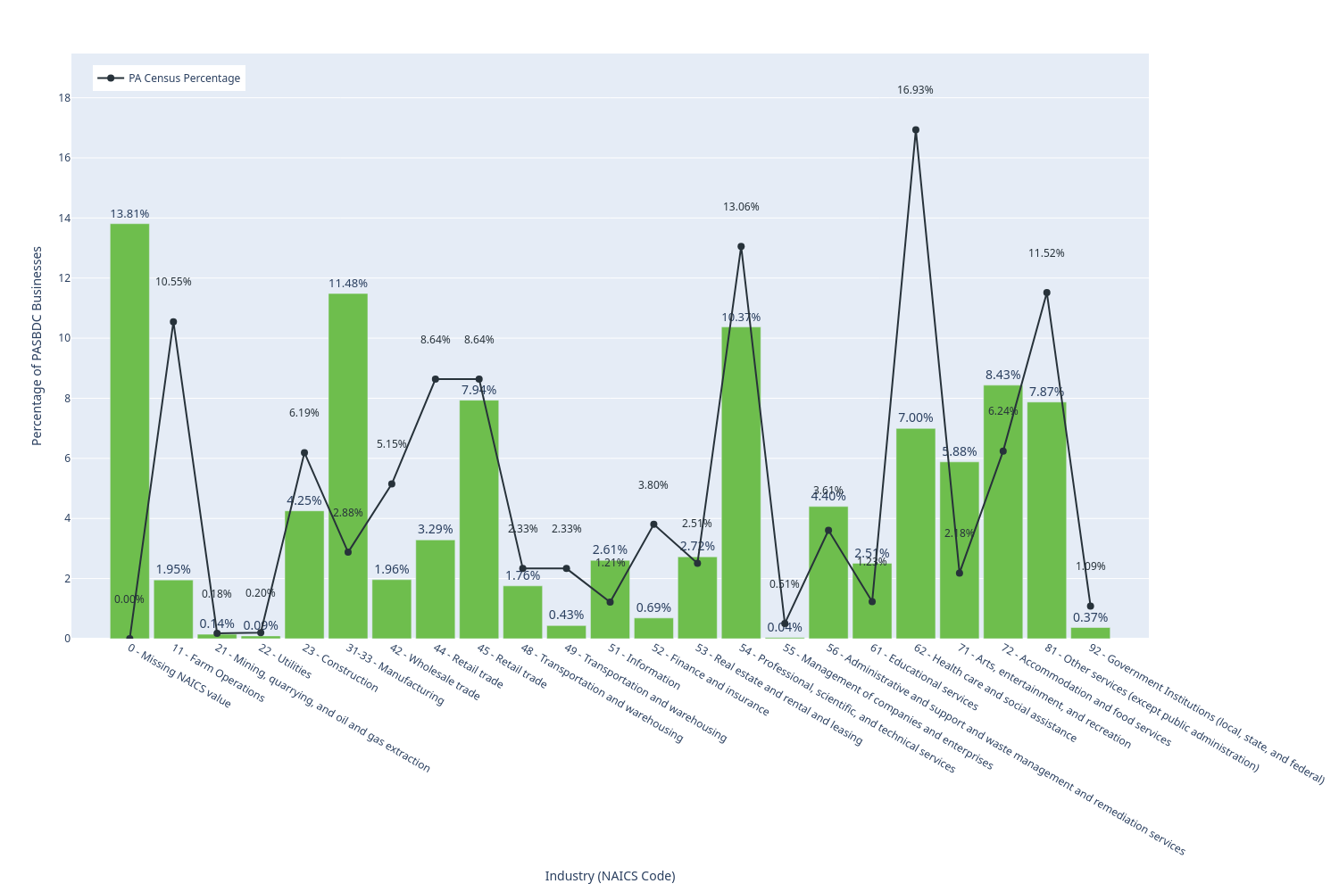
Figure 1.1.1 shows the percentage of PASBDC clients per NAICS code compared to census percentages.
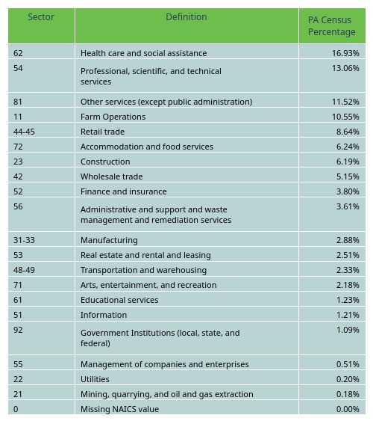
Table 1.1.1 Shows the NAICS codes for each sector along with the percentage that sector makes up of the PA census data. | NOTE: The US census does not cover agriculture (as that is the responsiblity of the USDA) nor government institutions (as the census measures the private sector). Agriculture data was soruced from the USDA where number of farm operations was used as the statistical stand in. As for government institutions, that data was sourced from the BLS by taking the number of NAICS code 92 organizations.
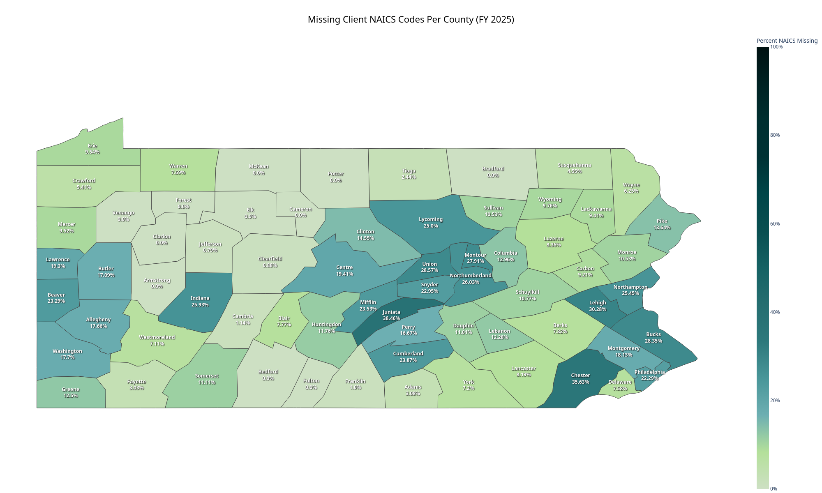
Figure 1.1.2 shows the percentage of clients whose NAICS codes were missing in Neoserra by county. Network wide, 14.87% of client profiles are missing NAICS codes.

