1.10 Client Satisfaction Analysis
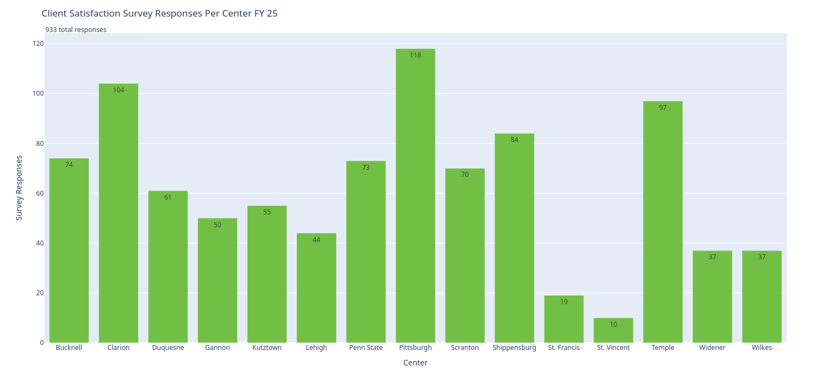 | 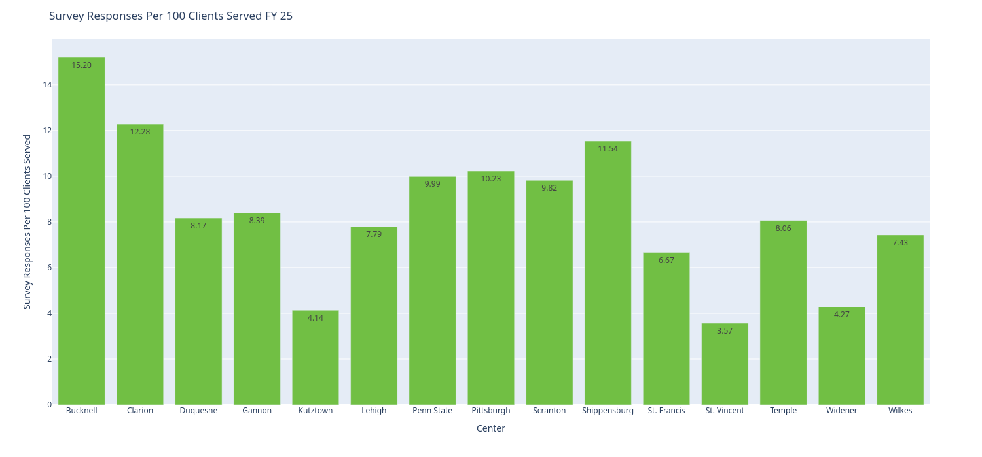
Figure 1.10.1 shows the count of servey responses for clients per center. | Figure 1.10.2 shows the count of servey responses per clinet served per center.
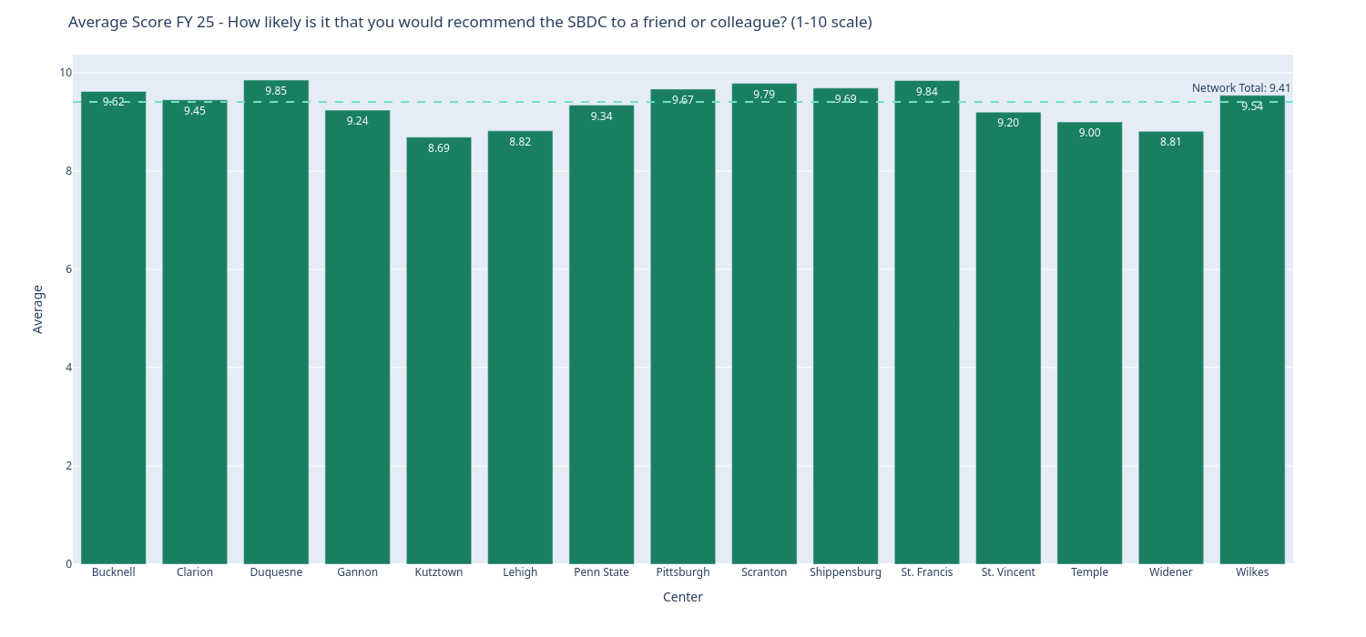 | 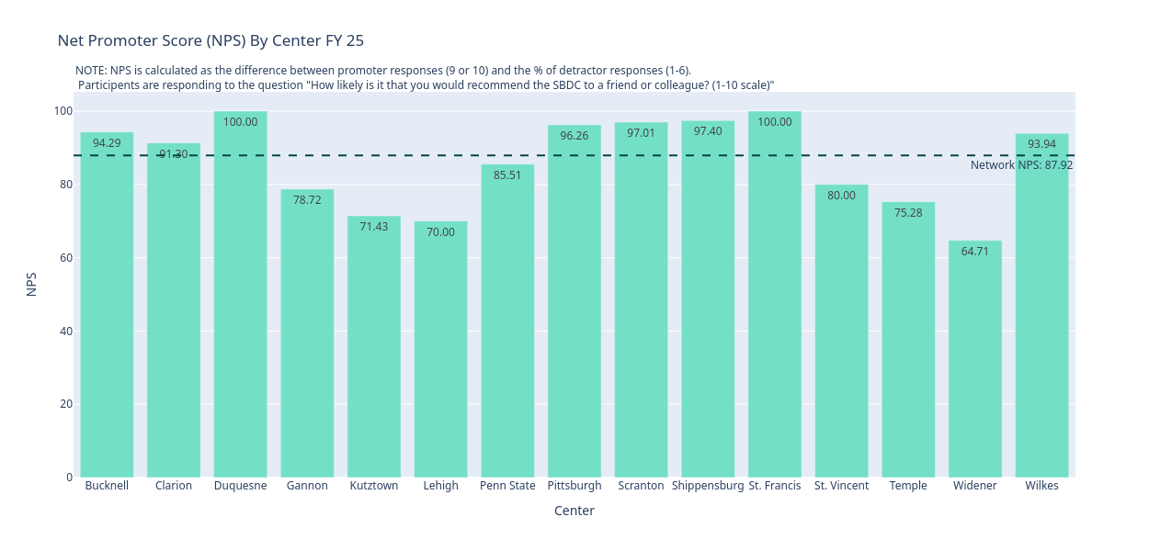
Figure 1.10.3 shows how clients responded to the listed question. | Figure 1.10.4 shows the NPS calculated for each center. See https://contentsquare.com/guides/net-promoter-score/ for a more in-depth explaination.

