1.5 Capital Funding Milestone Attribution Analysis
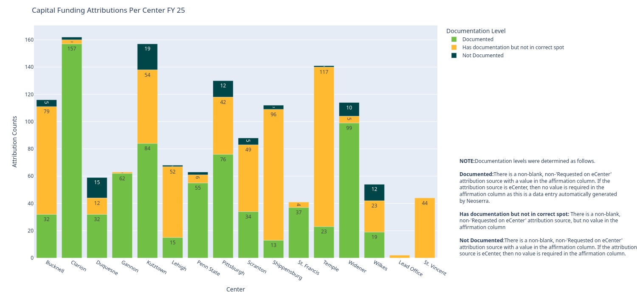
Figure 1.5.1 shows the counts of milestones in each documentation level per center.
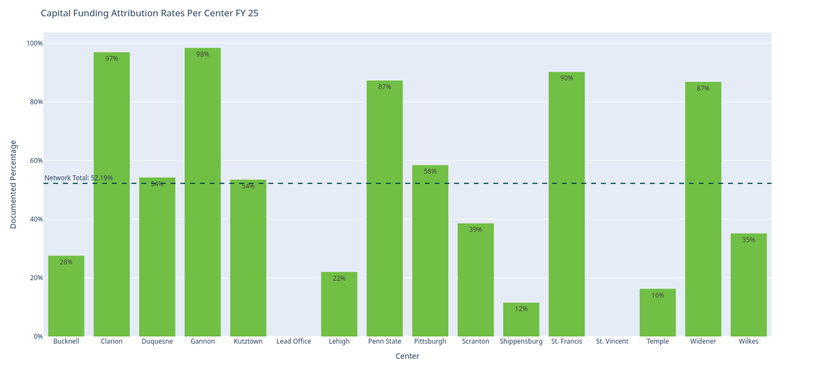 | 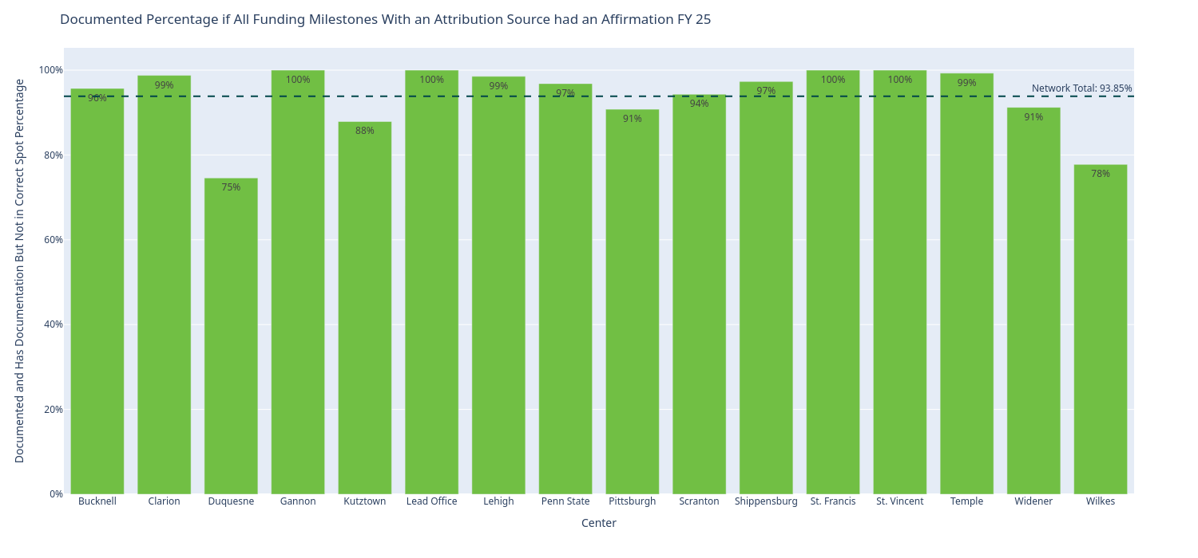
Figure 1.5.2 shows the percentage of funding attribution milestones had documentation per center. | Figure 1.5.3 shows what the attribution rate would be if all milestones were properly documented.
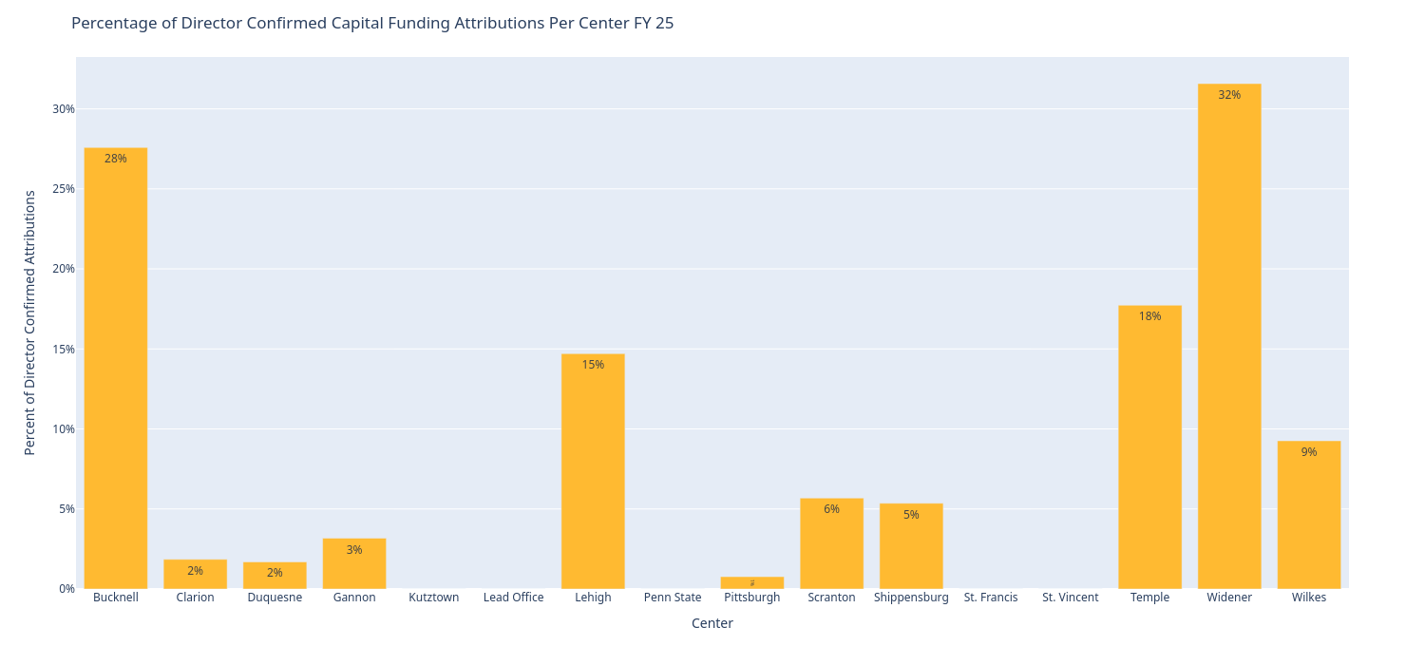
Figure 1.5.4 shows the percentage of milestones that were director confirmed.

New Business Start Milestone Attribution Analysis
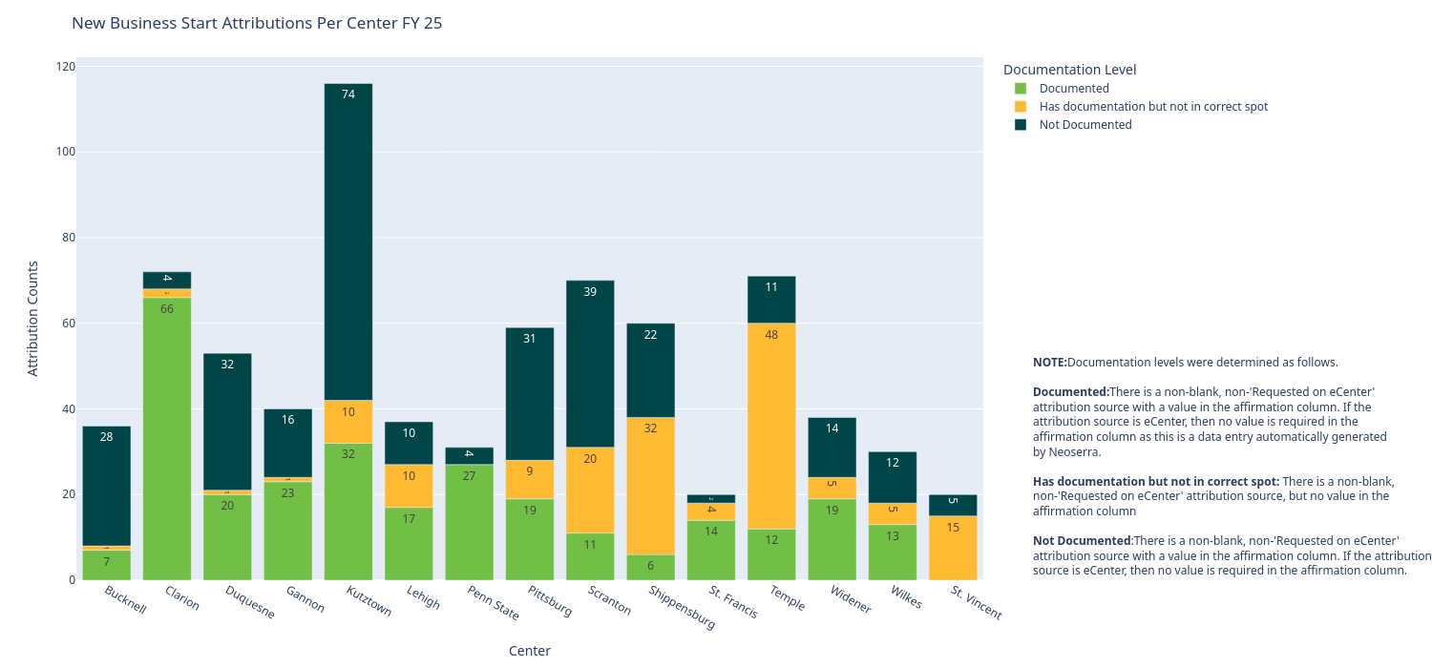
Figure 1.5.5 shows the counts of milestones in each documentation level per center.
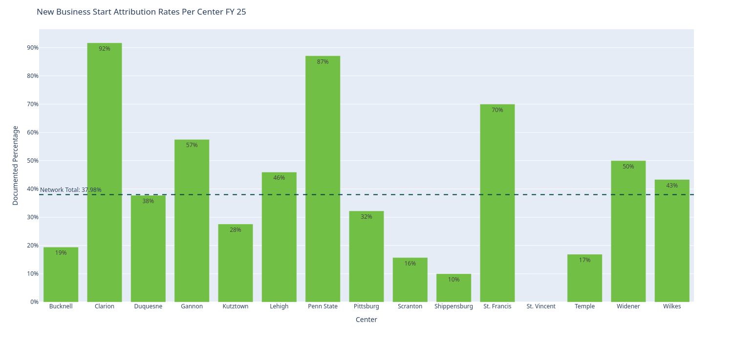 | 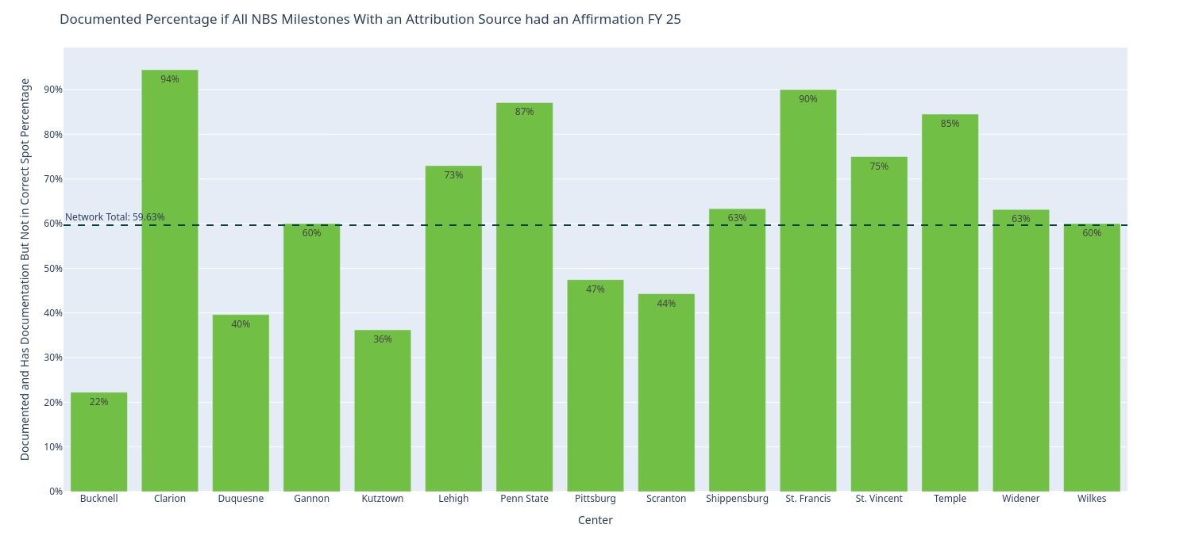
Figure 1.5.6 shows the percentage of NBS attribution milestones had documentation per center. | Figure 1.5.7 shows what the attribution rate would be if all milestones were properly documented.
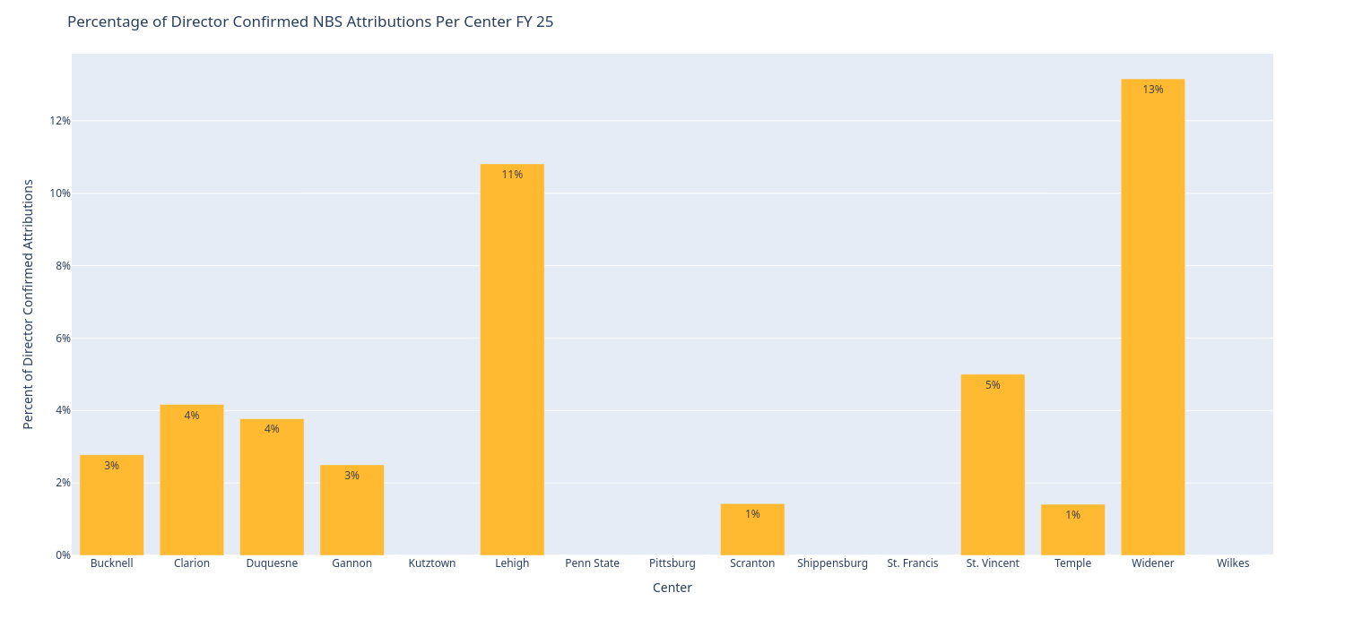
Figure 1.5.8 shows the percentage of milestones that were director confirmed.

